-

PICK Tool Test Plan

Version 2.0

4/28/2020

**Document Control**

**Approval**

The Guidance Team and the customer shall approve this document.

**Document Change Control**

|  |  |
| --- | --- |
| Initial Release: | 1.0 |
| Current Release: | 2.0 |
| Indicator of Last Page in Document: | $ |
| Date of Last Review: | 4/28/2020 |
| Date of Next Review: | 4/30/2020 |
| Target Date for Next Update: | 4/30/2020 |

**Distribution List**

This following list of people shall receive a copy of this document every time a new version of this document becomes available: Guidance Team Members, Clients, Software Team.

Guidance Team Members:

Dr. Ann Gates

Dr. Salamah Salamah

Dr. Steven Roach

Ms. Elsa Tai Ramirez

Customer:

Dr. Oscar Perez

Mr. Vincent Fonseca

Ms. Herandy Vazquez

Mr. Baltazar Santaella

Ms. Florencia Larsen

Mr. Erick De Nava

Software Team Members:

Mr. Valente Arellano

Mr. Tarek Haddad

Mr. Joseph Warren

Mr. Mark Williams

Mr. Ivan Torres

**Change Summary**

The following table details changes made between versions of this document

|  |  |  |  |
| --- | --- | --- | --- |
| Version | Date | Modifier | Description |
| 1.0 | 4/16/2020 | All team members | Initial draft of test plan |
| 1.1 | 4/22/2020 | All team members | Updated initial draft to include more test cases. Final draft of test plan. |
| 2.0 | 4/26/2020 | All team members | Updated final draft of test plan based on guidance team feedback, |

Note: The template presented in this document was taken from:

Donaldson, S., and S. Siegel, *Successful Software Development*. Upper Saddle River, NJ: Prentice Hall, 2001, pp. 321-323.

Note: The template presented in this document was taken from: Donaldson, S., and S. Siegel, *Successful Software Development*. Upper Saddle River, NJ: Prentice Hall, 2001, pp. 321-323 and modified by Humberto Mendoza and Steve Roach.

Supplementary information is from:

Pfleeger, S. *Software Engineering, Theory and Practice*. Upper Saddle River, NJ: Prentice Hall, 1998, p. 365.

**Table of Contents**

**1. Introduction** **6**

Purpose 6

Scope 6

System Overview 6

**Suspension and Exit Criteria** **7**

Document Overview 7

References 7

**2. Test Items and Features** **8**

**3. Testing Approach** **9**

**4. Test Cases** **12**

4.1. Test EC - 1 12

4.2. Test EC - 2 13

4.3. Test EC - 3 14

4.4. Test EC - 4 14

4.5. Test EC - 5 16

4.6. Test EC - 6 16

4.7. Test I - 1 18

4.8. Test I - 2 19

4.9. Test I - 3 20

4.10. Test I - 4 21

4.11. Test LF - 1 22

4.12. Test LF - 2 23

4.13. Test LF - 3 23

4.14. Test LF - 4 25

4.15. Test LF - 5 26

4.16. Test LF - 6 27

4.17.Test LF - 7 28

4.18. Test LF - 8 29

4.19. Test LF - 9 30

4.20. Test LF - 10 31

4.21. Test LE - 1 32

4.22. Test LE - 2 33

4.23. Test LE - 3 34

4.24. Test LE - 4 35

4.25. Test LE - 5 36

4.26. Test LE - 6 37

4.27. Test LE - 7 38

4.28. Test V - 1 39

4.29. Test V - 2 40

4.30. Test V - 3 41

4.31. Test V - 4 42

4.32. Test V - 5 43

4.33. Test V - 6 44

4.34. Test V - 7 45

4.35. Test V - 8 46

4.36. Test V - 9 47

4.37 Test V - 10 48

4.38 Test V - 11 49

4.39. Test V - 12 50

4.40. Test V - 13 51

4.41. Test V - 14 52

4.42. Test V - 15 53

4.43. Test V - 16 54

4.44. Test V - 17 55

4.45. Test V - 18 56

4.46. Test V - 19 57

4.47. Test V - 20 58

4.48. Test V - 21 59

**5. Test Schedule** **61**

**6. Appendix** **62**

# 1. Introduction

In this section, we provide introductory information regarding the project, the system to be tested, and the testing approach.

## Purpose

The purpose of this document is to provide an in-depth description of the test plan for the PICK tool product that focuses on overall test approach as well as individual test cases. This document allows us to organize the development and test effort and provide guidance to testers to make tests reproducible and analyzable. Furthermore, this document allows us to manage the testing for this project, allowing us to continue to adhere to our structured development plan.

## Scope

The current project baseline (i.e. the most recent version) is the focus of this test plan. It is important to note that other releases of our product are partially covered by the contents of this test plan, but only the most recent version is fully covered.

## System Overview

This system we will develop will aid the clients in their efforts by allowing analysts to associate significant events that occur in an AA (Adversarial Assessment) to vectors. In the context of the system, these vectors will represent a series of activities/steps an adversary executes or attempts to execute that are necessary to achieve an objective [1]. Vectors will be represented in two forms in the system: a table form and a graphical form. Both representations will be able to be edited which will help analysts dynamically construct vectors. The PICK tool will also support the filtering of events that occur during an AA which will fulfill another of the analyst’s needs: the ability to easily find events of significance in an AA.

Essentially, the main features of the system being produced are as follows:

1. The PICK tool will allow analysts to define vectors.
2. The PICK tool will enable analysts to discover significant events by allowing analysts to filter through all of the events that occur in an AA.
3. The PICK tool will allow analysts to associate significant events to vectors which can be represented as a visual graph or table [2].
4. The PICK tool will allow analysts to correlate events into vectors.
5. The PICK tool will allow analysts to export vectors as an image of the visual graph or as a CSV file of the table.

## Suspension and Exit Criteria

If one of the critical tests fails, we will suspend testing for one day. For the exit criteria of this test plan to be met, all critical tests must pass and at least 75% of non-critical tests must pass.

## Document Overview

In the remainder of this document, we describe the features that we are testing and their related test items before illustrating each of our unique test suites. After we provide our test suites, we review each individual test case in depth,

## References

[1]  Oroware Team (2019). SRS

[2]  Oroware Team (2020). SDD

# 2. Test Items and Features

The following features will be tested:

|  |  |
| --- | --- |
| **Feature** | **Test Items (Classes)** |
| Add icons based on provided user input | Icon, Icon Manager |
| Set root path for log entry ingestion based on provided user input | Log File Manager |
| Cleanse, validate, and ingest textual log files | Log File, Splunk Interface |
| Cleanse, validate, and ingest audio log files | Audio Log File |
| Cleanse, validate, and ingest video log files | Video Log File |
| Cleanse, validate, and ingest PDF log files | PDF Log File |
| Cleanse, validate, and ingest image log files | Image Log File |
| Start ingestion process when prompted by user | Log File Manager |
| Create log entries from ingested log files | Log Entry, Log Entry Manager |
| Edit log entry based on provided user input | Log Entry, Log Entry Manager |
| Add vector based on provided user input | Vector, Vector Manager |
| Associate log entry to vector | Vector, Vector Manager, Graph Widget, Significant Event |
| Edit significant event based on provided user input | Vector, Vector Manager, Graph Widget, Significant Event |
| Create significant event in vector | Vector, Vector Manager, Graph Widget, Significant Event |
| Remove significant event from vector | Vector, Vector Manager, Graph Widget, Log Entry Manager |
| Correlate significant events together in a relationship | Relationship, Vector, Vector Manager, Graph Widget, Significant Event |
| Edit relationship based on provided user input | Relationship, Vector, Vector Manager, Graph Widget |
| Change node visibility on graph | Significant Event, Vector, Graph Widget |
| Edit node’s position on graph | Vector, Graph Widget |
| Change vector’s visibility attributes | Vector, Graph Widget |
| Export vector as table | Vector |
| Export vector as image | Graph Widget |
| Edit event configuration based on provided user input | Event Configuration |
| Search log entries based on provided user input | Log Entry Manager, Log Entry |
| Push vectors to vector db | Vector, Vector Manager, Client Handler |
| Pull vectors from vector db | Vector, Vector Manager, Client Handler |
| Connect to lead machine (through server) based on provided user input | Client Handler |
| Set lead status | Client Handler |
| Approve vector as lead | Vector, Vector Manager, Client Handler |
| Reject vectors as lead | Vector, Vector Manager, Client Handler |
| Display event configuration and lead information | Team Configuration |
| Display log files and enforcement action reports | Ingestion Configuration |
| Display log entries | Log Entry Configuration |
| Display vector in graphical and tabular view | Edit Vector Configuration |
| Display icons | Icon Configuration |
| Display local vectors | Vector Configuration |
| Display pulled, pushed, and (if lead) pending vectors | Vector Db Configuration |

# 3. Testing Approach

We test our system by creating and executing several test suites that each focus on sets of similar features. Most of the tests in a given test suite are system tests, meaning that we focus on exercising system functionalities altogether. However, a few of the tests we create are user interface tests, so we do also test our user interfaces. We also integrate user interface tests with normal tests in our test suites for simplicity. It is important to note that we do not perform testing of functional requirements (e.g. latency, load time) in our test suites.

**Table 1: Test Plan**

|  |  |  |
| --- | --- | --- |
| **TEST SUITE: Event Configuration** | | |
| **Description of Test Suite** | This test suite focuses on the functionality regarding the Event Configuration. | |
| **Test Case Identifier** | **Objective** | **Criticality** |
| EC - 1 | Test edit event configuration based on valid user input | Critical |
| EC - 2 | Test display event configuration | Normal |
| EC - 3 | Test handle invalid input when editing event configuration | Normal |
| EC - 4 | Test connect to lead machine (through server) based on valid user input | Critical |
| EC - 5 | Test handle invalid input when connecting to lead machine | Normal |
| EC - 6 | Test set lead status | Critical |

**Table 2: Test Plan**

|  |  |  |
| --- | --- | --- |
| **TEST SUITE: Icons** | | |
| **Description of Test Suite** | This test suite focuses on the functionality regarding icons. | |
| **Test Case Identifier** | **Objective** | **Criticality** |
| I - 1 | Test add icon based on valid user input | Critical |
| I - 2 | Test handle invalid input when adding icon | Normal |
| I - 3 | Test view an icon’s image | Normal |
| I - 4 | Test display icons | Normal |

**Table 3: Test Plan**

|  |  |  |
| --- | --- | --- |
| **TEST SUITE: Log File Ingestion** | | |
| **Description of Test Suite** | This test suite focuses on the functionality regarding log file ingestion. | |
| **Test Case Identifier** | **Objective** | **Criticality** |
| LF - 1 | Test set root path based on valid user input | Critical |
| LF - 2 | Test handle invalid input when setting root path | Critical |
| LF - 3 | Test start ingestion process with valid root path | Critical |
| LF - 4 | Test cleanse, validate, and ingest a textual log file | Critical |
| LF - 5 | Test cleanse, validate, and ingest an audio log file | Critical |
| LF - 6 | Test cleanse, validate, and ingest an image log file | Critical |
| LF - 7 | Test cleanse, validate, and ingest a PDF log file | Critical |
| LF - 8 | Test cleanse, validate, and ingest a video log file | Critical |
| LF - 9 | Test generate log entries from ingested log file | Critical |
| LF - 10 | Test display log files | Normal |

**Table 4: Test Plan**

|  |  |  |
| --- | --- | --- |
| **TEST SUITE: Log Entries** | | |
| **Description of Test Suite** | This test suite focuses on the functionality regarding log entries. | |
| **Test Case Identifier** | **Objective** | **Criticality** |
| LE - 1 | Test edit log entry based on valid input | Critical |
| LE - 2 | Test associate log entry to existing vector | Critical |
| LE - 3 | Test disassociate log entry from vector | Normal |
| LE - 4 | Test search log entries using regex | Critical |
| LE - 5 | Test search log entries by timestamp | Critical |
| LE - 6 | Test search log entries by creator | Normal |
| LE - 7 | Test display log entries | Normal |

**Table 5: Test Plan**

|  |  |  |
| --- | --- | --- |
| **TEST SUITE: Vectors** | | |
| **Description of Test Suite** | This test suite focuses on the functionality regarding vectors. | |
| **Test Case Identifier** | **Objective** | **Criticality** |
| V - 1 | Test add vector based on valid user input | Critical |
| V - 2 | Test handle invalid input when adding vector | Critical |
| V - 3 | Test export vector as table | Normal |
| V - 4 | Test export vector as graph | Normal |
| V - 5 | Test create significant event in vector | Critical |
| V - 6 | Test remove significant event from vector | Normal |
| V - 7 | Test change node visibility on graph | Critical |
| V - 8 | Test edit vector’s visibility properties for graph | Critical |
| V - 9 | Test edit node’s position on graph | Critical |
| V - 10 | Test edit significant event based on user input | Critical |
| V - 11 | Test correlate significant events in a relationship | Critical |
| V - 12 | Test edit relationship | Normal |
| V - 13 | Test display vector | Critical |
| V - 14 | Test zoom in to graph | Normal |
| V - 15 | Test zoom out of graph | Normal |
| V - 16 | Test push vectors to vector db | Critical |
| V - 17 | Test pull vectors from vector db | Critical |
| V - 18 | Test approve vector as lead | Critical |
| V - 19 | Test reject vector as lead | Normal |
| V - 20 | Test display vector Db | Normal |
| V - 21 | Test display vector Db as lead | Normal |

# 4. Test Cases

The purpose of this section is to:

* document test input, specific test procedures, and outcomes.
* establish test methods,
* explain the nature and extent of each test

## 4.1. Test EC - 1

**Objective:** Test edit event configuration based on valid user input

**Notes:**

|  |  |  |  |  |  |  |
| --- | --- | --- | --- | --- | --- | --- |
| Test No.: EC - 1 | | | | Current Status: Passed | | |
| Test title: Edit event configuration | | | | | | |
| Testing approach: This test will be conducted by interacting with the PICK tool. All of the environmental requirements of the PICK tool are also required to execute this test. Behavior will be observed on the team configuration GUI tab of the PICK tool. The test priority of this test is critical. | | | | | | |
| STEP  1  2 | OPERATOR ACTION  Begin test by opening up PICK tool and clicking Team Configuration Tab  Select the event name field in the window and enter “SQL Event”, select the event description field and enter “SQL Event by Red Team”, select the start date field and enter “4/11/2019 12:00 A.M”, select the end date field and enter “4/18/2021 12:00 A.M”  Click the *Save Event* button | PURPOSE  Initial Condition  Validate event information is saved when edited | | | EXPECTED RESULTS  A window identical to Image 1 in the Appendix is displayed on your screen  A window identical to Image 43 in the Appendix is displayed on your screen, there is a database entry in the “config” column of the system’s MongoDb database with an event name field whose value is “SQL Event”, an event description field whose value is “SQL Event by Red Team”, a start date field whose value is “4/11/2020 12:00 A.M.”, a end date field whose value is “4/18/2020 12:00 A.M.” | COMMENTS |
| Concluding Remarks: All expected results satisfied. | | | | | | |
| Testing Team:  Software Team Members  Lead:  Ivan Torres | | | Date Completed:  4/8/2020 | | | |

## 4.2. Test EC - 2

**Objective:** Test display event configuration

**Notes:**

|  |  |  |  |  |  |  |
| --- | --- | --- | --- | --- | --- | --- |
| Test No.: EC - 2 | | | | Current Status: Passed | | |
| Test title: Display event configuration | | | | | | |
| Testing approach: This test will be conducted by interacting with the PICK tool. All of the environmental requirements of the PICK tool are also required to execute this test. Behavior will be observed on the team configuration GUI tab of the PICK tool. The test priority of this test is normal and this test is a user interface test. | | | | | | |
| STEP  1 | OPERATOR ACTION  Begin test by opening up PICK tool and clicking Team Configuration Tab | PURPOSE  Initial Condition | | | EXPECTED RESULTS  A window identical to Image 1 in the Appendix is displayed on your screen | COMMENTS |
| Concluding Remarks: All expected results satisfied. | | | | | | |
| Testing Team:  Software Team Members  Lead:  Ivan Torres | | | Date Completed:  4/8/2020 | | | |

## 4.3. Test EC - 3

**Objective:** Test handle invalid input when editing event configuration

**Notes:**

|  |  |  |  |  |  |  |
| --- | --- | --- | --- | --- | --- | --- |
| Test No.: EC - 3 | | | | Current Status: Passed | | |
| Test title: Handle invalid event configuration input | | | | | | |
| Testing approach: This test will be conducted by interacting with the PICK tool. All of the environmental requirements of the PICK tool are also required to execute this test. Behavior will be observed on the team configuration GUI tab of the PICK tool. The test priority of this test is normal and this test is a user interface test. | | | | | | |
| STEP  1  2 | OPERATOR ACTION  Begin test by opening up PICK tool and clicking Team Configuration Tab  Select the event name field in the window and enter “SQL Event”, select the event description field and enter “SQL Event by Red Team”, select the start date field and enter “4/18/2021 12:00 A.M”, select the end date field and enter “4/11/2019 12:00 A.M”  Click the *Save Event* button | PURPOSE  Initial Condition  Validate invalid event information is not saved | | | EXPECTED RESULTS  A window identical to Image 1 in the Appendix is displayed on your screen  A notification popup appears on the window detailing that contains the following text “Invalid start or end timestamp” | COMMENTS  We currently do not have a functional notification popup, so you will have to observe the terminal output for the error message, which will be “Invalid start or end timestamp” |
| Concluding Remarks: All expected results satisfied. | | | | | | |
| Testing Team:  Software Team Members  Lead:  Ivan Torres | | | Date Completed:  4/8/2020 | | | |

## 4.4. Test EC - 4

**Objective:** Test connect to lead machine (through server) based on valid user input

**Notes:**

|  |  |  |  |  |  |  |
| --- | --- | --- | --- | --- | --- | --- |
| Test No.: EC - 4 | | | | Current Status: Passed | | |
| Test title: Connect to lead machine (through server) based on valid user input | | | | | | |
| Testing approach: This test will be conducted by interacting with the PICK tool. All of the environmental requirements of the PICK tool are also required to execute this test. Additionally, a stub for the server handler or the server handler itself must be running with an open socket at IP address “127.0.0.1” for this test to be initiated. Behavior will be observed on the team configuration GUI tab of the PICK tool. The test priority of this test is critical and this test is a user interface test. | | | | | | |
| STEP  1  2  3 | OPERATOR ACTION  Begin test by opening up PICK tool and clicking Team Configuration Tab  Select IP address field in the window and enter “127.0.0.1"  Click the *Connect* button  Close the PICK tool and reopen it. | PURPOSE  Initial Condition  Validate a client machine can connect to a server instance  Validate connection persists once application is terminated | | | EXPECTED RESULTS  A window identical to Image 1 in the Appendix is displayed on your screen  The client connects to the server at the specified IP address through a socket, a notification popup appears that contains the following text “Connected to server.”, a new file is created called ipAddress.pkl in the ui directory of the PICK tool that contains “127.0.0.1” serialized  The client automatically connects to the server or stub if it is still running, and a notification popup appears that contains the following text “Connected to server.” | COMMENTS  We currently do not have a functional notification popup, so you will have to observe the terminal output for the confirmation message, which will be “Connected to server.”  We currently do not have a functional notification popup, so you will have to observe the terminal output for the confirmation message, which will be “Connected to server.” |
| Concluding Remarks: All expected results satisfied. | | | | | | |
| Testing Team:  Software Team Members  Lead:  Ivan Torres | | | Date Completed:  4/8/2020 | | | |

## 4.5. Test EC - 5

**Objective:** Test handle invalid input when connecting to lead machine

**Notes:**

|  |  |  |  |  |  |  |
| --- | --- | --- | --- | --- | --- | --- |
| Test No.: EC - 5 | | | | Current Status: Passed | | |
| Test title: Handle invalid input when connecting to lead machine | | | | | | |
| Testing approach: This test will be conducted by interacting with the PICK tool. All of the environmental requirements of the PICK tool are also required to execute this test. Additionally, a stub for the server handler or the server handler itself must be running with an open socket at IP address “127.0.0.1” for this test to be initiated. Behavior will be observed on the team configuration GUI tab of the PICK tool. The test priority of this test is normal. | | | | | | |
| STEP  1  2 | OPERATOR ACTION  Begin test by opening up PICK tool and clicking Team Configuration Tab  Select IP address field in the window and enter “127.0.0.2"  Click the *Connect* button | PURPOSE  Initial Condition  Validate invalid IP address does not cause unwanted connection | | | EXPECTED RESULTS  A window identical to Image 1 in the Appendix is displayed on your screen  A notification popup appears that contains the following text “Invalid IP address entered.”. | COMMENTS  We currently do not have a functional notification popup, so you will have to observe the terminal output for the error message, which will be “Invalid IP address entered.”. |
| Concluding Remarks: All expected results satisfied. | | | | | | |
| Testing Team:  Software Team Members  Lead:  Ivan Torres | | | Date Completed:  4/8/2020 | | | |

## 4.6. Test EC - 6

**Objective:** Test set lead status

**Notes:**

|  |  |  |  |  |  |  |
| --- | --- | --- | --- | --- | --- | --- |
| Test No.: EC - 6 | | | | Current Status: Passed | | |
| Test title: Set lead status | | | | | | |
| Testing approach: This test will be conducted by interacting with the PICK tool. All of the environmental requirements of the PICK tool are also required to execute this test. Additionally, a stub for the server handler or the server handler itself must be running with an open socket at IP address “127.0.0.1” for this test to be initiated. Behavior will be observed on the team configuration GUI tab of the PICK tool. The test priority of this test is normal. | | | | | | |
| STEP  1  2  3  4 | OPERATOR ACTION  Begin test by opening up PICK tool, executing test case EC - 1, and clicking Team Configuration Tab  Click the *Lead* checkbox  Click the Vector Db Configuration Tab  Close the PICK tool and reopen it. | PURPOSE  Initial Condition  Validate lead can be set by a client machine  Validate updated privileges  Validate lead status persists once application is terminated | | | EXPECTED RESULTS  A window identical to Image 2 in the Appendix is displayed on your screen, the client machine is connected to the server or server stub  The client machine is granted lead privileges, a notification popup appears on the window that contains the following text “Lead status upgraded.”  A window identical to Image 3 in the Appendix is displayed on your screen, the client machine is connected to the server or server stub  A window identical to Image 4 in the Appendix is displayed on your screen | COMMENTS  We currently do not have a functional notification popup, so you will have to observe the terminal output for the notification message, which will be “Lead status upgraded.” |
| Concluding Remarks: All expected results satisfied. | | | | | | |
| Testing Team:  Software Team Members  Lead:  Ivan Torres | | | Date Completed:  4/8/2020 | | | |

## 4.7. Test I - 1

**Objective:** Test add icon based on valid user input

**Notes:**

|  |  |  |  |  |  |  |
| --- | --- | --- | --- | --- | --- | --- |
| Test No.: I - 1 | | | | Current Status: Passed | | |
| Test title: Add icon | | | | | | |
| Testing approach: This test will be conducted by interacting with the PICK tool. All of the environmental requirements of the PICK tool are also required to execute this test. Behavior will be observed on the Icon Configuration GUI tab of the PICK tool. The test priority of this test is critical. | | | | | | |
| STEP  1  2  3  4  5 | OPERATOR ACTION  Begin test by opening up PICK tool, executing test case EC - 1, and clicking Icon Configuration Tab  Click the *Add Icon* button located near the top of the window.  Click on the icon you would like to select and click the open button on the bottom right of the popup.  Click on the Icon Name field in the Add Icon Popup and type out the name of your icon.  Click the Add Icon button on the Add Icon Popup. | PURPOSE  Initial condition  Ensure that valid user input allows for an Icon to be added | | | EXPECTED RESULTS  A window identical to Image 44 in the Appendix is displayed on your screen  A popup window similar to Image 45 in the Appendix is displayed on your screen. | COMMENTS  This is assuming you already have valid images that can be used as an icon. |
| Concluding Remarks: All expected results satisfied. | | | | | | |
| Testing Team:  Software Team Members  Lead:  Ivan Torres | | | Date Completed:  4/21/20 | | | |

## 4.8. Test I - 2

**Objective:** Test handle invalid input when adding icon

**Notes:**

|  |  |  |  |  |  |  |
| --- | --- | --- | --- | --- | --- | --- |
| Test No.: I - 2 | | | | Current Status: Passed | | |
| Test title: Handle invalid input when adding icon | | | | | | |
| Testing approach: This test will be conducted by interacting with the PICK tool. All of the environmental requirements of the PICK tool are also required to execute this test. Behavior will be observed on the Icon Configuration GUI tab of the PICK tool. The test priority of this test is normal. | | | | | | |
| STEP  1  2  3  4 | OPERATOR ACTION  Begin test by opening up PICK tool, executing test case EC - 1, and clicking Icon Configuration Tab  Click the *Add Icon* button located near the top of the window.  Click on the Icon Name field in the Add Icon Popup and type out the name of your icon.  Click the Add Icon button on the Add Icon Popup. | PURPOSE  Initial condition | | | EXPECTED RESULTS  A window identical to Image 44 in the Appendix is displayed on your screen  The program will close since an image for the icon was not selected. | COMMENTS  We currently do not have a functional notification popup, so you will have to observe the terminal output for the error message, which will be “No icon name provided.” |
| Concluding Remarks: All expected results satisfied. | | | | | | |
| Testing Team:  Software Team Members  Lead:  Ivan Torres | | | Date Completed:  4/21/20 | | | |

## 4.9. Test I - 3

**Objective:** Test handle invalid input when adding icon

**Notes:**

|  |  |  |  |  |  |  |
| --- | --- | --- | --- | --- | --- | --- |
| Test No.: I - 3 | | | | Current Status: Passed | | |
| Test title: View an icon’s image | | | | | | |
| Testing approach: This test will be conducted by interacting with the PICK tool. All of the environmental requirements of the PICK tool are also required to execute this test. Behavior will be observed on the Icon Configuration GUI tab of the PICK tool. The test priority of this test is normal. | | | | | | |
| STEP  1  2 | OPERATOR ACTION  Begin test by opening up PICK tool, executing test case EC - 1, and clicking Icon Configuration Tab  Find the icon you would like to view and click on the *View Icon* button next to it. | PURPOSE  Initial condition  Ensure the icon can be viewed after creation. | | | EXPECTED RESULTS  A window similar to Image 44 in the Appendix is displayed on your screen  A window similar to Image 49 in the Appendix is displayed on your screen. | COMMENTS |
| Concluding Remarks: All expected results satisfied. | | | | | | |
| Testing Team:  Software Team Members  Lead:  Ivan Torres | | | Date Completed:  4/21/20 | | | |

## 4.10. Test I - 4

**Objective:** Test display icons

**Notes:**

|  |  |  |  |  |  |  |
| --- | --- | --- | --- | --- | --- | --- |
| Test No.: I - 4 | | | | Current Status: Passed | | |
| Test title: Display icon | | | | | | |
| Testing approach: This test will be conducted by interacting with the PICK tool. All of the environmental requirements of the PICK tool are also required to execute this test. Behavior will be observed on the Edit Vector GUI tab of the PICK tool. The test priority of this test is normal. | | | | | | |
| STEP  1  2  3  4  5 | OPERATOR ACTION  Begin test by opening up PICK tool, executing test case EC - 1, and clicking Icon Configuration Tab.  Click on the Edit Vector tab.  Click on the dropdown menu under Vector and select the vector you would like to view.  Find the node you would like to add an icon for under the Nodes table.  Find the *Icon Type* dropdown for the node you want to change, click the dropdown menu, and select the icon you want for the node. | PURPOSE  Initial condition  Selecting a vector so you can change the icon of one of its nodes. | | | EXPECTED RESULTS  A window similar to Image 44 in the Appendix is displayed on your screen  The graph for that vector will appear if one exists for it.  The node you selected will now have the icon displaying as itself. | COMMENTS  If you do not already have nodes existing for the selected vector you must first add a node before moving forward with the rest of this test. |
| Concluding Remarks: All expected results satisfied. | | | | | | |
| Testing Team:  Software Team Members  Lead:  Ivan Torres | | | Date Completed:  4/21/20 | | | |

## 

## 4.11. Test LF - 1

**Objective:** Test set root path based on valid user input

**Notes:**

|  |  |  |  |  |  |  |
| --- | --- | --- | --- | --- | --- | --- |
| Test No.: LF - 1 | | | | Current Status: Passed | | |
| Test title: Set root path on valid user input | | | | | | |
| Testing approach: This test will be conducted by interacting with the PICK tool. All of the environmental requirements of the PICK tool are also required to execute this test. Behavior will be observed on the log file configuration GUI tab of the PICK tool.The test priority of this test is critical. | | | | | | |
| STEP  1  2 | OPERATOR ACTION  Begin test by opening up PICK tool, executing test case EC - 1, and clicking the ingestion tab  Click *Change Root Path* button and select the root directory that is in the ui directory of the PICK tool (which contains test data) and click the select folder button | PURPOSE  Initial Condition  Ensure that valid user input is accepted as root path | | | EXPECTED RESULTS  A window identical to Image 5 in the Appendix is displayed on your screen  A window identical to Image 6 in the Appendix is displayed on your screen, a new file is created called rootPath.pkl that contains the directory path selected | COMMENTS |
| Concluding Remarks: All expected results satisfied. | | | | | | |
| Testing Team:  Software Team Members  Lead:  Valente Arellano | | | Date Completed:  4/21/2020 | | | |

## 4.12. Test LF - 2

**Objective:** Test set root path based on valid user input

**Notes:**

|  |  |  |  |  |  |  |
| --- | --- | --- | --- | --- | --- | --- |
| Test No.: LF - 2 | | | | Current status: Pending | | |
| Test title: Test handle invalid input when setting root path | | | | | | |
| Testing approach: This test will be conducted by interacting with the PICK tool. All of the environmental requirements of the PICK tool are also required to execute this test. Additionally, some test data should be created and stored in a similar format to the real-world data the system will encounter. Behavior will be observed on the log file configuration GUI tab of the PICK tool.The test priority of this test is critical. | | | | | | |
| STEP  1  2 | OPERATOR ACTION  Begin test by opening up PICK tool, executing test case EC - 1, and clicking the ingestion tab  Click the *Start Data Ingestion*  button | PURPOSE  Initial Condition  Ensure that invalid user input (no root path selected) is handled | | | EXPECTED RESULTS  A window identical to Image 5 in the Appendix is displayed on your screen  Data ingestion does not begin, a notification popup that contains the following text "No root path selected" appears. | COMMENTS |
| Concluding Remarks: | | | | | | |
| Testing Team:  Software Team Members  Lead:  Valente Arellano | | | Date Completed: | | | |

## 4.13. Test LF - 3

**Objective:** Test start ingestion process with valid root path

**Notes:**

|  |  |  |  |  |  |  |
| --- | --- | --- | --- | --- | --- | --- |
| Test No.: LF - 3 | | | | Current Status: Passed | | |
| Test title: Start ingestion process with valid root path | | | | | | |
| Testing approach: This test will be conducted by interacting with the PICK tool. All of the environmental requirements of the PICK tool are also required to execute this test. Additionally, some test data should be created and stored in a similar format to the real-world data the system will encounter. Behavior will be observed on the log file configuration GUI tab of the PICK tool.The test priority of this test is critical. | | | | | | |
| STEP  1  2  3 | OPERATOR ACTION  Begin test by opening up PICK tool, executing test case EC - 1, and clicking the ingestion tab  Execute test case LF-1  Click the *Start Data Ingestion*  button | PURPOSE  Initial Condition  Change root directory  Start data ingestion | | | EXPECTED RESULTS  A window identical to Image 5 in the Appendix is displayed on your screen  A window identical to Image 6 in the Appendix is displayed on your screen  A window identical to Image 7 in the Appendix is displayed on your screen, there are 7 database entries in the “files” column of the system’s MongoDb database that have two field. The database entries are as follows:   |  |  | | --- | --- | | **_id** | **logFile** | | root/blue/blue_computer_log.txt | A serialized log file object | | root/blue/blue_log.pdf | A serialized log file object | | root/blue/blue_response.PNG | A serialized log file object | | root/red/red_escalation.mp4 | A serialized log file object | | root/red/red_offensive.txt | A serialized log file object | | root/white/white_computer_log.log | A serialized log file object | | root/white/white_recording.wav | A serialized log file object | | COMMENTS |
| Concluding Remarks: All expected results satisfied. | | | | | | |
| Testing Team:  Software Team Members  Lead:  TJ Haddad | | | Date Completed:  4/8/2020 | | | |

## 4.14. Test LF - 4

**Objective:** Test cleanse, validate, and ingest a textual log file

**Notes:**

|  |  |  |  |  |  |  |
| --- | --- | --- | --- | --- | --- | --- |
| Test No.: LF - 4 | | | | Current Status: Passed | | |
| Test title: Cleanse, validate, and ingest a textual log file | | | | | | |
| Testing approach: This test will be conducted by interacting with the PICK tool. All of the environmental requirements of the PICK tool are also required to execute this test. Some test data has been created and stored in a similar format to the real-world data the system will encounter. For this test, specifically, the test data created was a textual log file with some non-printable characters. The priority of this test is critical. | | | | | | |
| STEP  1  2  3 | OPERATOR ACTION  Begin test by opening up PICK tool, executing test case LF - 3, and clicking the Search Logs Tab  Select the keyword search and enter “Failed password for invalid user sysadmin”, select the end timestamp field and enter “1/1/2029 12:00 AM”  Click the *Apply Filters* button  Double click the only log entry in the table | PURPOSE  Initial Condition  Verify textual log file was ingested  Verify ingestion veracity | | | EXPECTED RESULTS  A window identical to Image 8 in the Appendix is displayed on your screen  A window identical to Image 9 in the Appendix is displayed on your screen  A window identical to Image 10 in the Appendix is displayed on your screen | COMMENTS |
| Concluding Remarks: All expected results satisfied. | | | | | | |
| Testing Team:  Software Team Members  Lead:  TJ Haddad | | | Date Completed:  4/8/2020 | | | |

## 4.15. Test LF - 5

**Objective:** Test cleanse, validate, and ingest an audio log file

**Notes:**

|  |  |  |  |  |  |  |
| --- | --- | --- | --- | --- | --- | --- |
| Test No.: LF - 5 | | | | Current Status: Passed | | |
| Test title: Cleanse, validate, and ingest an audio log file | | | | | | |
| Testing approach:This test will be conducted by interacting with the PICK tool. All of the environmental requirements of the PICK tool are also required to execute this test. Some test data has been created and stored in a similar format to the real-world data the system will encounter. For this test, specifically, the test data created was an audio log file. The priority of this test is critical. | | | | | | |
| STEP  1  2  3 | OPERATOR ACTION  Begin test by opening up PICK tool, executing test case LF - 3, and clicking the Search Logs Tab  Select the keyword search and enter “white team analyst starts taking notes”, select the end timestamp field and enter “1/1/2029 12:00 AM”  Click the *Apply Filters* button  Double click the only log entry in the table | PURPOSE  Initial Condition  Verify audio log file was ingested  Verify ingestion veracity | | | EXPECTED RESULTS  A window identical to Image 8 in the Appendix is displayed on your screen  A window identical to Image 11 in the Appendix is displayed on your screen  A window identical to Image 12 in the Appendix is displayed on your screen | COMMENTS |
| Concluding Remarks: All expected results satisfied. | | | | | | |
| Testing Team:  Software Team Members  Lead:  TJ Haddad | | | Date Completed:  4/8/2020 | | | |

## 4.16. Test LF - 6

**Objective:** Test cleanse, validate, and ingest an image log file

**Notes:**

|  |  |  |  |  |  |  |
| --- | --- | --- | --- | --- | --- | --- |
| Test No.: LF - 6 | | | | Current Status: Passed | | |
| Test title: Cleanse, validate, and ingest an image log file | | | | | | |
| Testing approach: This test will be conducted by interacting with the PICK tool. All of the environmental requirements of the PICK tool are also required to execute this test. Some test data has been created and stored in a similar format to the real-world data the system will encounter. For this test, specifically, the test data created was an image log file. The priority of this test is critical. | | | | | | |
| STEP  1  2  3 | OPERATOR ACTION  Begin test by opening up PICK tool, executing test case LF - 3, and clicking the Search Logs Tab  Select the keyword search and enter “Blue Team Defender Turns off Computer”, select the end timestamp field and enter “1/1/2029 12:00 AM”  Click the *Apply Filters* button  Double click the only log entry in the table | PURPOSE  Initial Condition  Verify image log file was ingested  Verify ingestion veracity | | | EXPECTED RESULTS  A window identical to Image 8 in the Appendix is displayed on your screen  A window identical to Image 13 in the Appendix is displayed on your screen  A window identical to Image 14 in the Appendix is displayed on your screen | COMMENTS |
| Concluding Remarks: All expected results satisfied. | | | | | | |
| Testing Team:  Software Team Members  Lead:  TJ Haddad | | | Date Completed: | | | |

## 4.17.Test LF - 7

**Objective:** Test cleanse, validate, and ingest a PDF log file

**Notes:**

|  |  |  |  |  |  |  |
| --- | --- | --- | --- | --- | --- | --- |
| Test No.: LF - 7 | | | | Current Status: Pending | | |
| Test title: Cleanse, validate, and ingest a PDF log file | | | | | | |
| Testing approach: This test will be conducted by interacting with the PICK tool. All of the environmental requirements of the PICK tool are also required to execute this test. Some test data has been created and stored in a similar format to the real-world data the system will encounter. For this test, specifically, the test data created was a PDF log file. The priority of this test is critical. | | | | | | |
| STEP  1  2  3 | OPERATOR ACTION  Begin test by opening up PICK tool, executing test case LF - 3, and clicking the Search Logs Tab  Select the keyword search and enter “Blue Team Defender Turns On Computer”, select the end timestamp field and enter “1/1/2029 12:00 AM”  Click the *Apply Filters* button  Double click the only log entry in the table | PURPOSE  Initial Condition  Verify PDF log file was ingested  Verify ingestion veracity | | | EXPECTED RESULTS  A window identical to Image 8 in the Appendix is displayed on your screen  A window identical to Image 15 in the Appendix is displayed on your screen  A window identical to Image 16 in the Appendix is displayed on your screen | COMMENTS |
| Concluding Remarks: | | | | | | |
| Testing Team:  Software Team Members  Lead:  TJ Haddad | | | Date Completed:  4/8/2020 | | | |

## 4.18. Test LF - 8

**Objective:** Test cleanse, validate, and ingest a video log file

**Notes:**

|  |  |  |  |  |  |  |
| --- | --- | --- | --- | --- | --- | --- |
| Test No.: LF - 8 | | | | Current Status: Passed | | |
| Test title: Cleanse, validate, and ingest a video log file | | | | | | |
| Testing approach: This test will be conducted by interacting with the PICK tool. All of the environmental requirements of the PICK tool are also required to execute this test. Some test data has been created and stored in a similar format to the real-world data the system will encounter. For this test, specifically, the test data created was a video log file. The priority of this test is critical. | | | | | | |
| STEP  1  2  3 | OPERATOR ACTION  Begin test by opening up PICK tool, executing test case LF - 3, and clicking the Search Logs Tab  Select the keyword search and enter “cross-site scripting attack from red team”, select the end timestamp field and enter “1/1/2029 12:00 AM”  Click the *Apply Filters* button  Double click the only log entry in the table | PURPOSE  Initial Condition  Verify video log file was ingested  Verify ingestion veracity | | | EXPECTED RESULTS  A window identical to Image 8 in the Appendix is displayed on your screen  A window identical to Image 17 in the Appendix is displayed on your screen  A window identical to Image 18 in the Appendix is displayed on your screen | COMMENTS |
| Concluding Remarks: All expected results satisfied. | | | | | | |
| Testing Team:  Software Team Members  Lead:  TJ Haddad | | | Date Completed:  4/8/2020 | | | |

## 4.19. Test LF - 9

**Objective:** Test generate log entries from ingested log file

**Notes:**

|  |  |  |  |  |  |  |
| --- | --- | --- | --- | --- | --- | --- |
| Test No.: LF - 9 | | | | Current Status: Passed | | |
| Test title: Generate log entries from ingested log file | | | | | | |
| Testing approach: This test will be conducted by interacting with the PICK tool. All of the environmental requirements of the PICK tool are also required to execute this test. Some test data has been created and stored in a similar format to the real-world data the system will encounter. The priority of this test is critical. | | | | | | |
| STEP  1  2 | OPERATOR ACTION  Begin test by opening up PICK tool, executing test case LF - 3, and clicking the Search Logs Tab  Select the end timestamp field and enter “1/1/2029 12:00 AM”  Click the *Apply Filters* button | PURPOSE  Initial Condition  Verify log entries were successfully generated for all ingested test log files | | | EXPECTED RESULTS  A window identical to Image 8 in the Appendix is displayed on your screen  A window identical to Image 20 in the Appendix is displayed on your screen, a total of 22 log entries are shown | COMMENTS |
| Concluding Remarks: All expected results satisfied. | | | | | | |
| Testing Team:  Software Team Members  Lead:  Valente Arellano | | | Date Completed:  4/22/2020 | | | |

## 4.20. Test LF - 10

**Objective:** Test display log files

**Notes:**

|  |  |  |  |  |  |  |
| --- | --- | --- | --- | --- | --- | --- |
| Test No.: LF - 10 | | | | Current Status: Pending | | |
| Test title: Display log files | | | | | | |
| Testing approach: This test will be conducted by interacting with the PICK tool. All of the environmental requirements of the PICK tool are also required to execute this test. Some test data has been created and stored in a similar format to the real-world data the system will encounter. The priority of this test is normal. | | | | | | |
| STEP  1  2  3 | OPERATOR ACTION  Begin test by opening up PICK tool and executing test case LF - 9  Double click on the first entry listed, “Timestamp: 4/15/2020 11:22 PM, “Content: cross-site scripting attack from red team”  Click on the source file path shown beside the Artifact label | PURPOSE  Initial Condition  Display log entry edit popup  Verify that log files can be displayed | | | EXPECTED RESULTS  A window identical to Image 20 in the Appendix is displayed on your screen  A window identical to Image 18 in the Appendix is displayed on your screen  Source log file “red_escalation.mp4” is opened | COMMENTS |
| Concluding Remarks: | | | | | | |
| Testing Team:  Software Team Members  Lead:  Valente Arellano | | | Date Completed: | | | |

## 4.21. Test LE - 1

**Objective:** Test edit log entry based on valid input

**Notes:**

|  |  |  |  |  |  |  |
| --- | --- | --- | --- | --- | --- | --- |
| Test No.: LE - 1 | | | | Current Status: Passed | | |
| Test title: Edit log entry | | | | | | |
| Testing approach: This test will be conducted by interacting with the PICK tool. All of the environmental requirements of the PICK tool are also required to execute this test. Some test data has been created and stored in a similar format to the real-world data the system will encounter. For this test, specifically, the content of a preexisting log entry will be modified. The priority of this test is critical. | | | | | | |
| STEP  1  2  3  4 | OPERATOR ACTION  Begin test by opening up PICK tool and clicking Search Logs tab  Double click on the Content field  Modify the text in the first text box labeled Content by adding the word “Test”.  Click the *Save Changes* button | PURPOSE  Initial Condition  Start editing process  Change the description of the log entry  Update the log entry in the database | | | EXPECTED RESULTS  A window identical to Image 9 in the Appendix is displayed on your screen  A popup window similar to the on shown in Image 10 in the Appendix should be displayed on the screen  The text in the Content box should be changed to whatever the tester has entered  The log entry should now have the new text displayed on the Search Logs page | COMMENTS  This assumes that a log file has already been ingested.  Only use standard printable ASCII characters for testing the editing functionality |
| Concluding Remarks: All expected results satisfied. | | | | | | |
| Testing Team:  Software Team Members  Lead:  Mark Williams | | | Date Completed:  4/8/2020 | | | |

## 4.22. Test LE - 2

**Objective:** Test associate log entry to existing vector

**Notes:**

|  |  |  |  |  |  |  |
| --- | --- | --- | --- | --- | --- | --- |
| Test No.: LE - 2 | | | | Current Status: Passed | | |
| Test title: Associate log entry to existing vector | | | | | | |
| Testing approach: This test will be conducted by interacting with the PICK tool. All of the environmental requirements of the PICK tool are also required to execute this test. Some test data has been created and stored in a similar format to the real-world data the system will encounter. | | | | | | |
| STEP  1  2  3  4  5 | OPERATOR ACTION  Begin test by opening up PICK tool and clicking the Vector Configuration Tab  Click the add vector button, select the vector name field and enter “Cross-Site Event”, select the vector description field and enter “Cross-Site Scripting Event”, click the *Add Vector* button  Execute test case LF - 8, then click the Search Logs Tab  Double click the only log entry in the table, select the associate vector dropdown and click the checkbox by Cross-Site Event, then click the *Save Changes* button  Click on the edit vector tab | PURPOSE  Initial Condition  Create vector to associate to  Search for log entry to associate to vector  Associate log entry to vector  Verify association was successful | | | EXPECTED RESULTS  A window identical to Image 19 in the Appendix is displayed on your screen  A window identical to Image 20 in the Appendix is displayed on your screen, the vectors.pkl file is updated to include the serialized vector with the name “Cross-Site Event”  A window identical to Image 17 in the Appendix is displayed on your screen  The vectors.pkl file is updated to include the new version of the vector with name “Cross-Site Event”  A window identical to Image 21 in the Appendix is displayed on your screen | COMMENTS |
| Concluding Remarks: All expected results satisfied. | | | | | | |
| Testing Team:  Software Team Members  Lead:  Valente Arellano | | | Date Completed:  4/8/2020 | | | |

## 4.23. Test LE - 3

**Objective:** Test disassociate log entry from vector

**Notes:**

|  |  |  |  |  |  |  |
| --- | --- | --- | --- | --- | --- | --- |
| Test No.: LE - 3 | | | | Current Status: Passed | | |
| Test title: Disassociate log entry from vector | | | | | | |
| Testing approach: This test will be conducted by interacting with the PICK tool. All of the environmental requirements of the PICK tool are also required to execute this test. Some test data has been created and stored in a similar format to the real-world data the system will encounter. | | | | | | |
| STEP  1  2  3 | OPERATOR ACTION  Begin test by opening up PICK tool and the clicking Search Logs tab  Locate a log entry that currently has a vector associated to it  Click the drop-down menu in the Vectors column and uncheck the vector currently associated with that log entry | PURPOSE  Initial Condition  Choose a log entry to disassociate  Remove the association from that log entry and the vector | | | EXPECTED RESULTS  A window identical to Image 9 in the Appendix is displayed on your screen  The drop-down menu will have a value displayed under the Vectors section  The log entry is no longer associated with that vector and will be removed from the table/graph view | COMMENTS  If there are no vectors associated with any log entries, then perform test LE-2 prior to this test. |
| Concluding Remarks: All expected results satisfied. | | | | | | |
| Testing Team:  Software Team Members  Lead:  Joseph Warren | | | Date Completed:  4/8/2020 | | | |

## 4.24. Test LE - 4

**Objective:** Test search log entries using regex

**Notes:**

|  |  |  |  |  |  |  |
| --- | --- | --- | --- | --- | --- | --- |
| Test No.: LE - 4 | | | | Current Status: Passed | | |
| Test title: Search log entries using regex | | | | | | |
| Testing approach: This test will be conducted by interacting with the PICK tool. All of the environmental requirements of the PICK tool are also required to execute this test. Some test log entries will have to be created in a similar format to the real-world data the system will encounter and stored in system storage to execute this test. Behavior will be observed on the log entry configuration GUI tab of the PICK tool. The test priority of this test is critical. | | | | | | |
| STEP  1  2  3 | OPERATOR ACTION  Begin test by opening up PICK tool, executing test case LF - 3, and clicking the Search Logs Tab  Select the keyword search and enter “red AND attack”, select the end timestamp field and enter “1/1/2029 12:00 AM”  Click the *Apply Filters* button  Double click the only log entry in the table | PURPOSE  Initial Condition  Search using regex  Check regex search results | | | EXPECTED RESULTS  A window identical to Image 8 in the Appendix is displayed on your screen  A window identical to Image 22 in the Appendix is displayed on your screen  A window identical to Image 23 in the Appendix is displayed on your screen | COMMENTS |
| Concluding Remarks: All expected results satisfied. | | | | | | |
| Testing Team:  Software Team Members  Lead:  Valente Arellano | | | Date Completed:  4/8/2020 | | | |

## 

## 4.25. Test LE - 5

**Objective:** Test search log entries by timestamp

**Notes:**

|  |  |  |  |  |  |  |
| --- | --- | --- | --- | --- | --- | --- |
| Test No.: LE - 5 | | | | Current Status: Passed | | |
| Test title: Search log entries by timestamp | | | | | | |
| Testing approach: This test will be conducted by interacting with the PICK tool. All of the environmental requirements of the PICK tool are also required to execute this test. Some test data has been created and stored in a similar format to the real-world data the system will encounter. The test priority of this test is critical. | | | | | | |
| STEP  1  2  3  4 | OPERATOR ACTION  Begin test by opening up PICK tool and clicking Search Logs tab  Change the Start Timestamp to “1/1/2020 12:00 AM”  Change the End Timestamp to “1/1/2021 12:00 AM”  Click the *Apply Filters* button | PURPOSE  Initial Condition  Set the beginning of the date range  Set the end of the date range  Program starts searching for log entries within the date range | | | EXPECTED RESULTS  A window identical to Image 9 in the Appendix is displayed on your screen  The entered timestamp is displayed on the Search Logs page  The entered timestamp is displayed on the Search Logs page  A filtered result result of log entries will be displayed on the Search Logs page | COMMENTS |
| Concluding Remarks: All expected results satisfied. | | | | | | |
| Testing Team:  Software Team Members  Lead:  Tarek Haddad | | | Date Completed:  4/8/2020 | | | |

## 4.26. Test LE - 6

**Objective:** Test search log entries by creator

**Notes:**

|  |  |  |  |  |  |  |
| --- | --- | --- | --- | --- | --- | --- |
| Test No.: LE - 6 | | | | Current Status: Passed | | |
| Test title: Search log entries by creator | | | | | | |
| Testing approach: This test will be conducted by interacting with the PICK tool. All of the environmental requirements of the PICK tool are also required to execute this test. Some test data has been created and stored in a similar format to the real-world data the system will encounter. | | | | | | |
| STEP  1  2  3 | OPERATOR ACTION  Begin test by opening up PICK tool and clicking Search Logs tab  Check the “Blue Team” checkbox under the creator section  Click the *Apply Filters* button | PURPOSE  Initial Condition  Set Creator search criteria  Program searches for log entries that contain “Blue Team” in the Creator field | | | EXPECTED RESULTS  A window identical to Image 9 in the Appendix is displayed on your screen  The entered Creator is displayed on the Search Logs page  A filtered result result of log entries will be displayed on the Search Logs page | COMMENTS |
| Concluding Remarks: All expected results satisfied. | | | | | | |
| Testing Team:  Software Team Members  Lead:  Ivan Torres | | | Date Completed:  4/8/2020 | | | |

## 4.27. Test LE - 7

**Objective:** Test display log entries

**Notes:**

|  |  |  |  |  |  |  |
| --- | --- | --- | --- | --- | --- | --- |
| Test No.: LE - 7 | | | | Current Status: Passed | | |
| Test title: Display log entries | | | | | | |
| Testing approach: This test will be conducted by interacting with the PICK tool. All of the environmental requirements of the PICK tool are also required to execute this test. Some test data has been created and stored in a similar format to the real-world data the system will encounter. | | | | | | |
| STEP  1  2  3 | OPERATOR ACTION  Begin test by opening up PICK tool and clicking Search Logs tab  Make sure all fields have their default null values  Click the *Apply Filters* button | PURPOSE  Initial Condition  Setting up search criteria to display all log files  Program searches for all log files | | | EXPECTED RESULTS  A window identical to Image 9 in the Appendix is displayed on your screen  Text fields are blank; check boxes are empty; Date range includes all log files  All log entries should be displayed | COMMENTS  When all the search criteria is blank, clicking the Apply Filter button will display all log entries |
| Concluding Remarks: All expected results satisfied. | | | | | | |
| Testing Team:  Software Team Members  Lead:  Tarek Haddad | | | Date Completed:  4/8/2020 | | | |

## 4.28. Test V - 1

**Objective:** Test add vector based on valid user input

**Notes:**

|  |  |  |  |  |  |  |
| --- | --- | --- | --- | --- | --- | --- |
| Test No.: V - 1 | | | | Current Status: Passed | | |
| Test title: Add vector based on valid user input | | | | | | |
| Testing approach: This test will be conducted by interacting with the PICK tool. All of the environmental requirements of the PICK tool are also required to execute this test. The priority of this test is critical. | | | | | | |
| STEP  1  2  3 | OPERATOR ACTION  Begin test by opening up PICK tool and clicking on the Vector Configuration tab  Click the *Add Vector* button  Enter “TEST NAME” in the Vector Name field, “TEST DESCRIPTION” in the Vector Description field and then click the *Add Vector* button | PURPOSE  Initial Condition  Display *Add Vector* pop-up  Provide valid input for Vector Name and Description text fields | | | EXPECTED RESULTS  A window identical to Image 20 in the Appendix is displayed on your screen  A window identical to Image 51 in the Appendix is displayed on your screen  A Vector named “TEST NAME” with description “TEST DESCRIPTION” appears in vector table,  a window identical to Image 52 in the Appendix is displayed on your screen | COMMENTS |
| Concluding Remarks: All expected results satisfied. | | | | | | |
| Testing Team:  Software Team Members  Lead:  Valente Arellano | | | Date Completed:  4/21/2020 | | | |

## 4.29. Test V - 2

**Objective:** Test handle invalid input when adding vector

**Notes:**

|  |  |  |  |  |  |  |
| --- | --- | --- | --- | --- | --- | --- |
| Test No.: V - 2 | | | | Current Status: Passed | | |
| Test title: Handle invalid input when adding vector | | | | | | |
| Testing approach: This test will be conducted by interacting with the PICK tool. All of the environmental requirements of the PICK tool are also required to execute this test. The test priority of this test is critical. | | | | | | |
| STEP  1  2  3 | OPERATOR ACTION  Begin test by opening up PICK tool and clicking on the Vector Configuration tab  Click the *Add Vector* button  In the Add Vector popup window, leave the Vector Name field blank and click the *Add Vector* button. | PURPOSE  Initial Condition  Display *Add Vector* pop-up  Show how the Add Vector feature will handle no input | | | EXPECTED RESULTS  A window identical to Image 20 in the Appendix is displayed on your screen  A window identical to Image 51 in the Appendix is displayed on your screen  An error popup should appear saying “Vector Name cannot be blank” | COMMENTS |
| Concluding Remarks: All expected results satisfied. | | | | | | |
| Testing Team:  Software Team Members  Lead:  Joseph Warren | | | Date Completed:  4/8/2020 | | | |

## 

## 4.30. Test V - 3

**Objective:** Test export vector as table

**Notes:**

|  |  |  |  |  |  |  |
| --- | --- | --- | --- | --- | --- | --- |
| Test No.: V - 3 | | | | Current Status: Passed | | |
| Test title: Export vector as table | | | | | | |
| Testing approach: This test will be conducted by interacting with the PICK tool. All of the environmental requirements of the PICK tool are also required to execute this test. A test vector with some test significant events will have to be created in a similar format to the real-world data the system will encounter and stored in system storage to execute this test. Behavior will be observed on the edit vector configuration GUI tab of the PICK tool. The test priority of this test is normal. | | | | | | |
| STEP  1  2  3 | OPERATOR ACTION  Begin test by opening up PICK tool, executing test case LE - 2, and clicking the Edit Vector Tab  Click the *Export* button, choose the ui directory of the pick tool as the export location  Click the *Export* button in the popup | PURPOSE  Initial Condition  Display export popup in window  Export vector to the desired directory | | | EXPECTED RESULTS  A window identical to Image 21 in the Appendix is displayed on your screen  A window identical to Image 24 in the Appendix is displayed on your screen  Two files are added to the ui directory, Cross-Site Event_RelationshipTable.csv and Cross-Site Event_SignificantEventTable.csv that have contents as described by Image 25 and Image 26 respectively when opened with Microsoft Excel | COMMENTS |
| Concluding Remarks: All expected results satisfied. | | | | | | |
| Testing Team:  Software Team Members  Lead:  Mark Williams | | | Date Completed:  4/8/2020 | | | |

## 4.31. Test V - 4

**Objective:** Test export vector as a graph

**Notes:**

|  |  |  |  |  |  |  |
| --- | --- | --- | --- | --- | --- | --- |
| Test No.: V - 4 | | | | Current Status: Passed | | |
| Test title: Export vector as a graph | | | | | | |
| Testing approach: This test will be conducted by interacting with the PICK tool. All of the environmental requirements of the PICK tool are also required to execute this test. A test vector with some significant events will have to be created in a similar format to the real-world data the system will encounter and stored in system storage to execute this test. Behavior will be observed on the edit vector configuration GUI tab of the PICK tool. The test priority of this test is normal. | | | | | | |
| STEP  1  2  3 | OPERATOR ACTION  Begin test by opening up PICK tool, executing test case LE - 2, and clicking the Edit Vector Tab  Click the *Export* button, choose the ui directory of the pick tool as the export location  Click the *Export* button in the popup | PURPOSE  Initial Condition  Display export popup in window  Export vector to the desired directory | | | EXPECTED RESULTS  A window identical to Image 21 in the Appendix is displayed on your screen  A window identical to Image 24 in the Appendix is displayed on your screen  A file is added to the ui directory,Cross-Site Event_Graph.PNGthat has contents identical to Image 27 | COMMENTS |
| Concluding Remarks: All expected results satisfied. | | | | | | |
| Testing Team:  Software Team Members  Lead:  Mark Williams | | | Date Completed:  4/8/2020 | | | |

## 4.32. Test V - 5

**Objective:** Test create significant event in vector

**Notes:**

|  |  |  |  |  |  |  |
| --- | --- | --- | --- | --- | --- | --- |
| Test No.: V - 5 | | | | Current Status: Passed | | |
| Test title: Create significant event in vector | | | | | | |
| Testing approach: This test will be conducted by interacting with the PICK tool. All of the environmental requirements of the PICK tool are also required to execute this test. The test priority of this test is critical. | | | | | | |
| STEP  1  2 | OPERATOR ACTION  Begin test by opening up PICK tool, executing test case V - 1, and clicking the Edit Vector tab  Click the *Add Node* button | PURPOSE  Initial Condition  Create a significant event in vector, add node to vector graph | | | EXPECTED RESULTS  A window similar to Image 29 in the Appendix is displayed on your screen  A node is added to the vector graph and a significant event entry is added to the vector node table, a window identical to Image 53 in the Appendix will appear on your screen. | COMMENTS |
| Concluding Remarks: All expected results satisfied. | | | | | | |
| Testing Team:  Software Team Members  Lead:  Valente Arellano | | | Date Completed:  4/21/2020 | | | |

## 4.33. Test V - 6

**Objective:** Test remove significant event from vector

**Notes:**

|  |  |  |  |  |  |  |
| --- | --- | --- | --- | --- | --- | --- |
| Test No.: V - 6 | | | | Current Status: Passed | | |
| Test title: Remove significant event from vector | | | | | | |
| Testing approach: This test will be conducted by interacting with the PICK tool. All of the environmental requirements of the PICK tool are also required to execute this test. | | | | | | |
| STEP  1  2  3 | OPERATOR ACTION  Begin test by opening up PICK tool, executing test cases V - 1 and V - 2, and clicking the Edit Vector tab  Double click on the significant entry in the node table  Click the *Delete* button | PURPOSE  Initial Condition  Bring up the popup window so the tester can edit a node  Remove the node from the vector | | | EXPECTED RESULTS  A window identical to Image 29 in the Appendix is displayed on your screen  A popup window will be displayed  The node is removed from the table | COMMENTS |
| Concluding Remarks: All expected results satisfied. | | | | | | |
| Testing Team:  Software Team Members  Lead:  Ivan Torres | | | Date Completed:  4/21/2020 | | | |

## 4.34. Test V - 7

**Objective:** Test change node visibility on graph

**Notes:**

|  |  |  |  |  |  |  |
| --- | --- | --- | --- | --- | --- | --- |
| Test No.: V - 7 | | | | Current Status: Passed | | |
| Test title: Change node visibility on graph | | | | | | |
| Testing approach: This test will be conducted by interacting with the PICK tool. All of the environmental requirements of the PICK tool are also required to execute this test. A test vector with some test significant events will have to be created in a similar format to the real-world data the system will encounter and stored in system storage to execute this test. Behavior will be observed on the edit vector configuration GUI tab of the PICK tool. The test priority of this test is critical. | | | | | | |
| STEP  1  2 | OPERATOR ACTION  Begin test by opening up PICK tool, executing test case LE - 2, and clicking the Edit Vector Tab  Click the *Visibility* checkbox beside the only significant event in the table | PURPOSE  Initial Condition  Modifies node’s visibility on a graph | | | EXPECTED RESULTS  A window identical to Image 21 in the Appendix is displayed on your screen  A window identical to Image 28 in the Appendix is displayed on your screen, the vectors.pkl file is updated to include the new version of the vector with name “Cross-Site Event” | COMMENTS |
| Concluding Remarks: All expected results satisfied. | | | | | | |
| Testing Team:  Software Team Members  Lead:  Mark Williams | | | Date Completed:  4/8/2020 | | | |

## 4.35. Test V - 8

**Objective:** Test edit vector’s visibility properties for graph

**Notes:**

|  |  |  |  |  |  |  |
| --- | --- | --- | --- | --- | --- | --- |
| Test No.: V - 8 | | | | Current Status: Passed | | |
| Test title: Edit vector’s visibility properties for graph | | | | | | |
| Testing approach: This test will be conducted by interacting with the PICK tool. All of the environmental requirements of the PICK tool are also required to execute this test. A test vector with some test significant events will have to be created in a similar format to the real-world data the system will encounter and stored in system storage to execute this test. Behavior will be observed on the edit vector configuration GUI tab of the PICK tool. The test priority of this test is critical. | | | | | | |
| STEP  1  2 | OPERATOR ACTION  Begin test by opening up PICK tool, executing test case LE - 2, and clicking the Edit Vector Tab  Click the *Visibility* checkbox beside the column titled “Timestamp” in the test vector’s significant event table | PURPOSE  Initial Condition  Modifies vector information’s visibility on a graph | | | EXPECTED RESULTS  A window identical to Image 21 in the Appendix is displayed on your screen  A window identical to Image 29 in the Appendix is displayed on your screen, the vectors.pkl file is updated to include the new version of the vector with name “Cross-Site Event” | COMMENTS |
| Concluding Remarks: All expected results satisfied. | | | | | | |
| Testing Team:  Software Team Members  Lead:  Mark Williams | | | Date Completed:  4/8/2020 | | | |

## 4.36. Test V - 9

**Objective:** Test edit node’s position on graph

**Notes:**

|  |  |  |  |  |  |  |
| --- | --- | --- | --- | --- | --- | --- |
| Test No.: V - 9 | | | | Current Status: Passed | | |
| Test title: Edit node’s position on graph | | | | | | |
| Testing approach: This test will be conducted by interacting with the PICK tool. All of the environmental requirements of the PICK tool are also required to execute this test. A test vector with some test significant events will have to be created in a similar format to the real-world data the system will encounter and stored in system storage to execute this test. Behavior will be observed on the edit vector configuration GUI tab of the PICK tool. The test priority of this test is critical. | | | | | | |
| STEP  1  2 | OPERATOR ACTION  Begin test by opening up PICK tool, executing test case LE - 2, and clicking the Edit Vector Tab  Click and hold the only node on the graph, then move your mouse, while still holding it, to the top-right corner of the graph window  Release the mouse | PURPOSE  Initial Condition  Modifies node’s position on graph | | | EXPECTED RESULTS  A window identical to Image 21 in the Appendix is displayed on your screen  A window identical to Image 30 in the Appendix is displayed on your screen, the vectors.pkl file is updated to include the new version of the vector with name “Cross-Site Event” | COMMENTS |
| Concluding Remarks: All expected results satisfied. | | | | | | |
| Testing Team:  Software Team Members  Lead:  Mark Williams | | | Date Completed:  4/8/2020 | | | |

## 4.37 Test V - 10

**Objective:** Test edit significant event based on user input

**Notes:**

|  |  |  |  |  |  |  |
| --- | --- | --- | --- | --- | --- | --- |
| Test No.: V - 10 | | | | Current Status: Passed | | |
| Test title: Edit significant event based on user input | | | | | | |
| Testing approach: This test will be conducted by interacting with the PICK tool. All of the environmental requirements of the PICK tool are also required to execute this test. The test priority of this test is critical. | | | | | | |
| STEP  1  2 | OPERATOR ACTION  Begin test by opening up PICK tool, executing test case V - 5, and clicking the Edit Vector tab  Double click the field in the Name column of the newly created node. Add the word “Test” to the name and save the changes | PURPOSE  Initial Condition  Modify the name of the significant event | | | EXPECTED RESULTS  A window identical to Image 29 in the Appendix is displayed on your screen  The name of the event has changed and now contains the word “Test” | COMMENTS |
| Concluding Remarks: All expected results satisfied. | | | | | | |
| Testing Team:  Software Team Members  Lead:  Tarek Haddad | | | Date Completed:  4/21/2020 | | | |

## 4.38 Test V - 11

**Objective:** Test correlate significant events in a relationship

**Notes:**

|  |  |  |  |  |  |  |
| --- | --- | --- | --- | --- | --- | --- |
| Test No.: V - 11 | | | | Current Status: Passed | | |
| Test title: Correlate significant events in a relationship | | | | | | |
| Testing approach: This test will be conducted by interacting with the PICK tool. All of the environmental requirements of the PICK tool are also required to execute this test. The test priority of this test is critical. | | | | | | |
| STEP  1  2  3 | OPERATOR ACTION  Begin test by opening up PICK tool, executing test case V -5, and clicking the Edit Vector tab  Double click the field in the Label column of the *Relationships* table  Type the word “Causes” in the text field in the popup window and save changes | PURPOSE  Initial Condition  Bring up the popup window so the tester can edit the relationship  Add a relationship between two nodes | | | EXPECTED RESULTS  A window identical to Image 29 in the Appendix is displayed on your screen  A popup window will appear.  The word “Causes” should appear on the line connecting the two nodes | COMMENTS |
| Concluding Remarks: All expected results satisfied. | | | | | | |
| Testing Team:  Software Team Members  Lead:  Joseph Warren | | | Date Completed:  4/21/2020 | | | |

## 4.39. Test V - 12

**Objective:** Test edit relationship

**Notes:**

|  |  |  |  |  |  |  |
| --- | --- | --- | --- | --- | --- | --- |
| Test No.: V - 12 | | | | Current Status: Passed | | |
| Test title: Edit relationship | | | | | | |
| Testing approach: This test will be conducted by interacting with the PICK tool. All of the environmental requirements of the PICK tool are also required to execute this test. Behavior will be observed on the Edit Vector GUI tab of the PICK tool. The test priority of this test is normal. | | | | | | |
| STEP  1  2  3  4  5 | OPERATOR ACTION  Begin test by opening up PICK tool and clicking the Edit Vector tab  Select the vector you would like to edit under the Vector dropdown.  Under the relationships table, find the relationship you would like to edit and double click on its entry.  Click on the text field under label on the Relationship Edit Popup and input your changes.  Click the *Save Changes* button. | PURPOSE  Initial condition | | | EXPECTED RESULTS  A window similar to Image 39 in the Appendix is displayed on your screen  A popup named Relationship Edit Popup will appear on your screen.  The changes to the relationship will appear on the vector graph. | COMMENTS  This step is assuming the vector you selected already has nodes with relationships in them. If no relationships exist, you must create one before moving on with the rest of the test. |
| Concluding Remarks: All expected results satisfied. | | | | | | |
| Testing Team:  Software Team Members  Lead:  Mark Williams | | | Date Completed:  4/21/2020 | | | |

## 

## 4.40. Test V - 13

**Objective:** Test display vector

**Notes:**

|  |  |  |  |  |  |  |
| --- | --- | --- | --- | --- | --- | --- |
| Test No.: V - 13 | | | | Current Status: Passed | | |
| Test title: Display vector | | | | | | |
| Testing approach: This test will be conducted by interacting with the PICK tool. All of the environmental requirements of the PICK tool are also required to execute this test. Behavior will be observed on the edit vector configuration GUI tab of the PICK tool. The test priority of this test is normal and this test is a user interface test. | | | | | | |
| STEP  1 | OPERATOR ACTION  Begin test by opening up PICK tool and clicking the Edit Vector | PURPOSE  Initial Condition | | | EXPECTED RESULTS  A window identical to Image 39 in the Appendix is displayed on your screen | COMMENTS |
| Concluding Remarks: All expected results satisfied. | | | | | | |
| Testing Team:  Software Team Members  Lead:  Mark Williams | | | Date Completed:  4/8/2020 | | | |

## 4.41. Test V - 14

**Objective:** Test zoom in to the vector graph

**Notes:**

|  |  |  |  |  |  |  |
| --- | --- | --- | --- | --- | --- | --- |
| Test No.: V - 14 | | | | Current Status: Passed | | |
| Test title: Zoom in to the vector graph | | | | | | |
| Testing approach: This test will be conducted by interacting with the PICK tool. All of the environmental requirements of the PICK tool are also required to execute this test. A test vector with some test significant events will have to be created in a similar format to the real-world data the system will encounter and stored in system storage to execute this test. Behavior will be observed on the edit vector configuration GUI tab of the PICK tool. The test priority of this test is normal and this test is a user interface test. | | | | | | |
| STEP  1  2 | OPERATOR ACTION  Begin test by opening up PICK tool, executing test case LE - 2, and clicking the Edit Vector Tab  Press *CTRL + UP ARROW* 3 times | PURPOSE  Initial Condition  Show a magnified version of the graph | | | EXPECTED RESULTS  A window identical to Image 21 in the Appendix is displayed on your screen  A window identical to Image 31 in the Appendix is displayed on your screen | COMMENTS |
| Concluding Remarks: All expected results satisfied. | | | | | | |
| Testing Team:  Software Team Members  Lead:  Mark Williams | | | Date Completed:  4/8/2020 | | | |

## 4.42. Test V - 15

**Objective:** Test zoom out of the vector graph

**Notes:**

|  |  |  |  |  |  |  |
| --- | --- | --- | --- | --- | --- | --- |
| Test No.: V - 15 | | | | Current Status: Passed | | |
| Test title: Zoom in to the vector graph | | | | | | |
| Testing approach: This test will be conducted by interacting with the PICK tool. All of the environmental requirements of the PICK tool are also required to execute this test. . A test vector with some test significant events will have to be created in a similar format to the real-world data the system will encounter and stored in system storage to execute this test. Behavior will be observed on the edit vector configuration GUI tab of the PICK tool. The test priority of this test is normal and this test is a user interface test. | | | | | | |
| STEP  1  2 | OPERATOR ACTION  Begin test by opening up PICK tool, executing test case LE - 2, and clicking the Edit Vector Tab  Press *CTRL + DOWN ARROW* 3 times | PURPOSE  Initial Condition  Show a magnified version of the graph | | | EXPECTED RESULTS  A window identical to Image 21 in the Appendix is displayed on your screen  A window identical to Image 32 in the Appendix is displayed on your screen | COMMENTS |
| Concluding Remarks: All expected results satisfied. | | | | | | |
| Testing Team:  Software Team Members  Lead:  Mark Williams | | | Date Completed:  4/8/2020 | | | |

## 4.43. Test V - 16

**Objective:** Test push vectors to vector db

**Notes**

|  |  |  |  |  |  |  |
| --- | --- | --- | --- | --- | --- | --- |
| Test No.: V - 16 | | | | Current Status: Passed | | |
| Test title: Push vectors to vector db | | | | | | |
| Testing approach: This test will be conducted by interacting with the PICK tool. All of the environmental requirements of the PICK tool are also required to execute this test. Some test vectors will have to be created that are in similar format to the real-world data the system will encounter and stored in system storage to execute this test. Behavior will be observed on the vector db configuration GUI tab of the PICK tool. The test priority of this test is critical. | | | | | | |
| STEP  1  2  3 | OPERATOR ACTION  Begin test by opening up PICK tool, executing test case LE - 2, executing test case EC - 4, and clicking the Vector Db Configuration  Click the *Push Vectors* button  Click the *View Graph* button of the only vector in the pushed vectors table | PURPOSE  Initial Condition  Push vectors to lead  Check pushed vectors veracity | | | EXPECTED RESULTS  A window identical to Image 33 in the Appendix is displayed on your screen, the expected results of LE - 2 occur  The vector with vector name “Cross-Site Event” is sent to the server and stored in a serialized format in pending vectors.pkl, a window identical to Image 34 in the Appendix is displayed on your screen  A window identical to Image 35 in the Appendix is displayed on your screen | COMMENTS |
| Concluding Remarks: All expected results satisfied. | | | | | | |
| Testing Team:  Software Team Members  Lead:  Mark Williams | | | Date Completed:  4/8/2020 | | | |

## 4.44. Test V - 17

**Objective:** Test pull vectors from vector db

**Notes:**

|  |  |  |  |  |  |  |
| --- | --- | --- | --- | --- | --- | --- |
| Test No.: V - 17 | | | | Current Status: Passed | | |
| Test title: Pull vectors from vector db | | | | | | |
| Testing approach: This test will be conducted by interacting with the PICK tool. All of the environmental requirements of the PICK tool are also required to execute this test. Some test vectors will have to be created that are in similar format to the real-world data the system will encounter and stored in system storage as approved vectors in the vector db to execute this test. Behavior will be observed on the vector db configuration GUI tab of the PICK tool. The test priority of this test is critical. | | | | | | |
| STEP  1  2  3  4  5 | OPERATOR ACTION  Begin test by opening up PICK tool, executing test case V - 18, and clicking the Team Configuration  Unselect the *Lead Box*  Click the edit vector tab  Click the vector db configuration tab, then click the *Pull Vector* button  Click the *View Graph* button of the only vector graph in the pulled vector table  Click the edit vector tab | PURPOSE  Initial Condition  Verify no vectors exist  Pull Vectors  Check pulled vector  Verify update to local vector db | | | EXPECTED RESULTS  A window identical to Image 2 in the Appendix is displayed on your screen  A window identical to Image 39 in the Appendix is displayed on your screen  A window identical to Image 40 in the Appendix is displayed on your screen, a copy of the vectors.pkl file in server storage is stored in the ui directory of the client  A window identical to Image 41 in the Appendix is displayed on your screen  A window identical to Image 42 in the Appendix is displayed on your screen | COMMENTS |
| Concluding Remarks: All expected results satisfied. | | | | | | |
| Testing Team:  Software Team Members  Lead:  Mark Williams | | | Date Completed:  4/8/2020 | | | |

## 4.45. Test V - 18

**Objective:** Test approve vector as lead

**Notes:**

|  |  |  |  |  |  |  |
| --- | --- | --- | --- | --- | --- | --- |
| Test No.: V - 18 | | | | Current Status: Passed | | |
| Test title: Test approve vector as lead | | | | | | |
| Testing approach: This test will be conducted by interacting with the PICK tool. All of the environmental requirements of the PICK tool are also required to execute this test. Some test vectors will have to be created that are in similar format to the real-world data the system will encounter and stored in system storage as pending vectors in the vector db to execute this test. Behavior will be observed on the vector db configuration GUI tab of the PICK tool. The test priority of this test is critical. | | | | | | |
| STEP  1  2  3 | OPERATOR ACTION  Begin test by opening up PICK tool, executing test case V - 16, executing test case EC - 4, then executing test case EC - 6, and clicking the Vector Db Configuration  Click the *Approve Vector* button beside the only pending vector in the pending vector table  Click the edit vector tab | PURPOSE  Initial Condition  Approve vector  Verify vector approved | | | EXPECTED RESULTS  A window identical to Image 36 in the Appendix is displayed on your screen  The vector with vector name “Cross-Site Event” is deleted from the pendingVectors.pkl file in the server’s storage, the vector with vector name “Cross-Site Event” is stored in “vectors.pkl” file in the servers storage as a serialized vector, a window identical to Image 37 in the Appendix is displayed on your screen  A window identical to Image 38 in the Appendix is displayed on your screen | COMMENTS |
| Concluding Remarks: All expected results satisfied. | | | | | | |
| Testing Team:  Software Team Members  Lead:  Mark Williams | | | Date Completed:  4/8/2020 | | | |

## 4.46. Test V - 19

**Objective:** Test reject vector as lead

**Notes:**

|  |  |  |  |  |  |  |
| --- | --- | --- | --- | --- | --- | --- |
| Test No.: V - 19 | | | | Current Status: Passed | | |
| Test title: Test reject vector as lead | | | | | | |
| Testing approach: This test will be conducted by interacting with the PICK tool. All of the environmental requirements of the PICK tool are also required to execute this test. Some test vectors will have to be created that are in similar format to the real-world data the system will encounter and stored in system storage as pending vectors in the vector db to execute this test. Behavior will be observed on the vector db configuration GUI tab of the PICK tool. The test priority of this test is critical. | | | | | | |
| STEP  1  2  3 | OPERATOR ACTION  Begin test by opening up PICK tool, executing test case V - 16, executing test case EC - 4, then executing test case EC - 6, and clicking the Vector Db Configuration  Click the *Reject Vector* button beside the only pending vector in the pending vector table  Click the edit vector tab | PURPOSE  Initial Condition  Reject vector  Verify vector rejected | | | EXPECTED RESULTS  A window identical to Image 36 in the Appendix is displayed on your screen  The vector with vector name “Cross-Site Event” is deleted from the pendingVectors.pkl file in the server’s storage, a window identical to Image 37 in the Appendix is displayed on your screen  A window identical to Image 39 in the Appendix is displayed on your screen | COMMENTS |
| Concluding Remarks: All expected results satisfied. | | | | | | |
| Testing Team:  Software Team Members  Lead:  Mark Williams | | | Date Completed:  4/8/2020 | | | |

## 4.47. Test V - 20

**Objective:** Test display vector db

**Notes:**

|  |  |  |  |  |  |  |
| --- | --- | --- | --- | --- | --- | --- |
| Test No.: V - 20 | | | | Current Status: Passed | | |
| Test title: Display vector db | | | | | | |
| Testing approach: This test will be conducted by interacting with the PICK tool. All of the environmental requirements of the PICK tool are also required to execute this test. Behavior will be observed on the vector db configuration GUI tab of the PICK tool. The test priority of this test is normal and this test is a user interface test. | | | | | | |
| STEP  1 | OPERATOR ACTION  Begin test by opening up PICK tool and clicking Vector Db Configuration tab | PURPOSE  Initial Condition | | | EXPECTED RESULTS  A window identical to Image 33 in the Appendix is displayed on your screen | COMMENTS |
| Concluding Remarks: All expected results satisfied. | | | | | | |
| Testing Team:  Software Team Members  Lead:  Mark Williams | | | Date Completed:  4/8/2020 | | | |

## 4.48. Test V - 21

**Objective:** Test display vector db as lead

**Notes:**

|  |  |  |  |  |  |  |
| --- | --- | --- | --- | --- | --- | --- |
| Test No.: V - 21 | | | | Current Status: Passed | | |
| Test title: Display vector db as lead | | | | | | |
| Testing approach: This test will be conducted by interacting with the PICK tool. All of the environmental requirements of the PICK tool are also required to execute this test. Behavior will be observed on the edit vector configuration GUI tab of the PICK tool. The test priority of this test is normal and this test is a user interface test. | | | | | | |
| STEP  1 | OPERATOR ACTION  Begin test by opening up PICK tool, executing test case EC - 4, then executing test case EC - 6, and clicking the Vector Db Configuration | PURPOSE  Initial Condition | | | EXPECTED RESULTS  A window identical to Image 37 in the Appendix is displayed on your screen | COMMENTS |
| Concluding Remarks: All expected results satisfied. | | | | | | |
| Testing Team:  Software Team Members  Lead:  Mark Williams | | | Date Completed:  4/8/2020 | | | |

# 5. User Interface Testing

We do not have any user interface tests in this section as we integrate user interface tests with regular tests in Section 4.

# 6. Test Schedule

In this section, we provide the schedule for testing activities.

|  |  |  |
| --- | --- | --- |
| **Task and date** | **People** | **Description** |
| Task: Event Configuration  Test Suite  Date: 4/16/2020 | Software Team Members | Execution and evaluation of Event Configuration Test Suite |
| Task: Icons Test Suite  Date: 4/18/2020 | Software Team Members | Execution and evaluation of Icons Test Suite |
| Task: Log File Test Suite  Date: 4/20/2020 | Software Team Members | Execution and evaluation of Log File Test Suite |
| Task: Log Entries Test Suite  Date: 4/22/2020 | Software Team Members | Execution and evaluation of Log Entries Test Suite |
| Task: Vectors Test Suite  Date: 4/24/2020 | Software Team Members | Execution and evaluation of Vectors Test Suite |

# 7. Other Sections

This section is not applicable.

# 8. Appendix

Image 1:

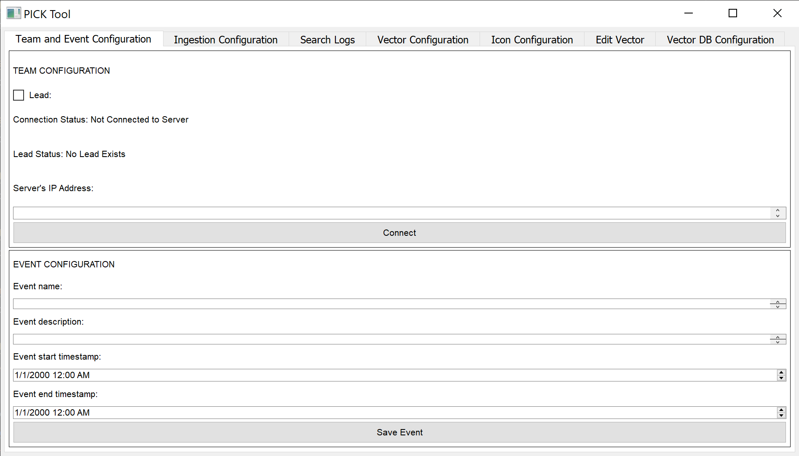

Image 2:

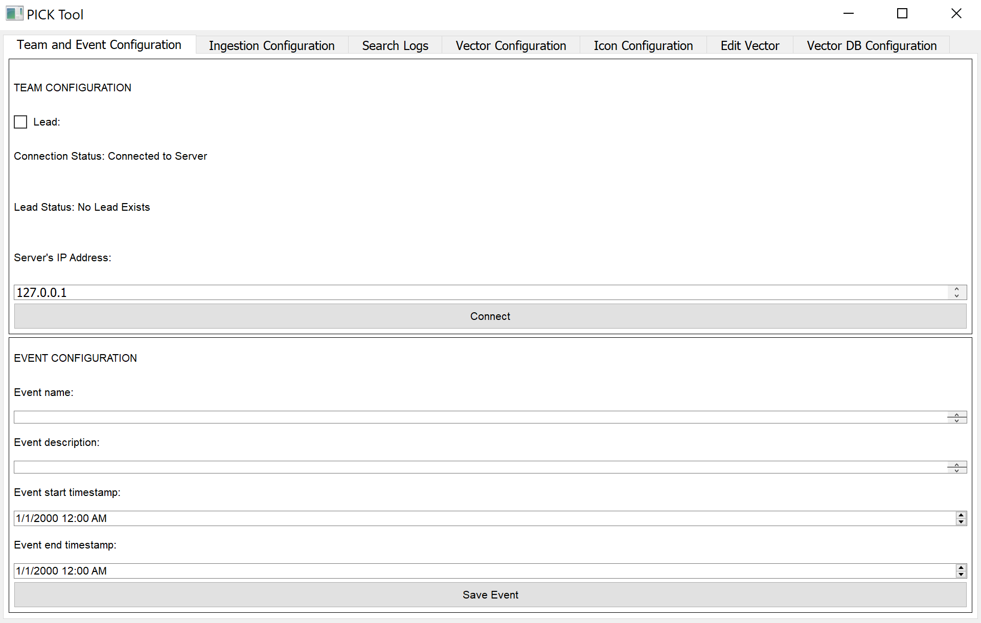

Image 3:

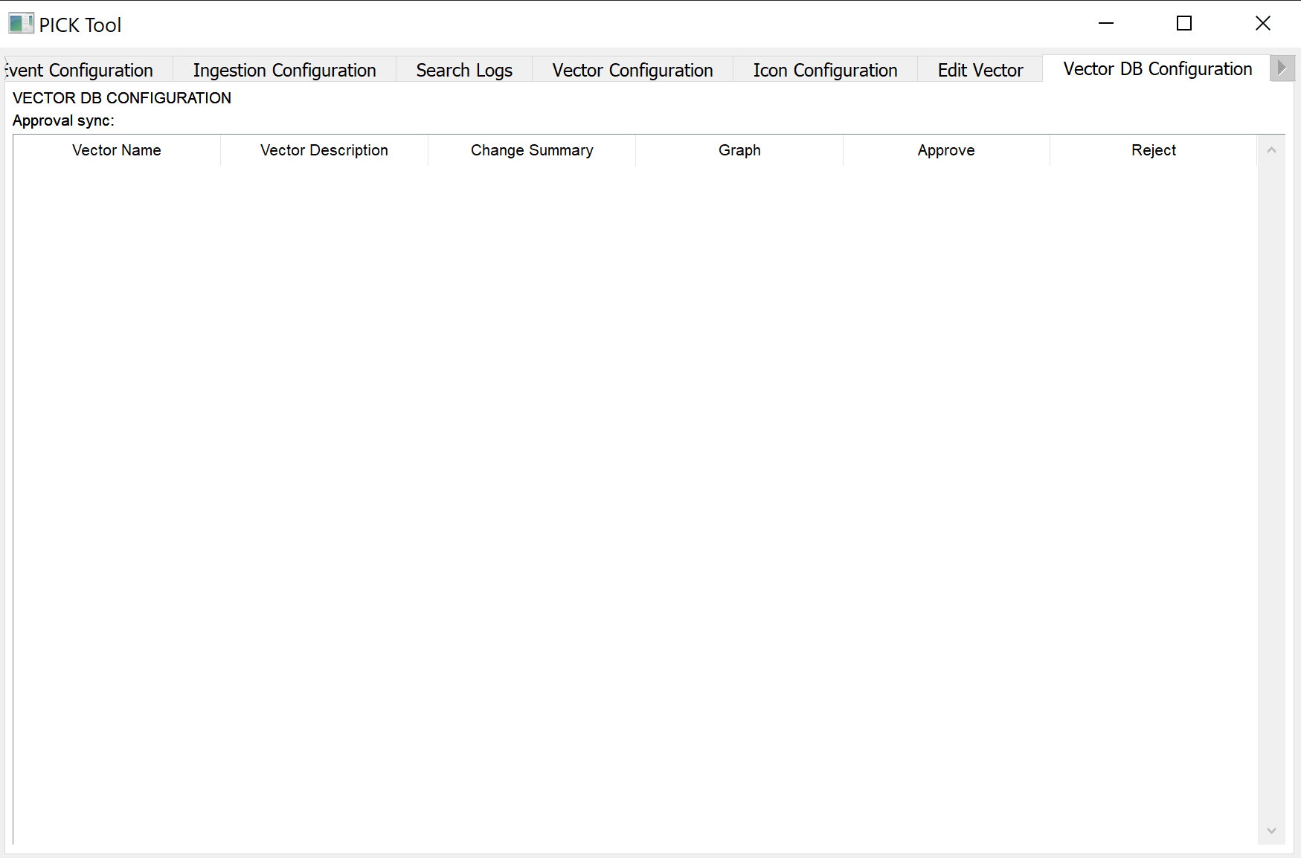

Image 4:

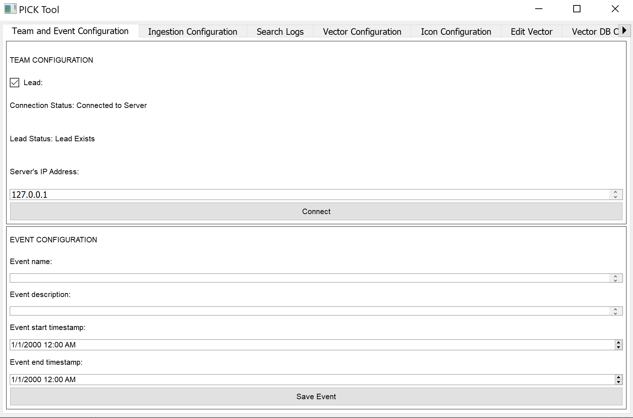

Image 5

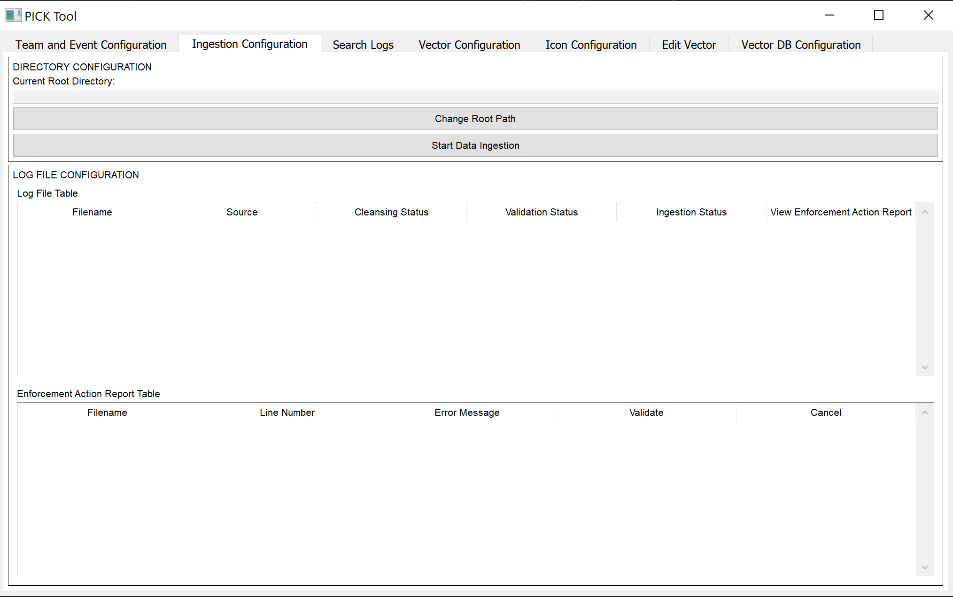

Image 6

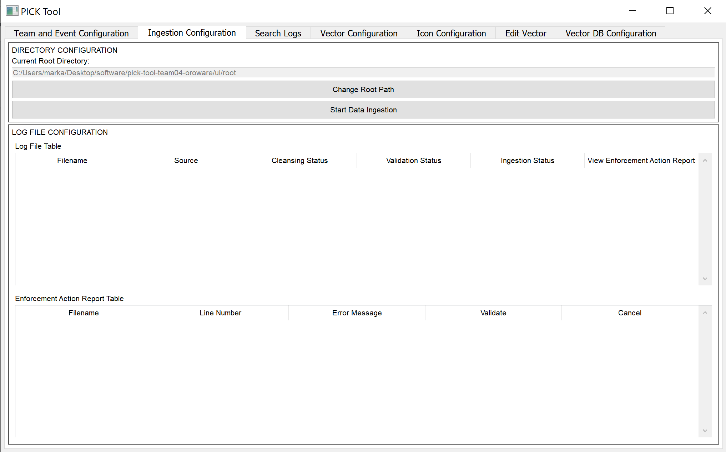

Image 7:

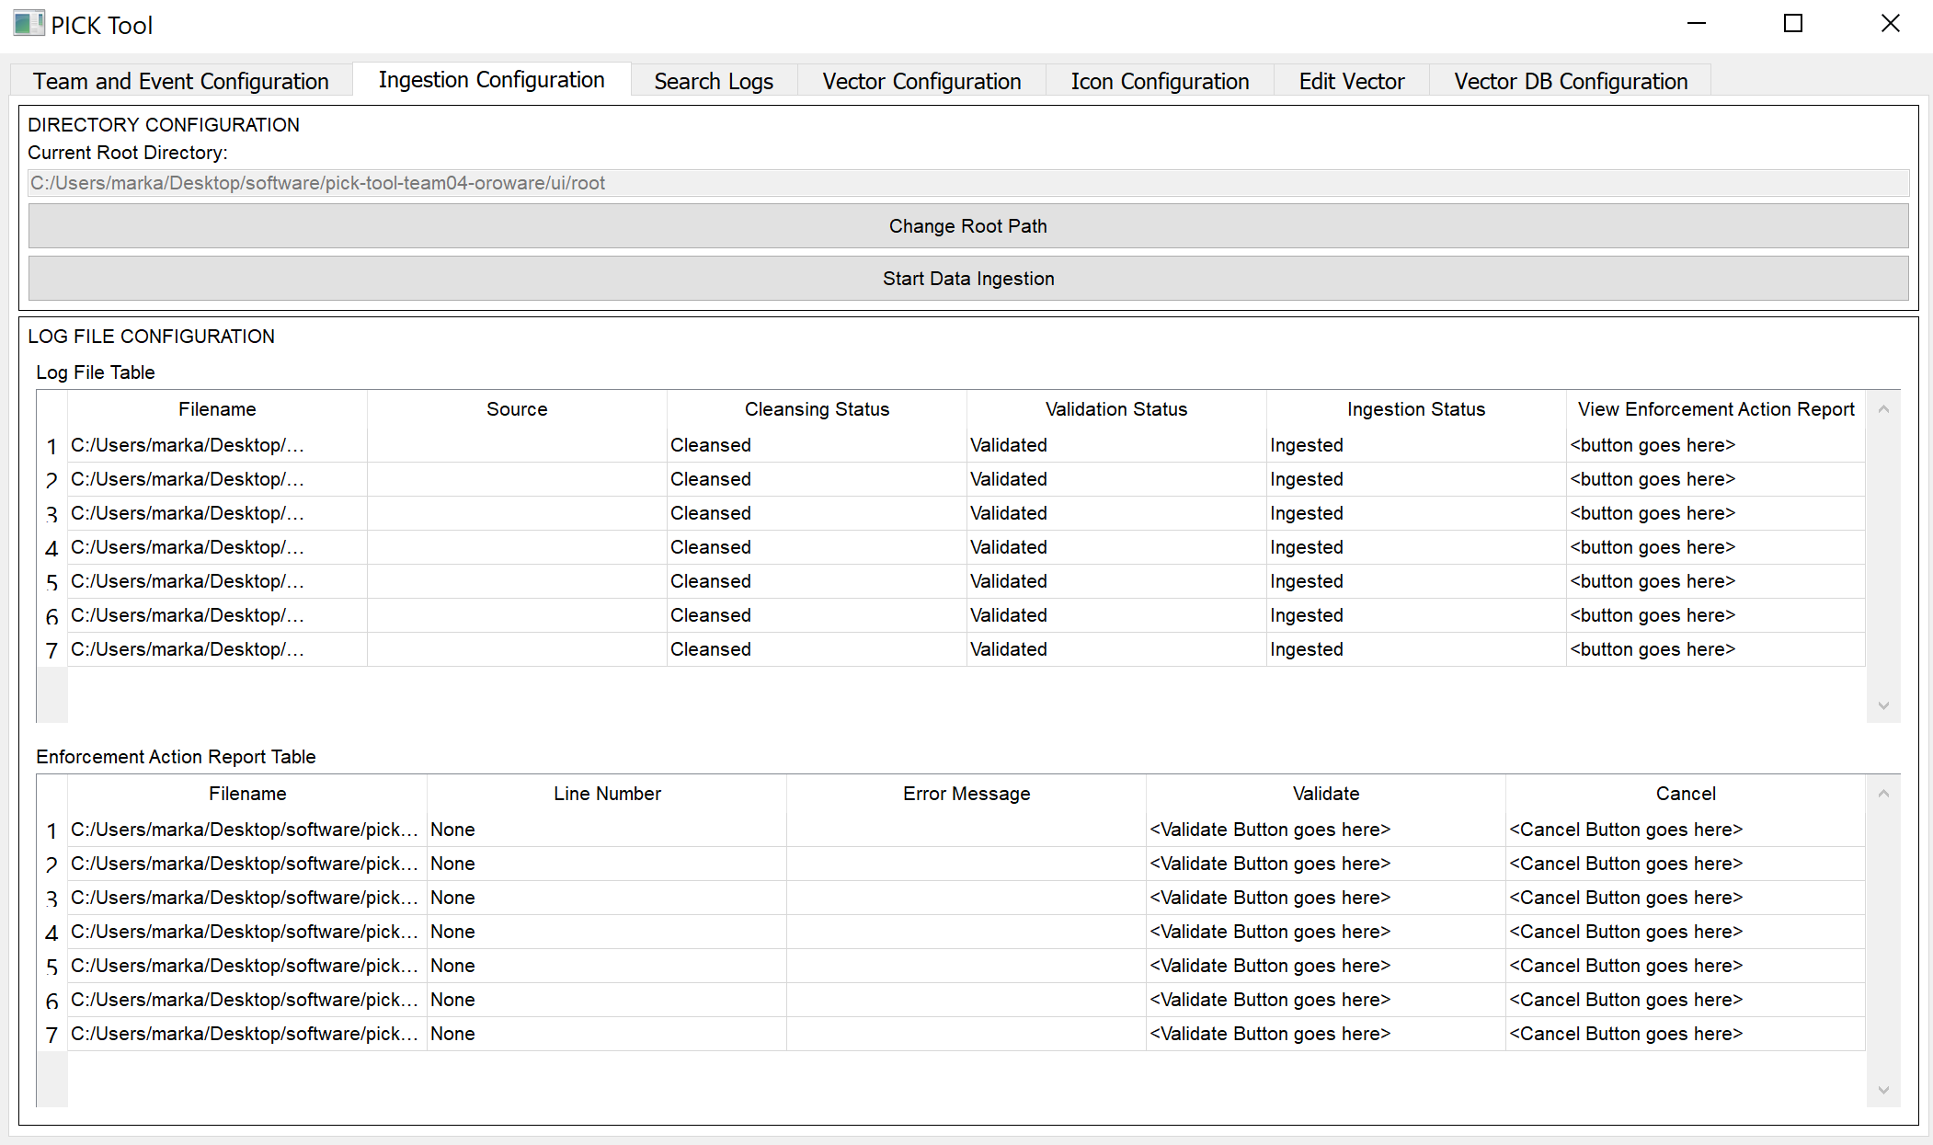

Image 8:

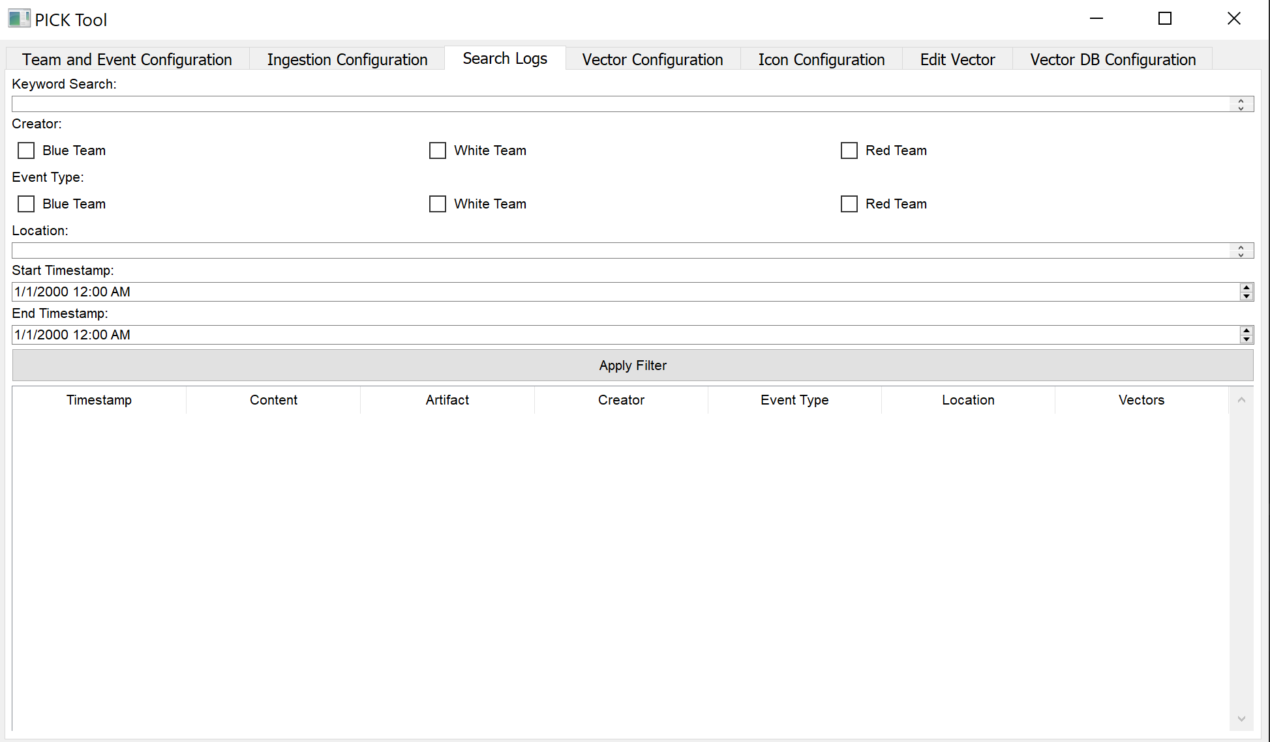

Image 9:

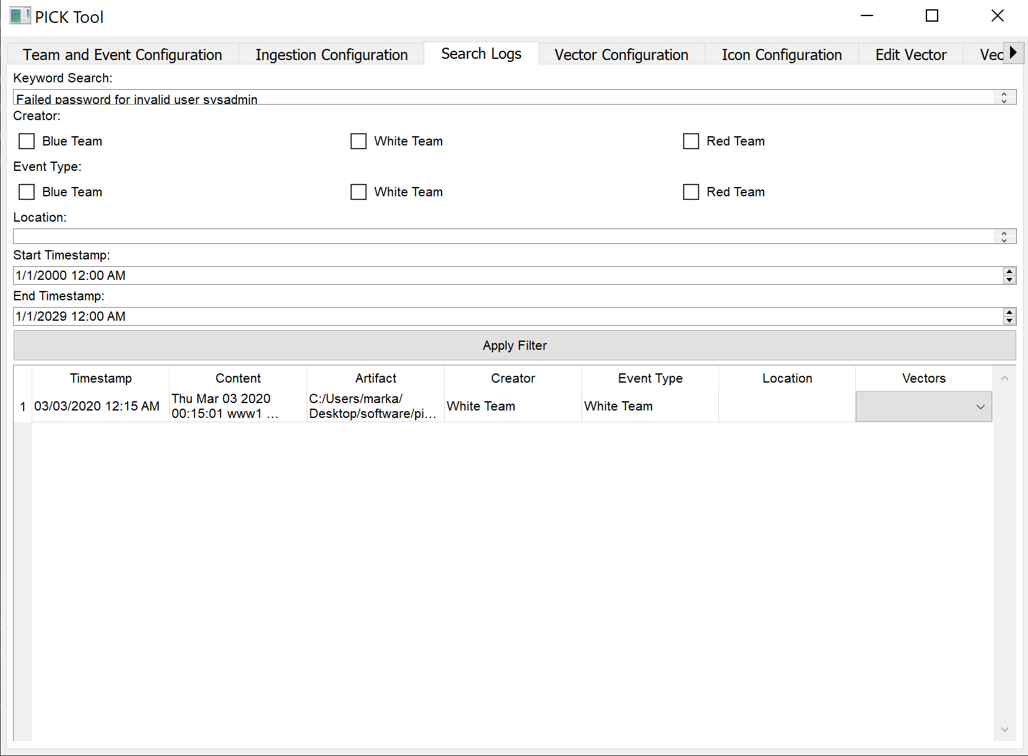

Image 10:

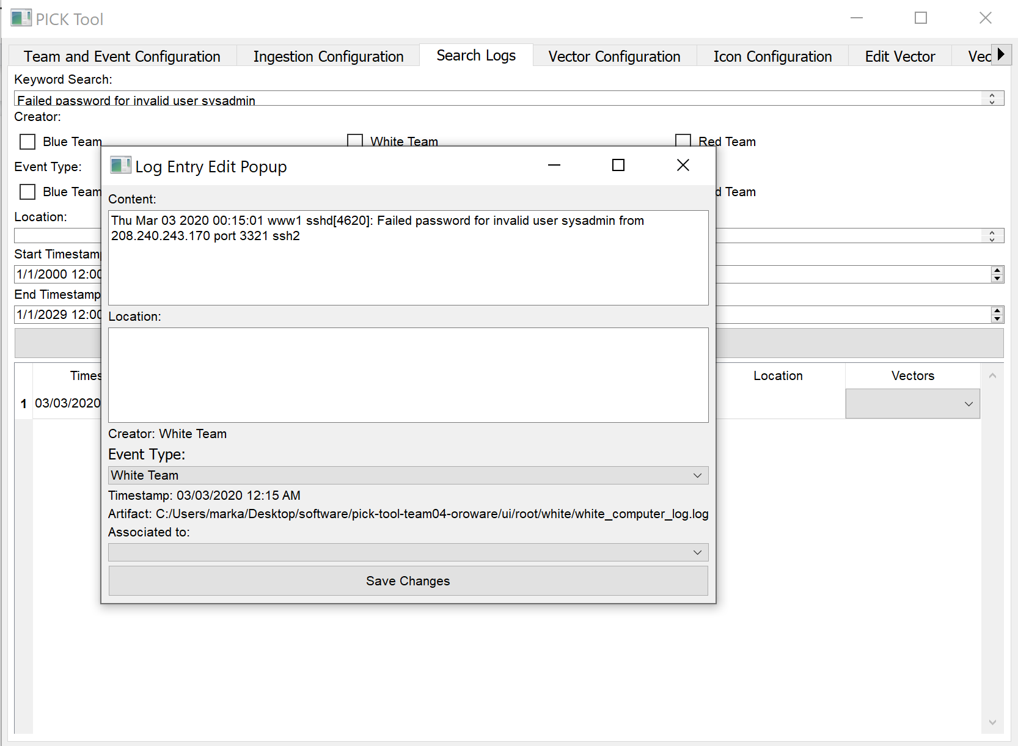

Image 11:

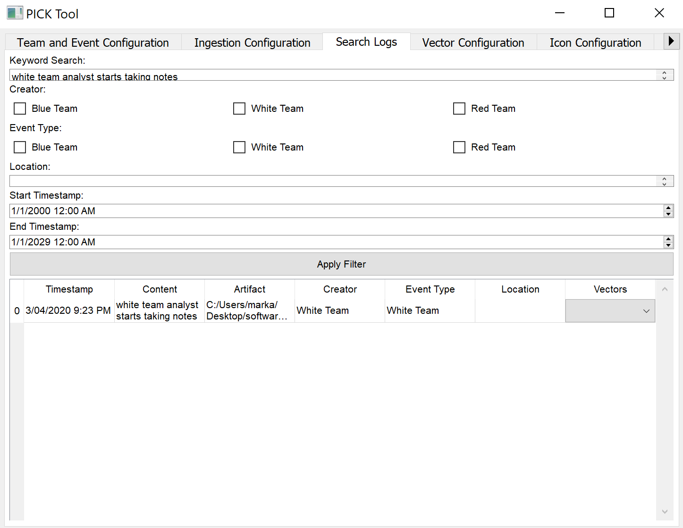

Image 12:

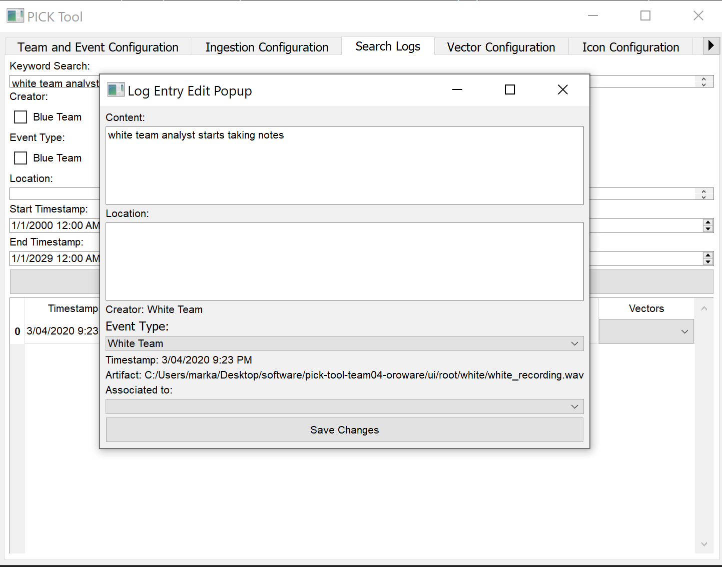

Image 13:

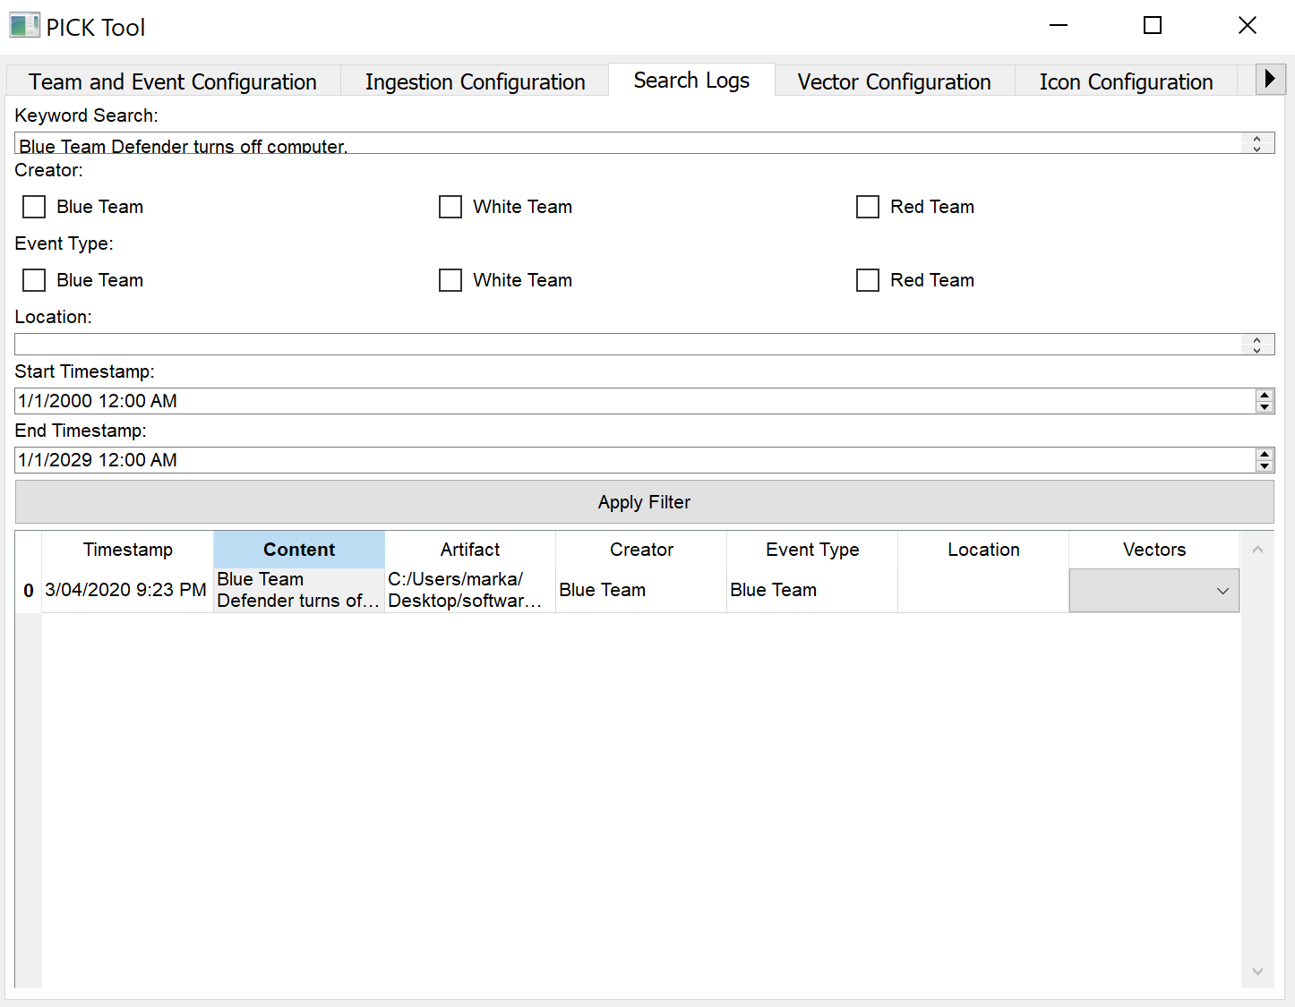

Image 14:

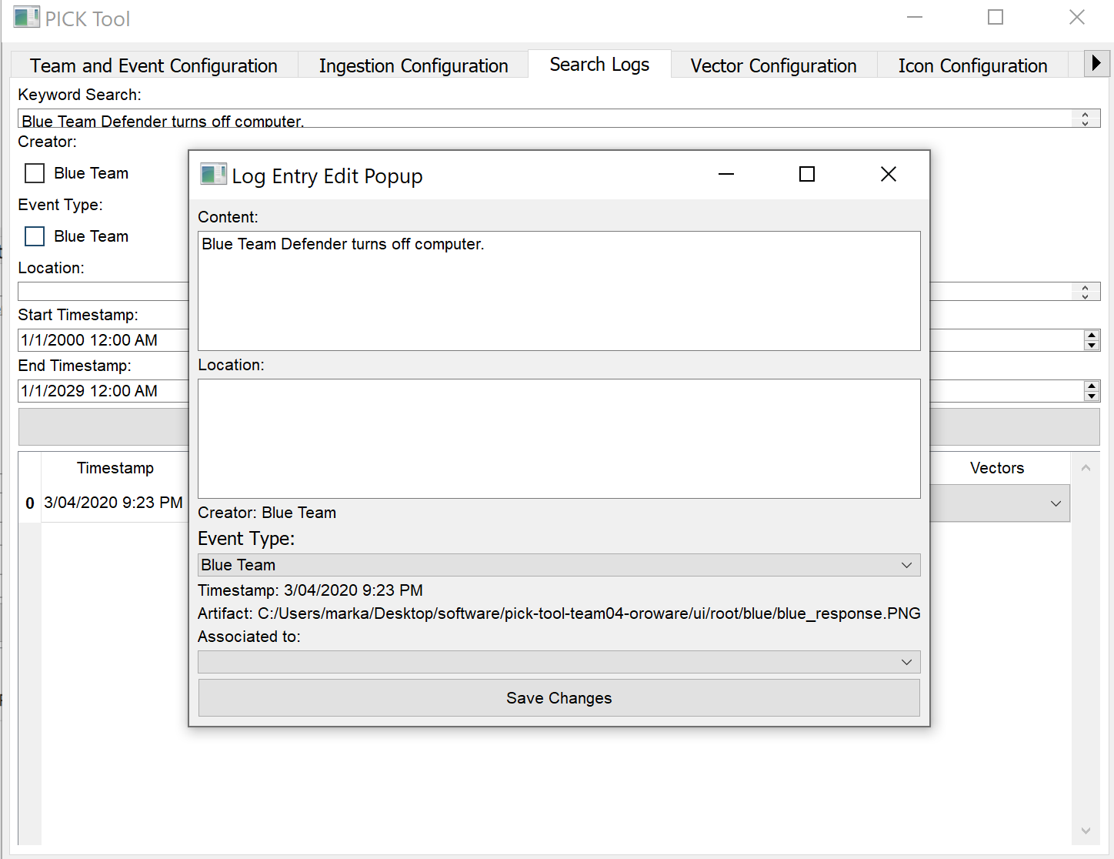

Image 15:

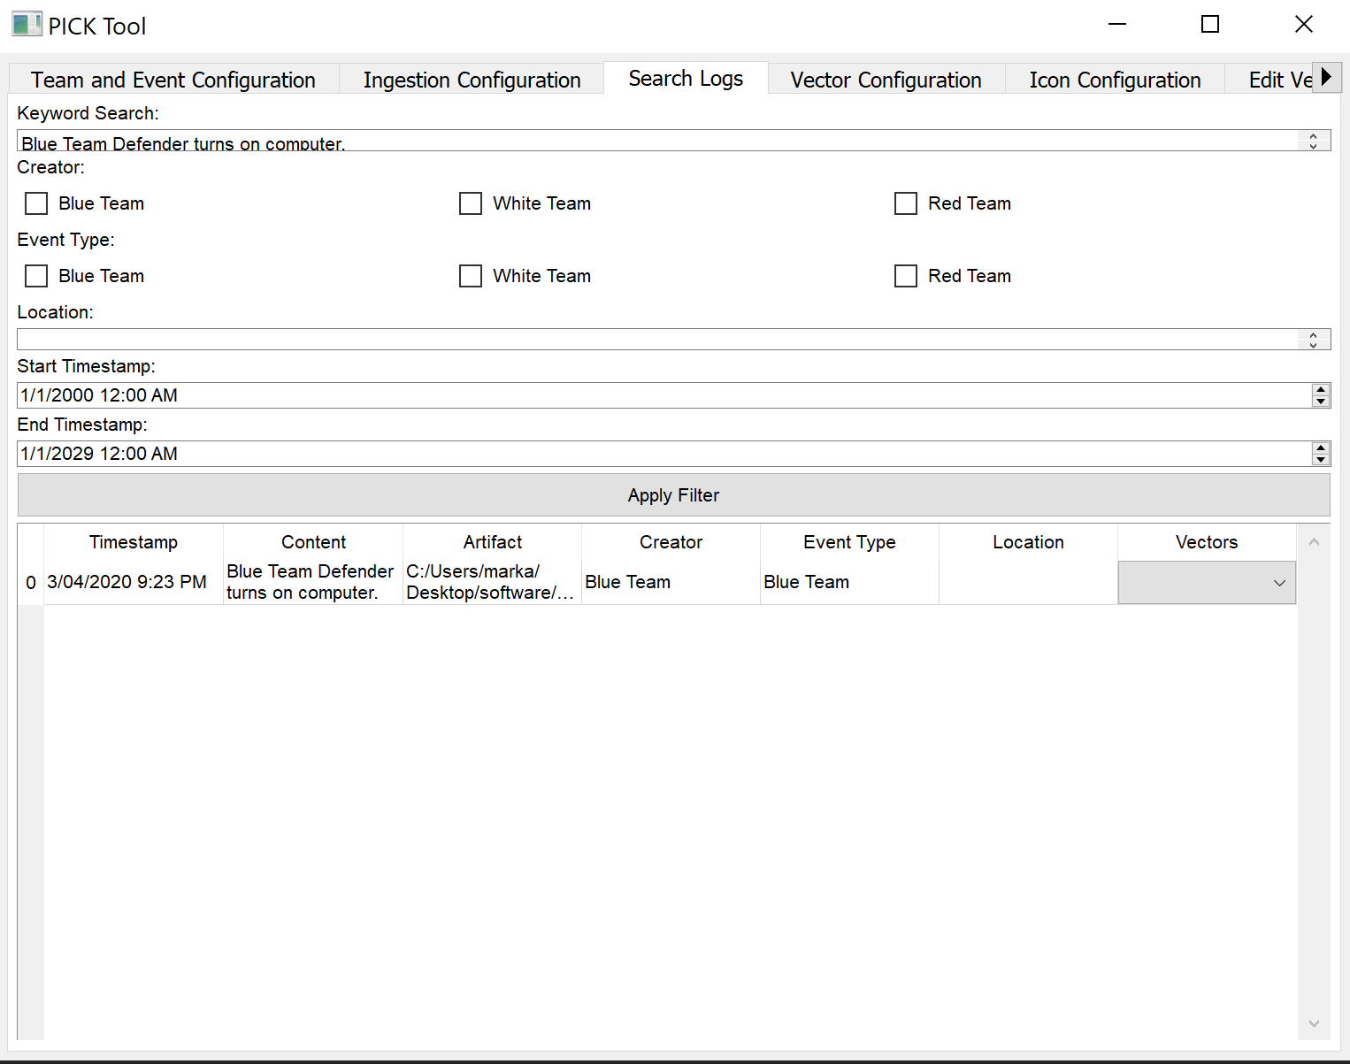

Image 16:

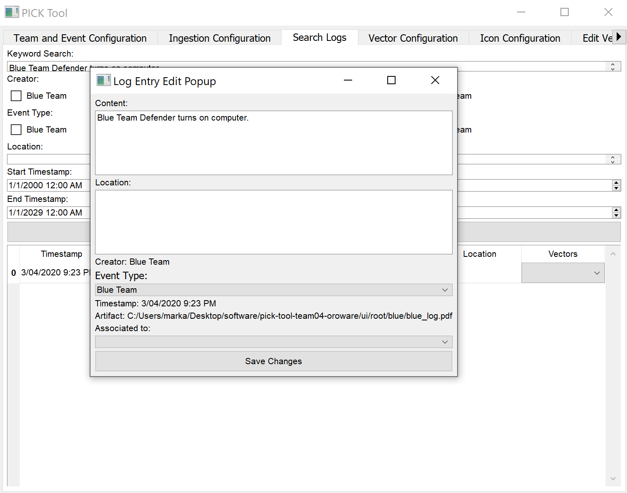

Image 17:

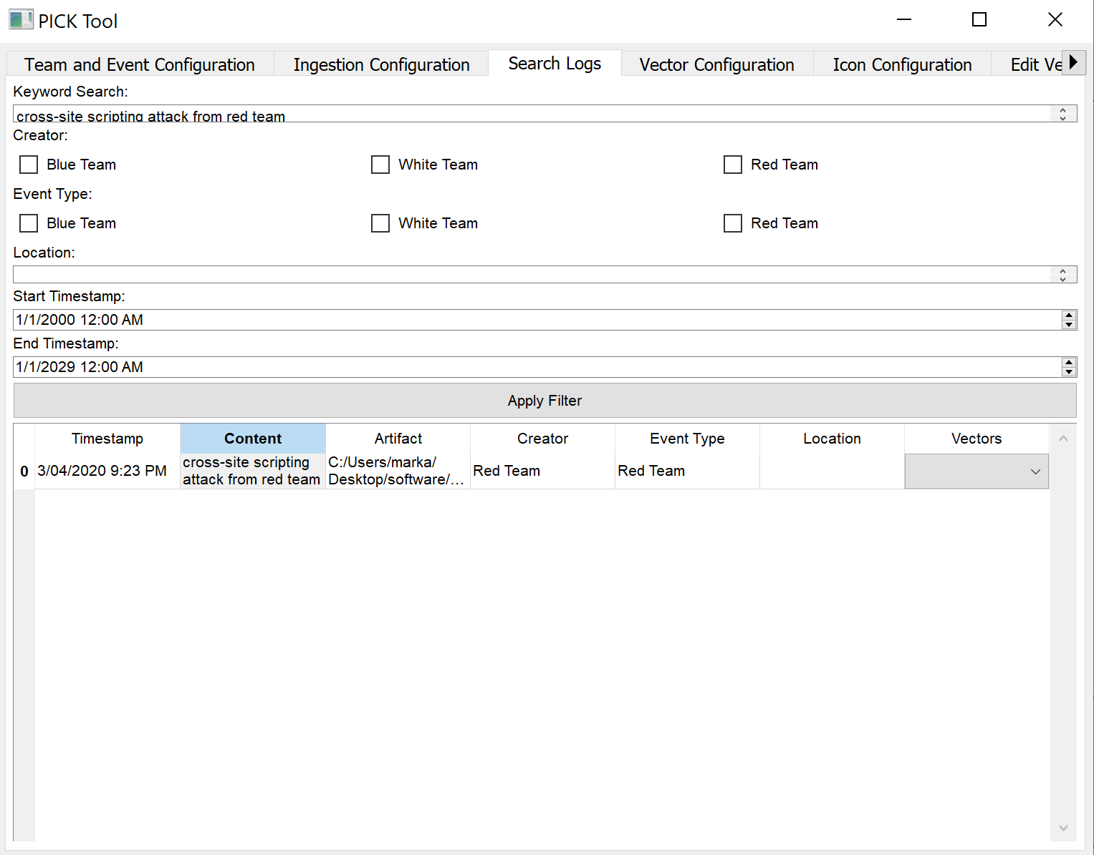

Image 18:

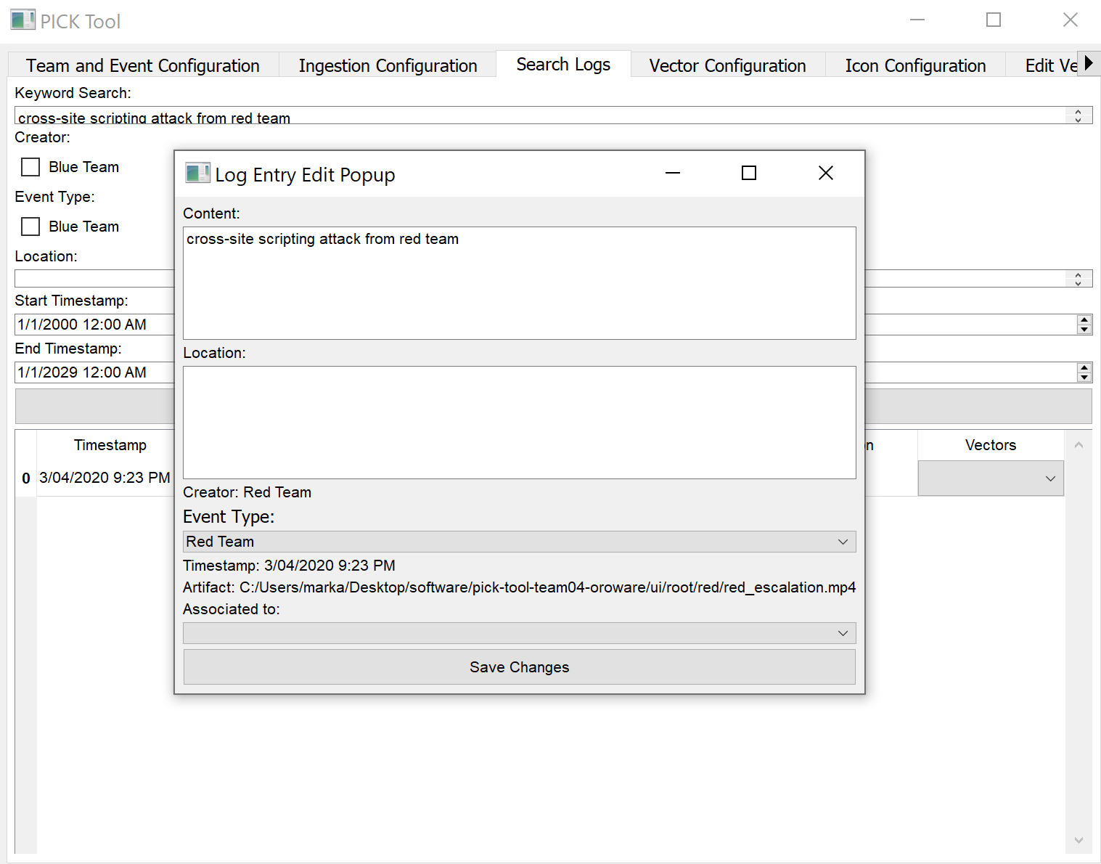

Image 19:

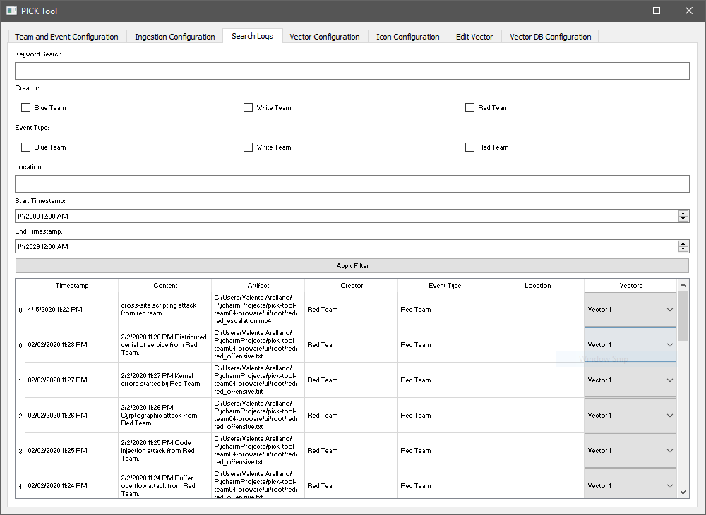

Image 20:

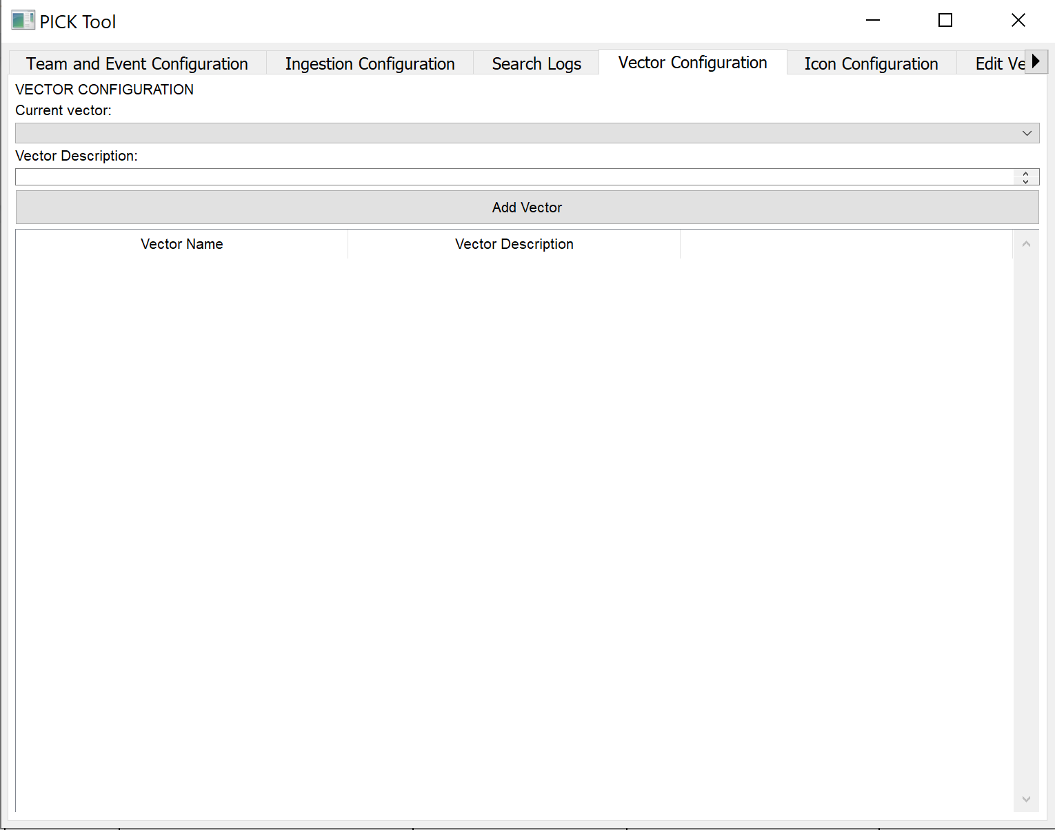

Image 21:

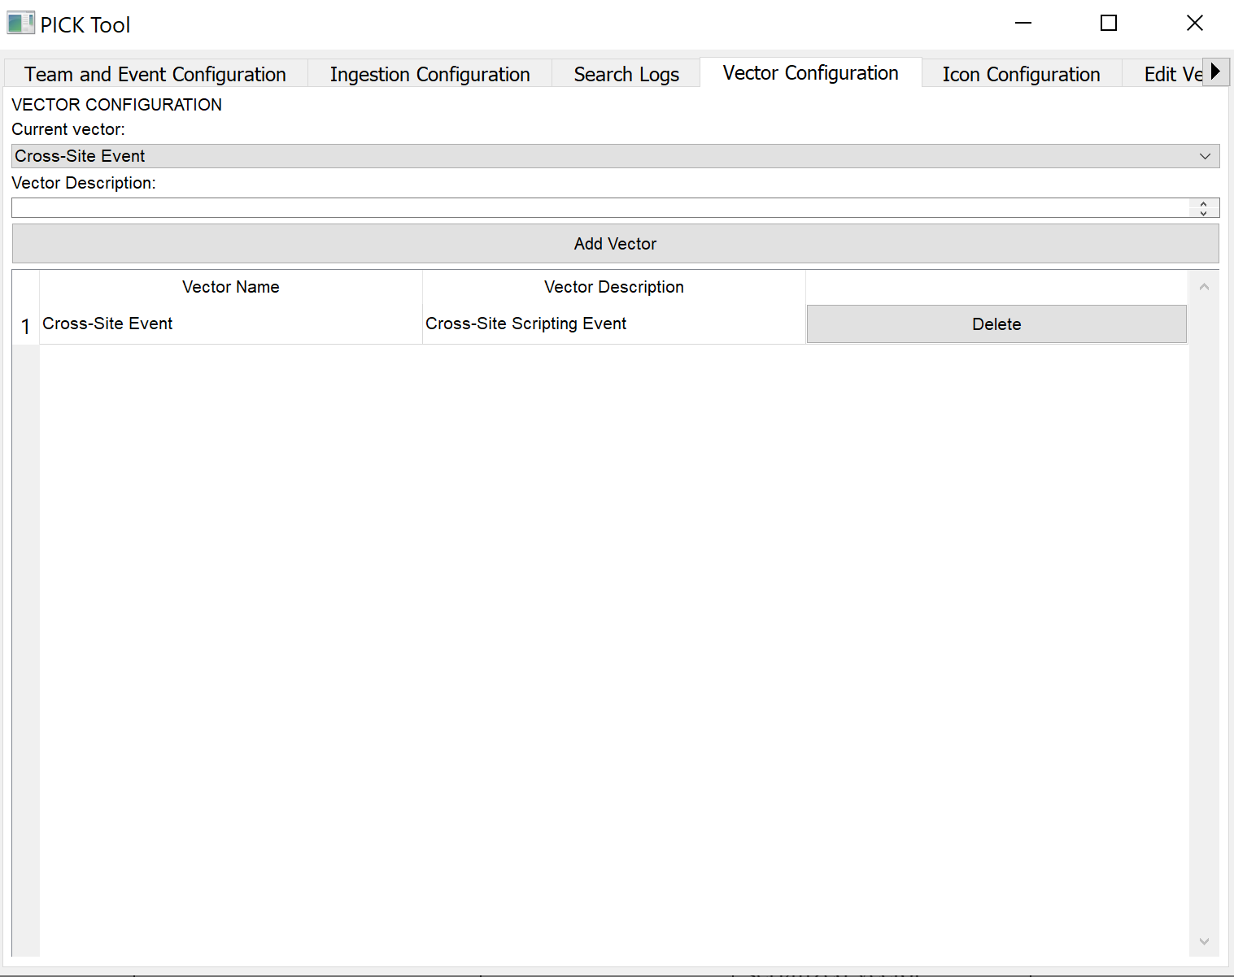

Image 22:

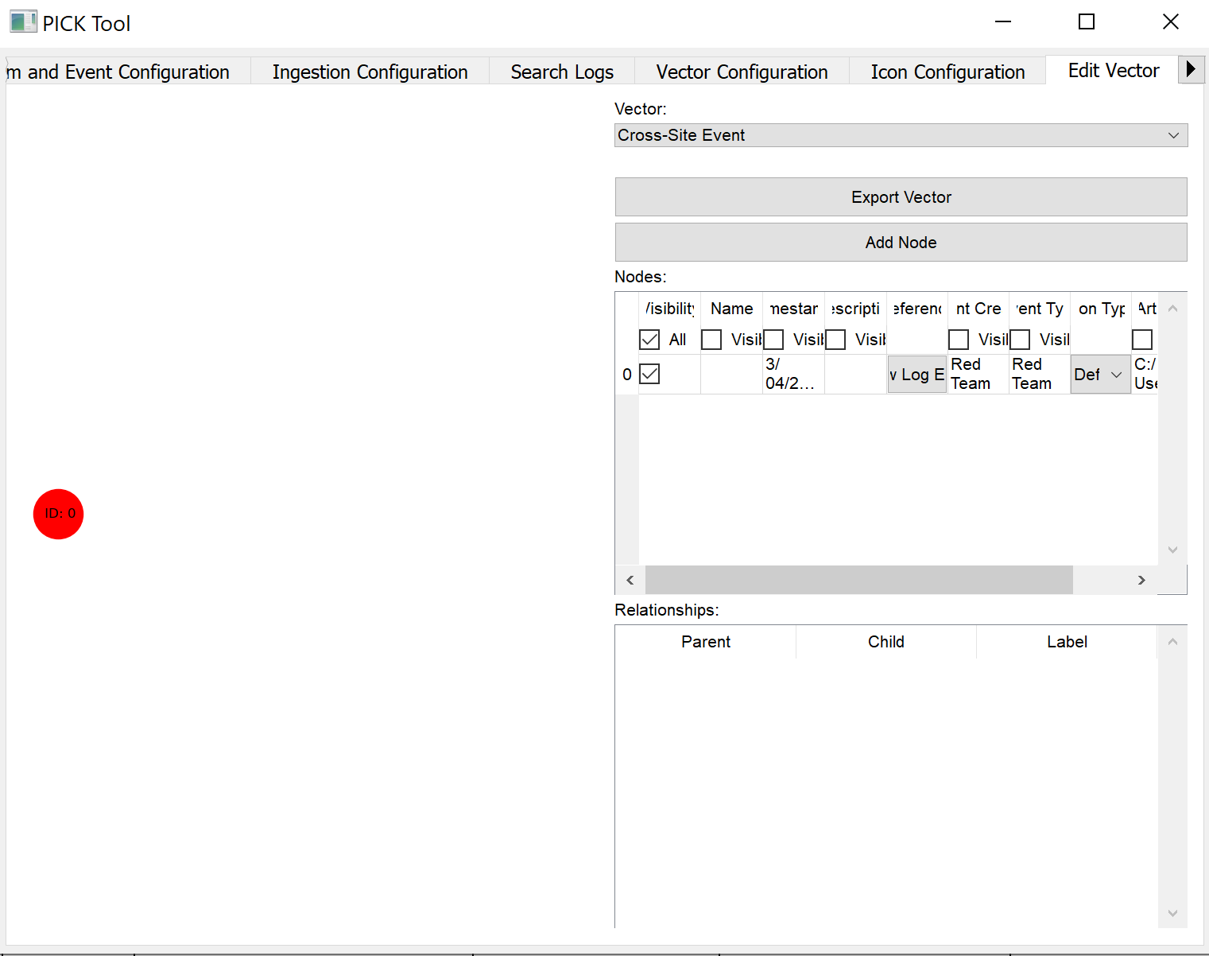

Image 23:

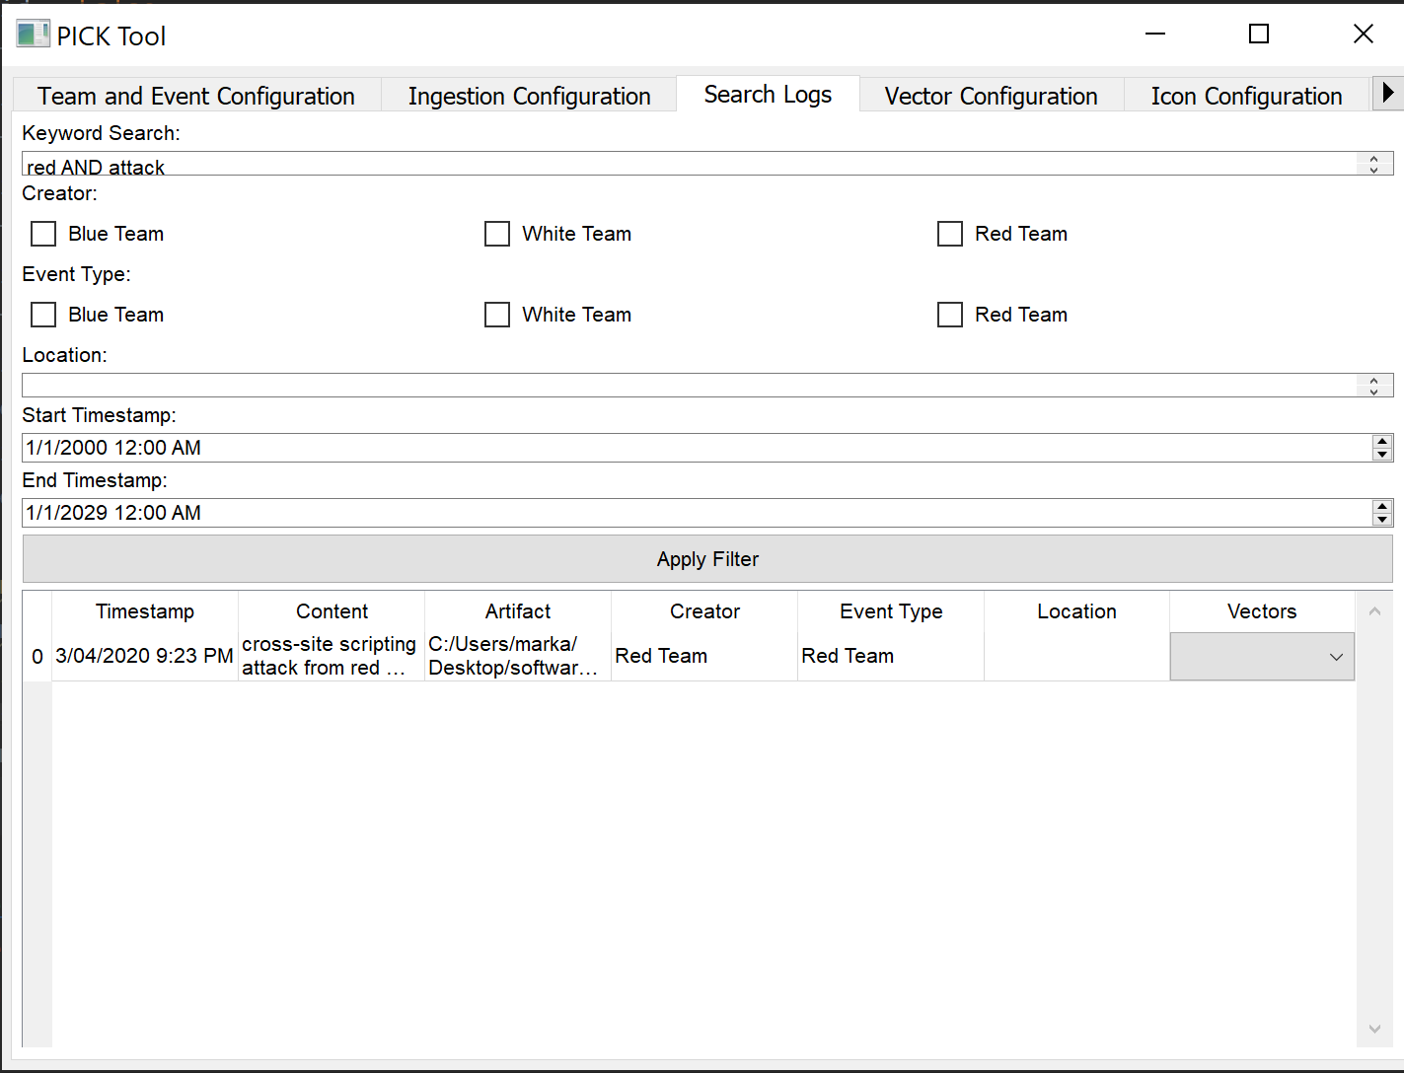

Image 24:

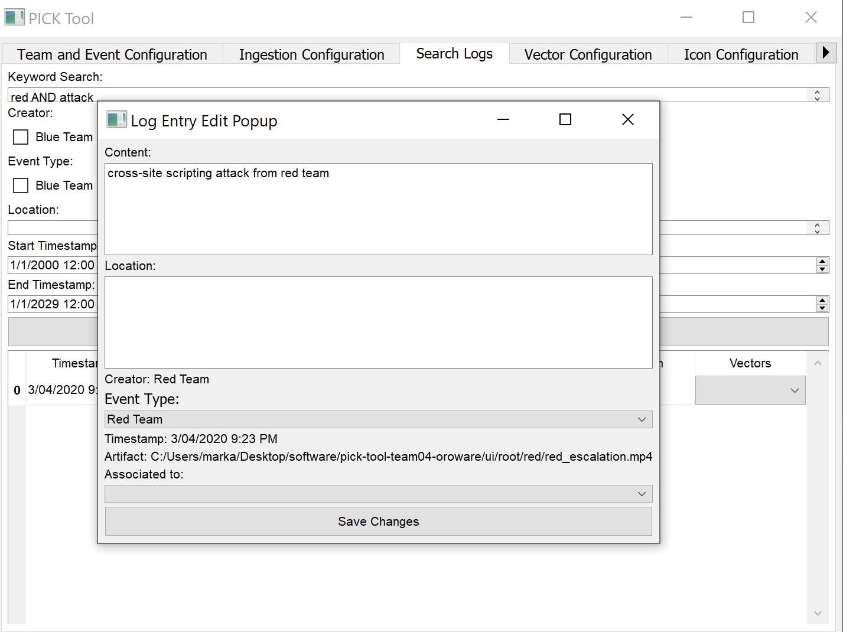

Image 25:

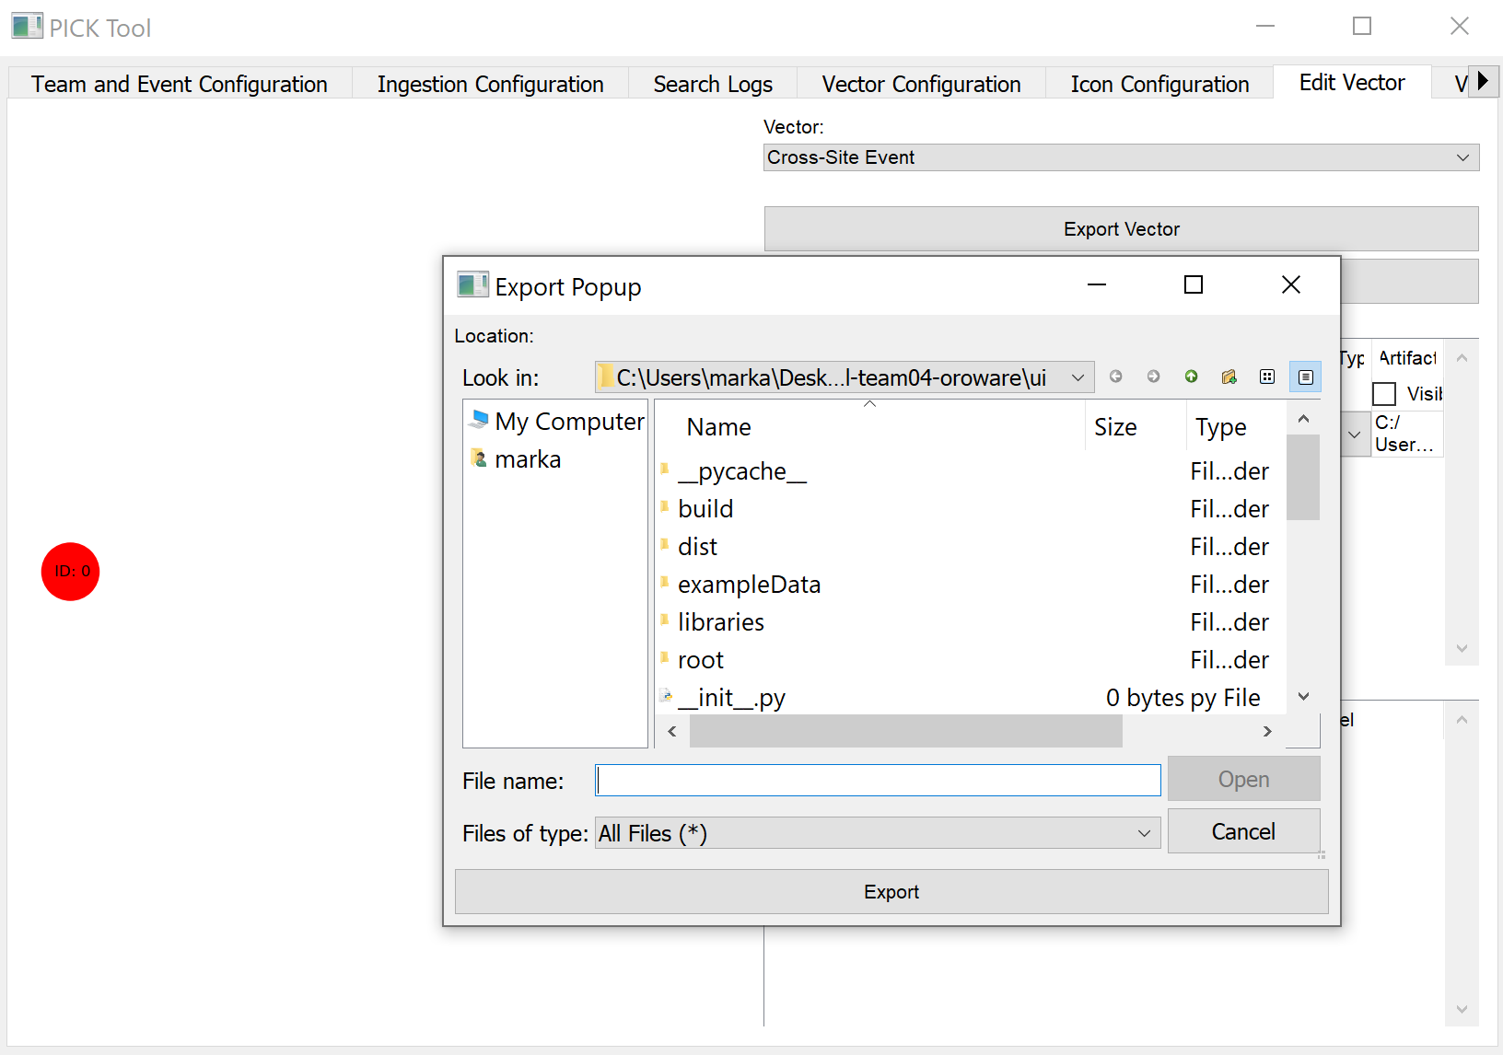

Image 26:

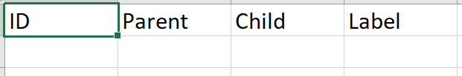

Image 27:



Image 28:



Image 29:

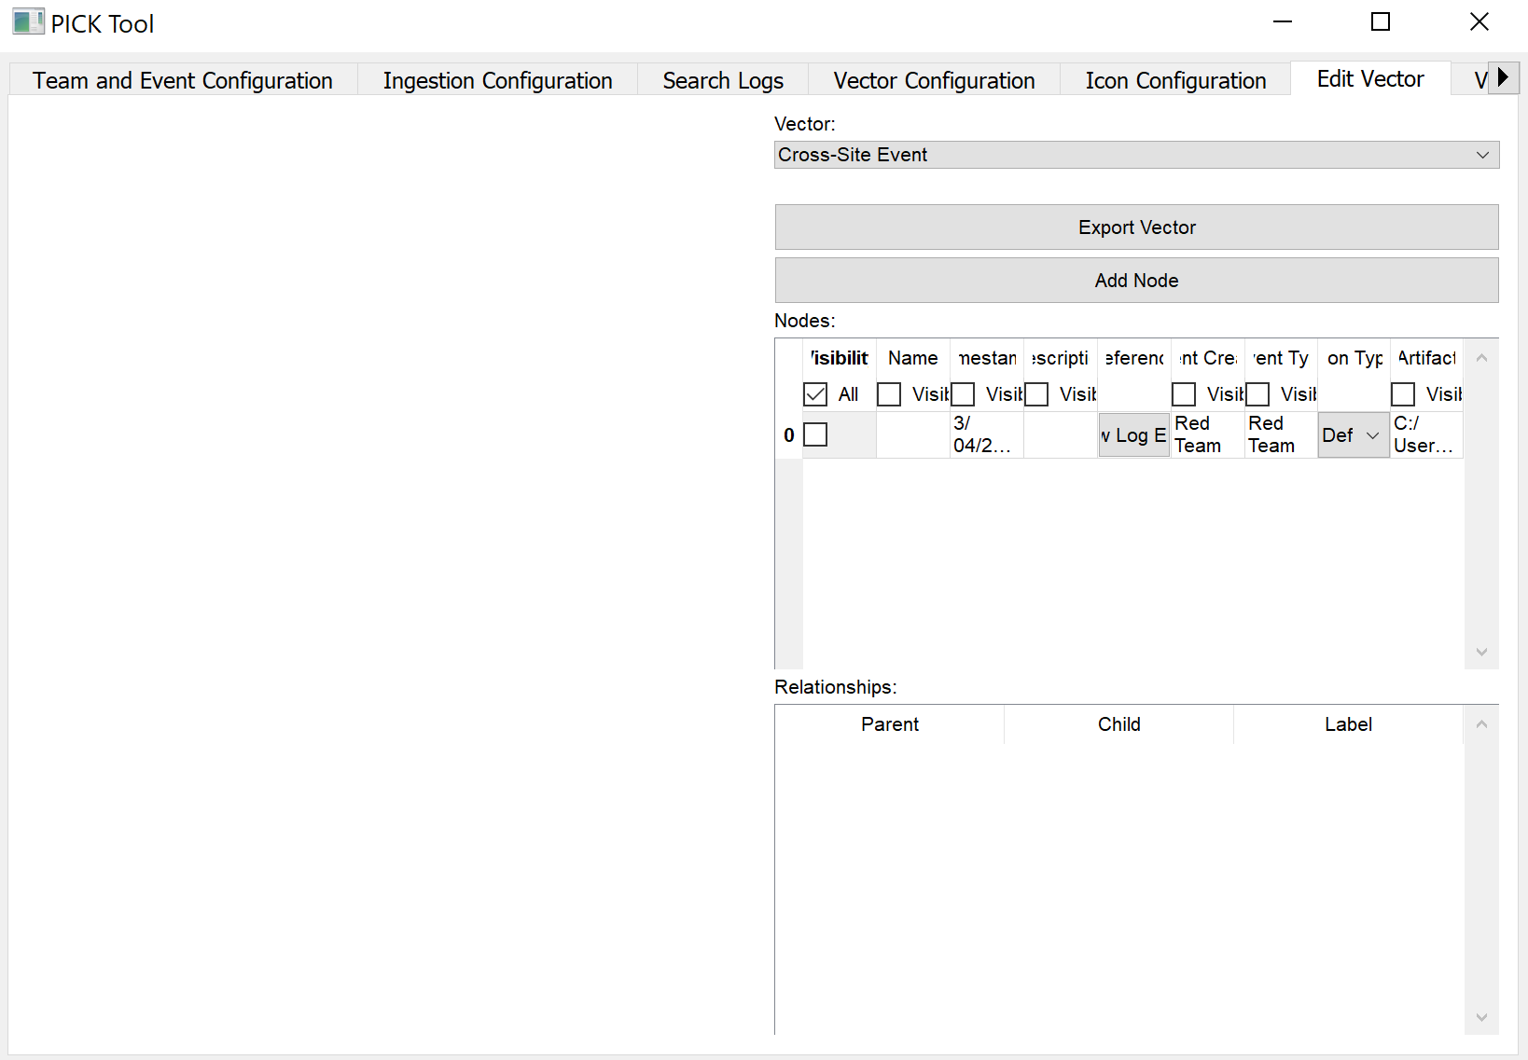

Image 30:

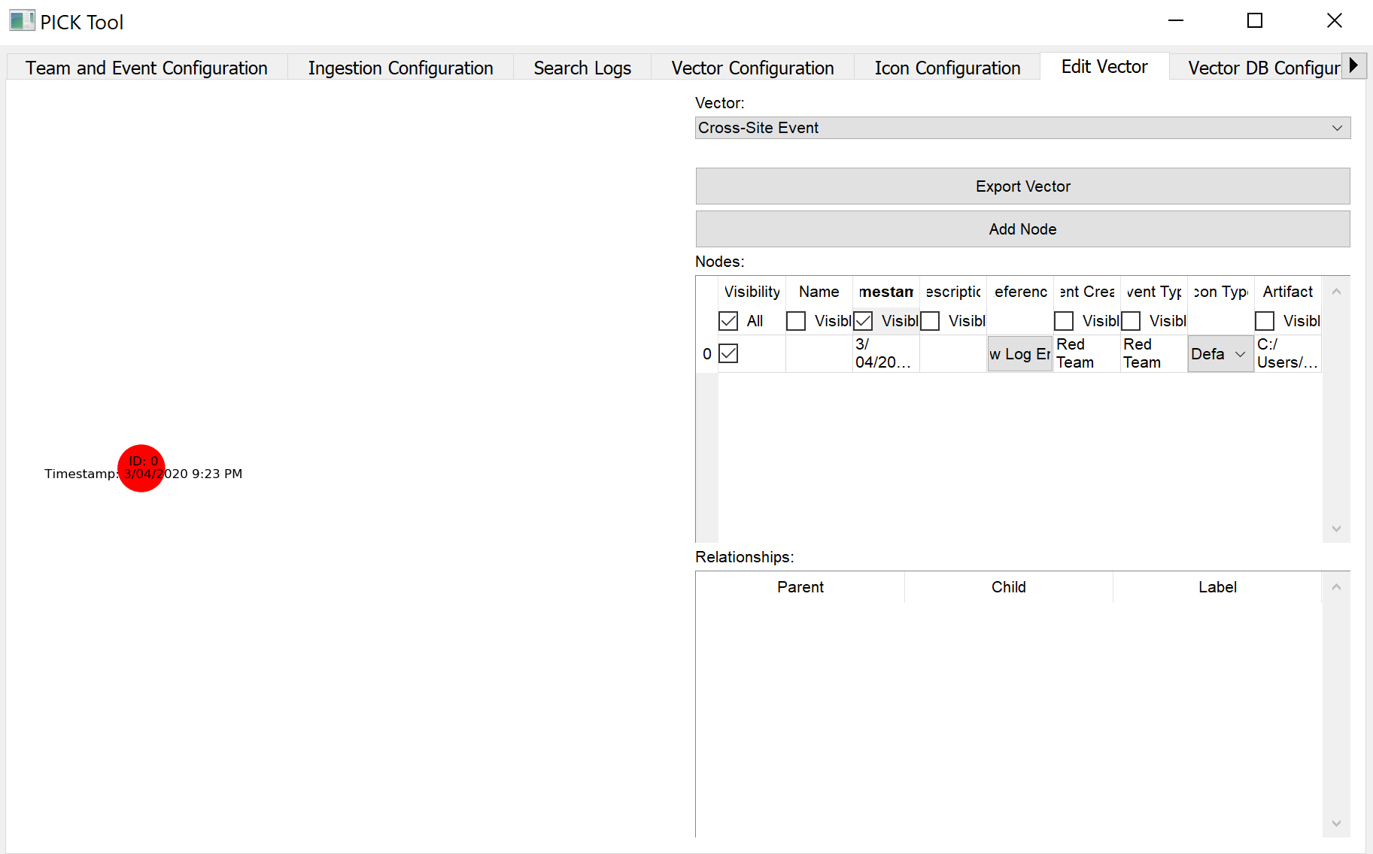

Image 31:

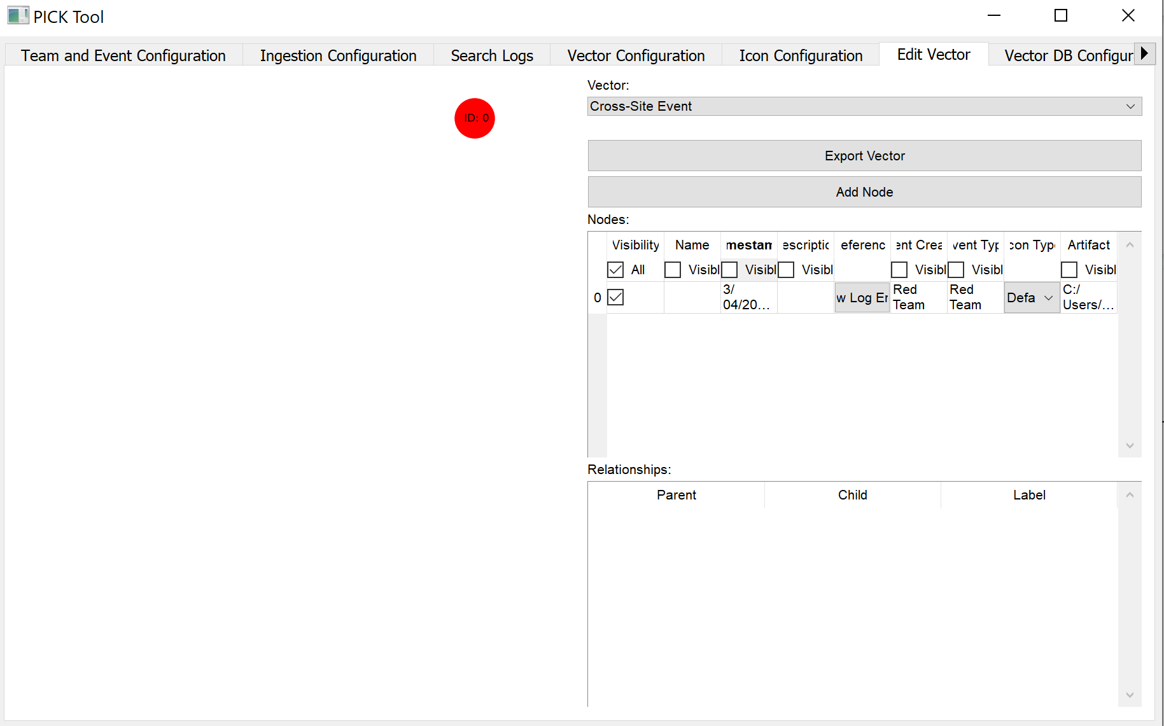

Image 32:

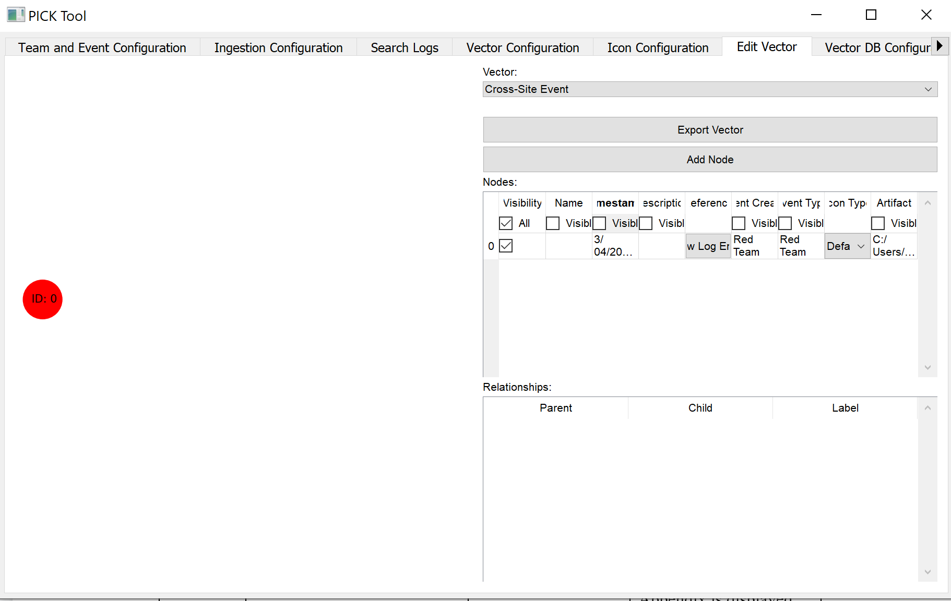

Image 33:

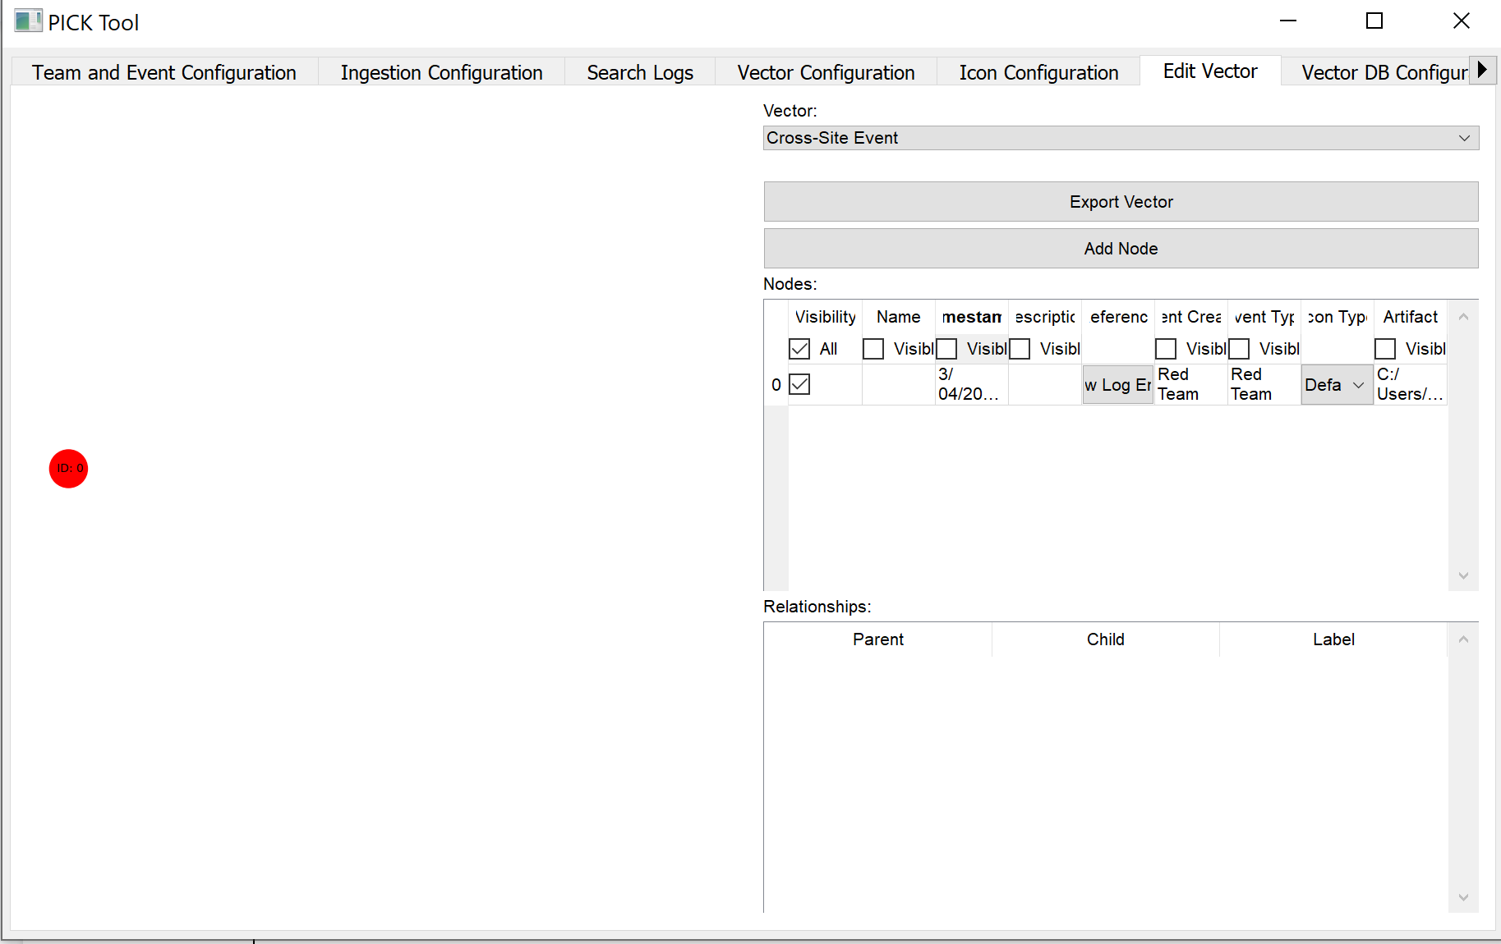

Image 34:

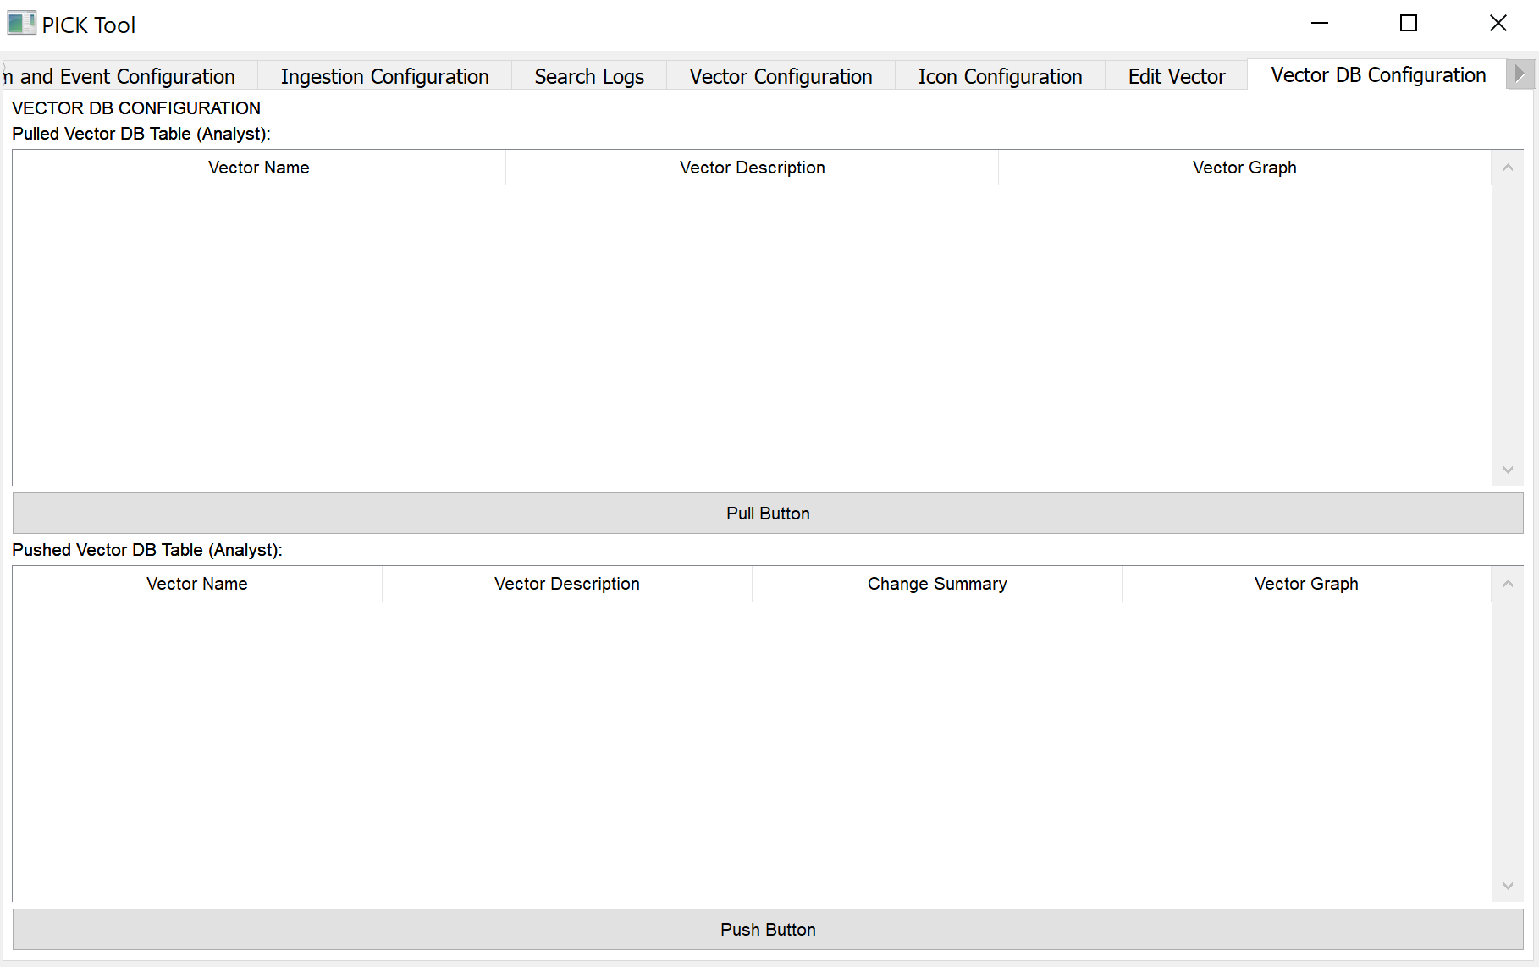

Image 35:

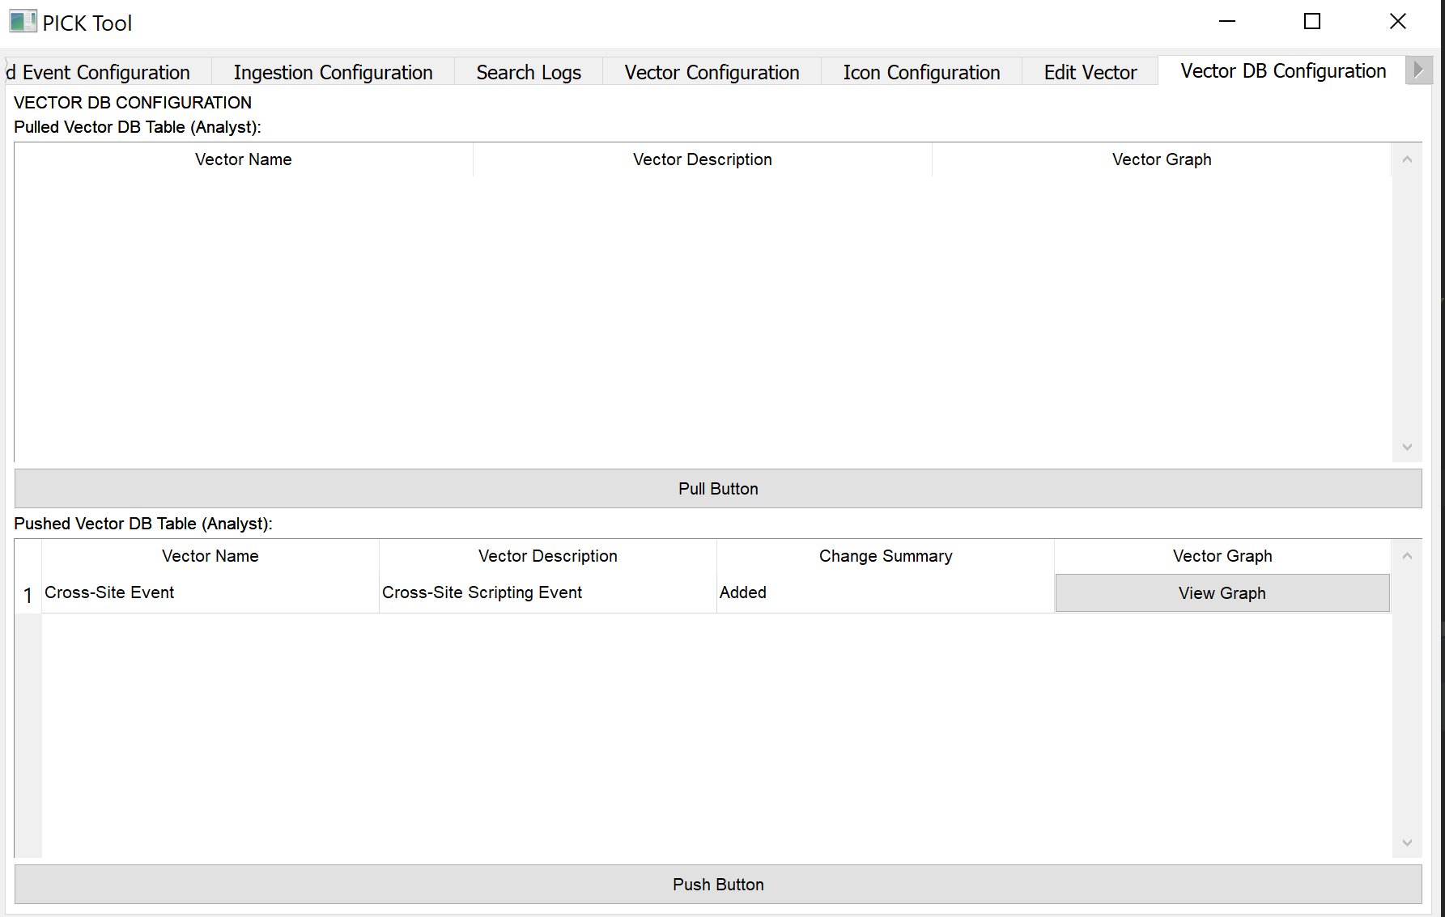

Image 36:

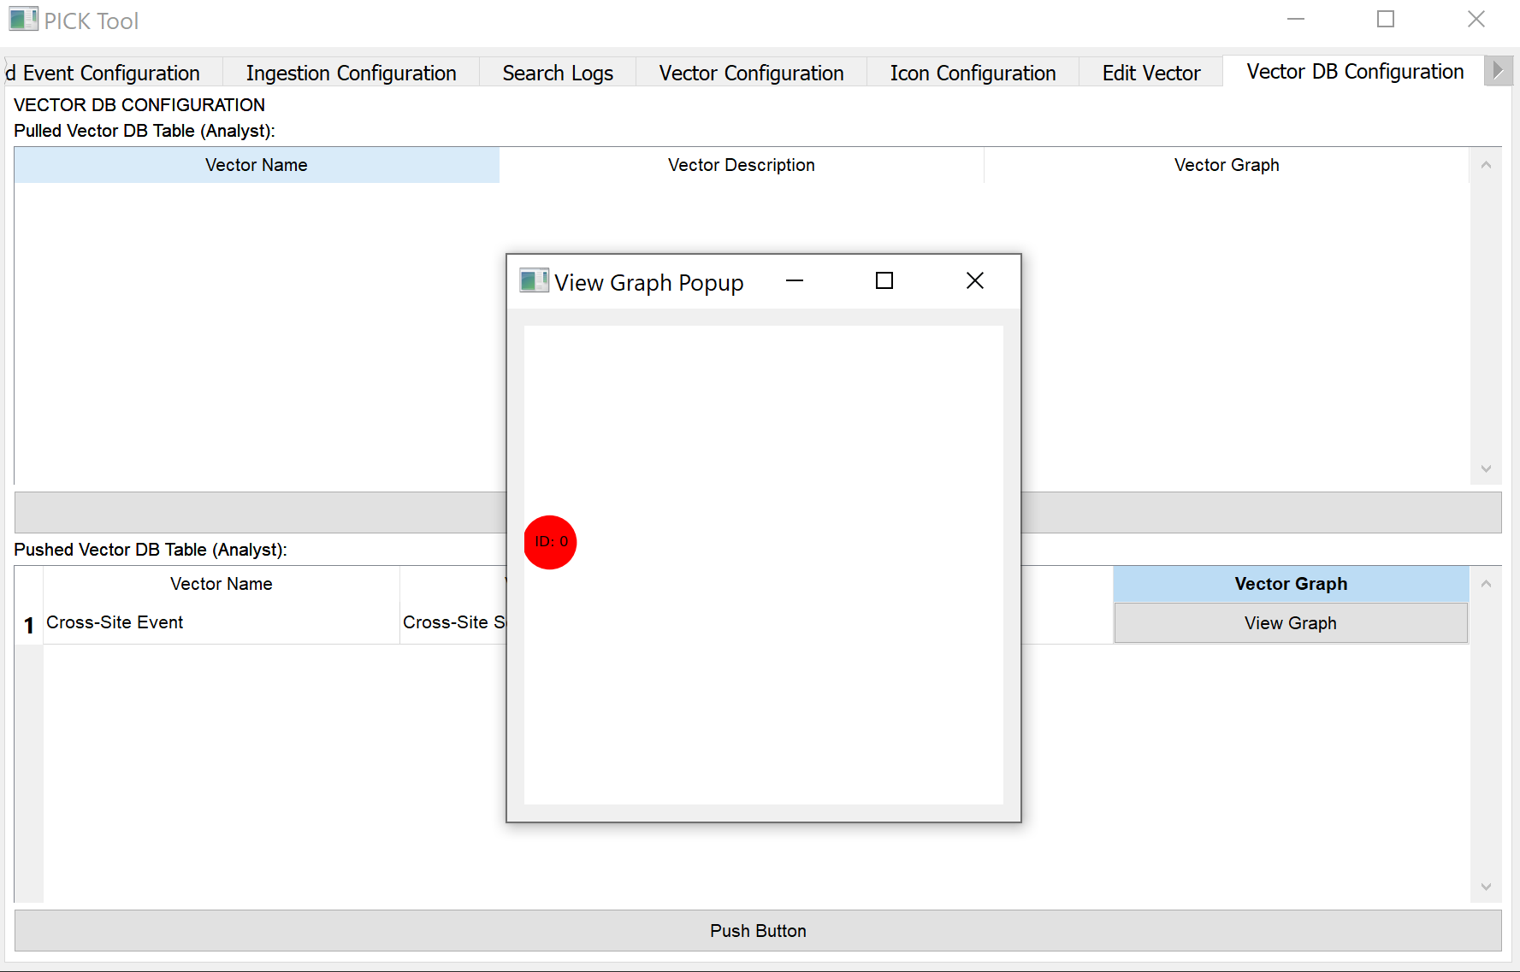

Image 37:

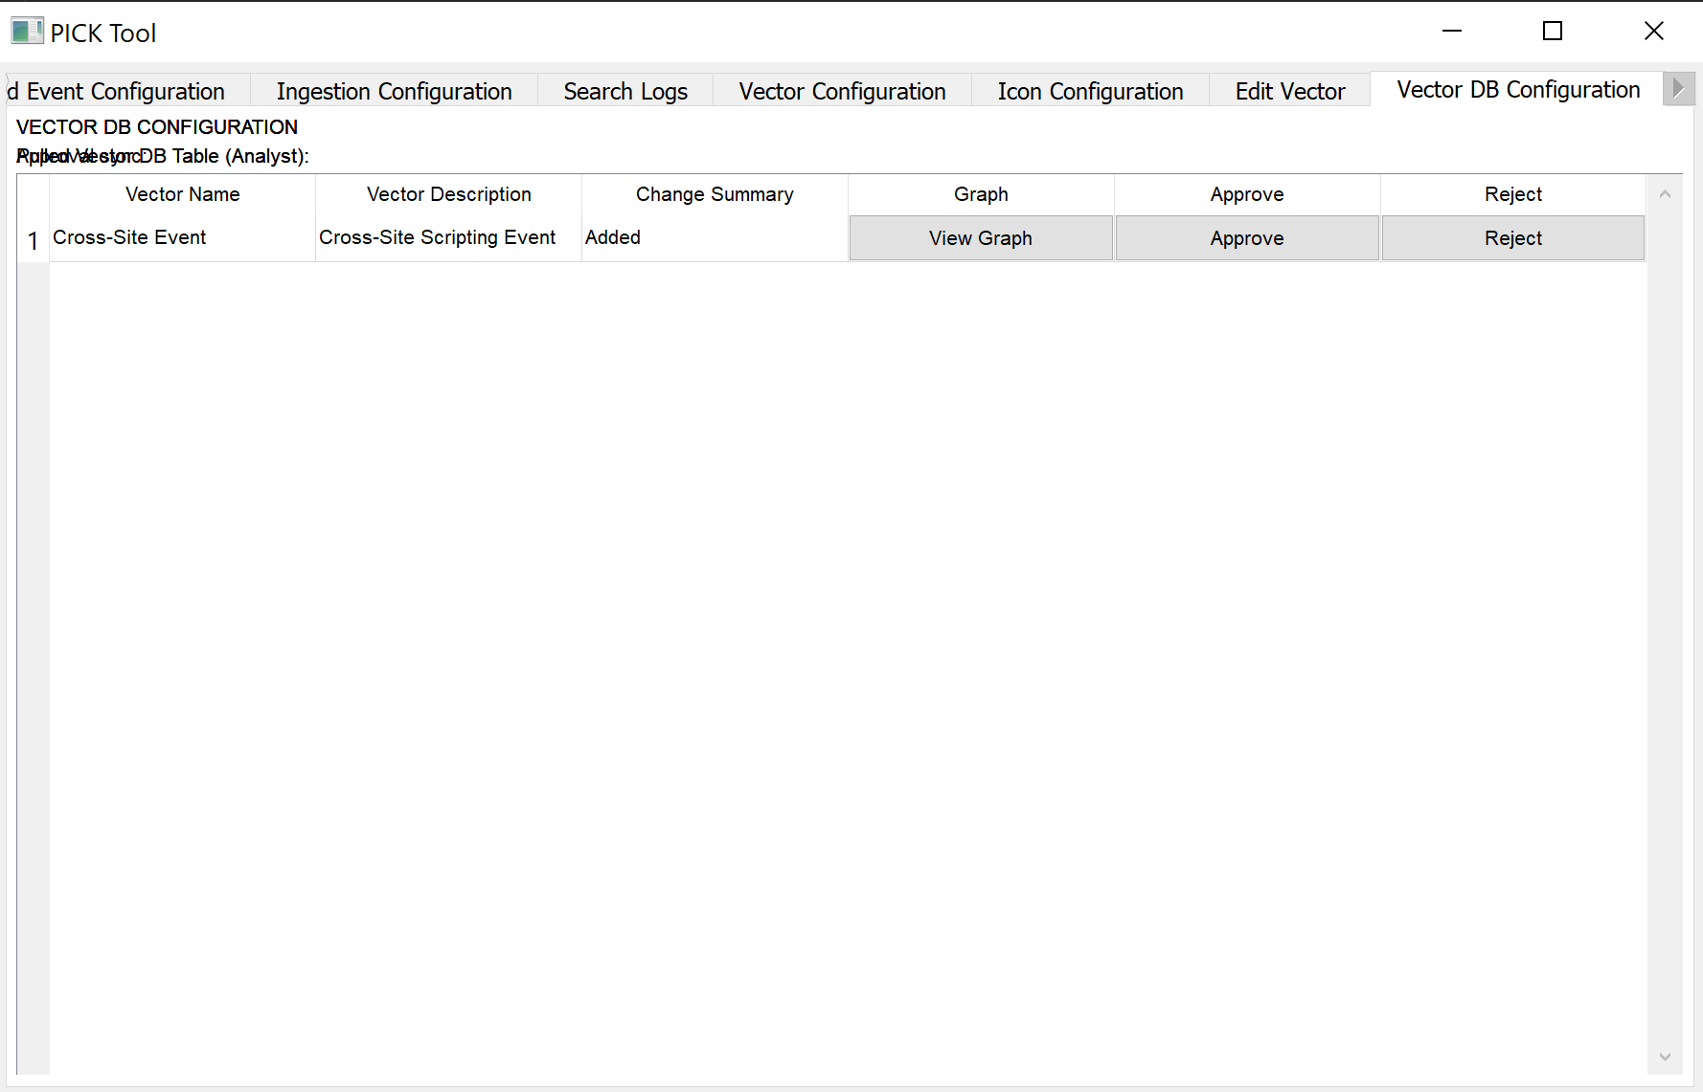

Image 38:

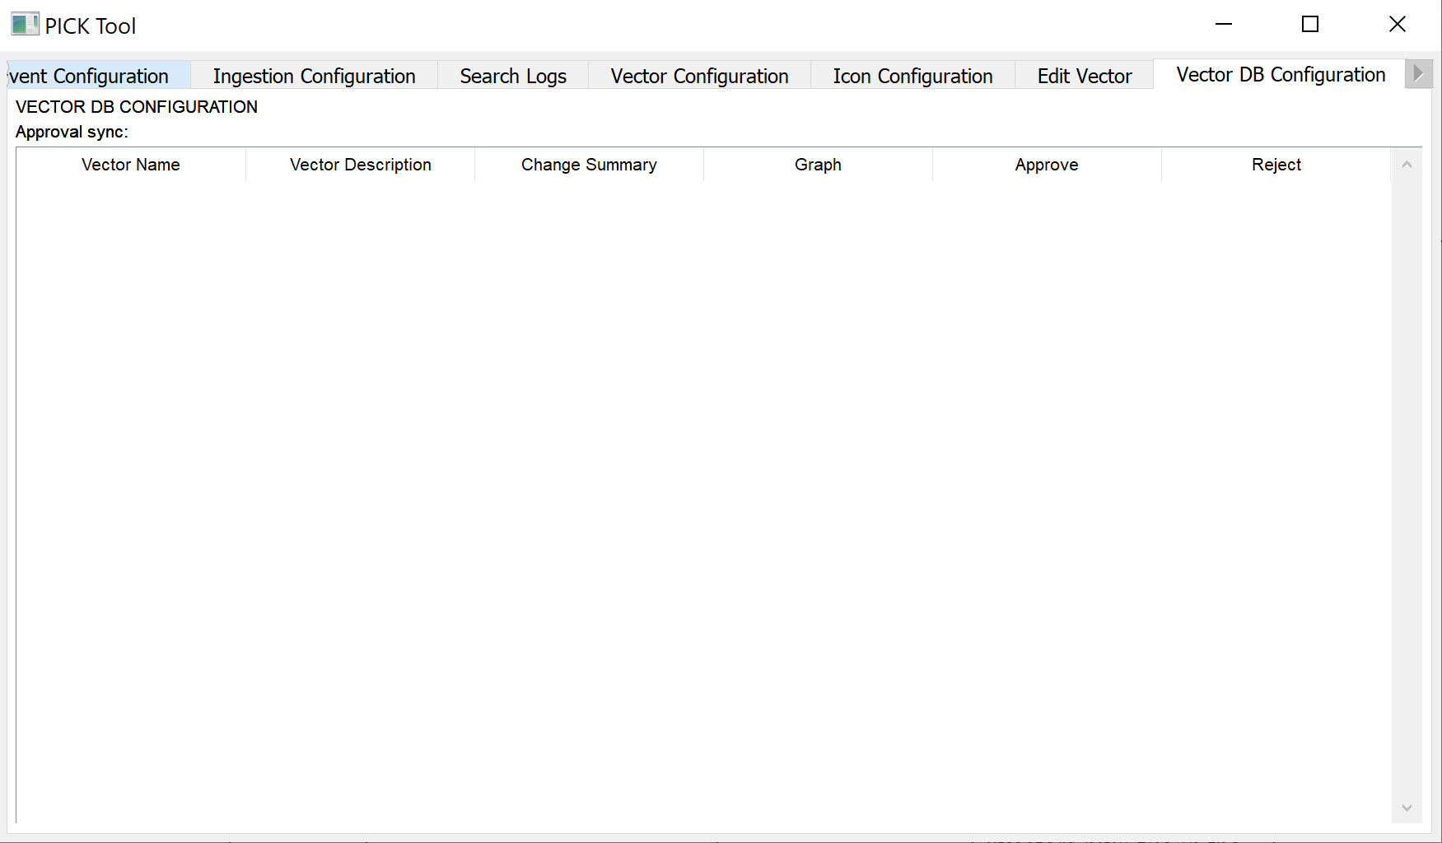

Image 39:

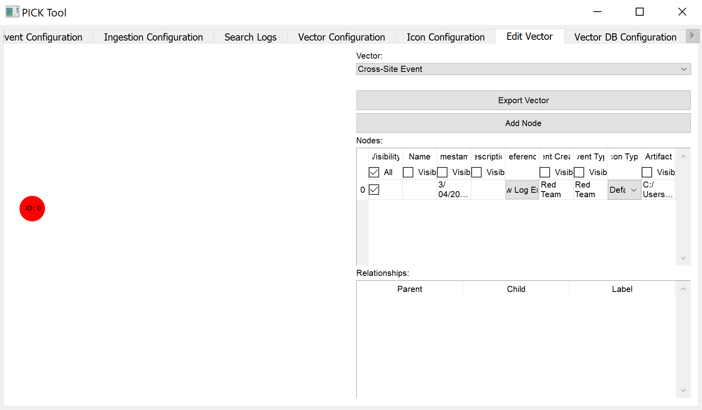

Image 40:

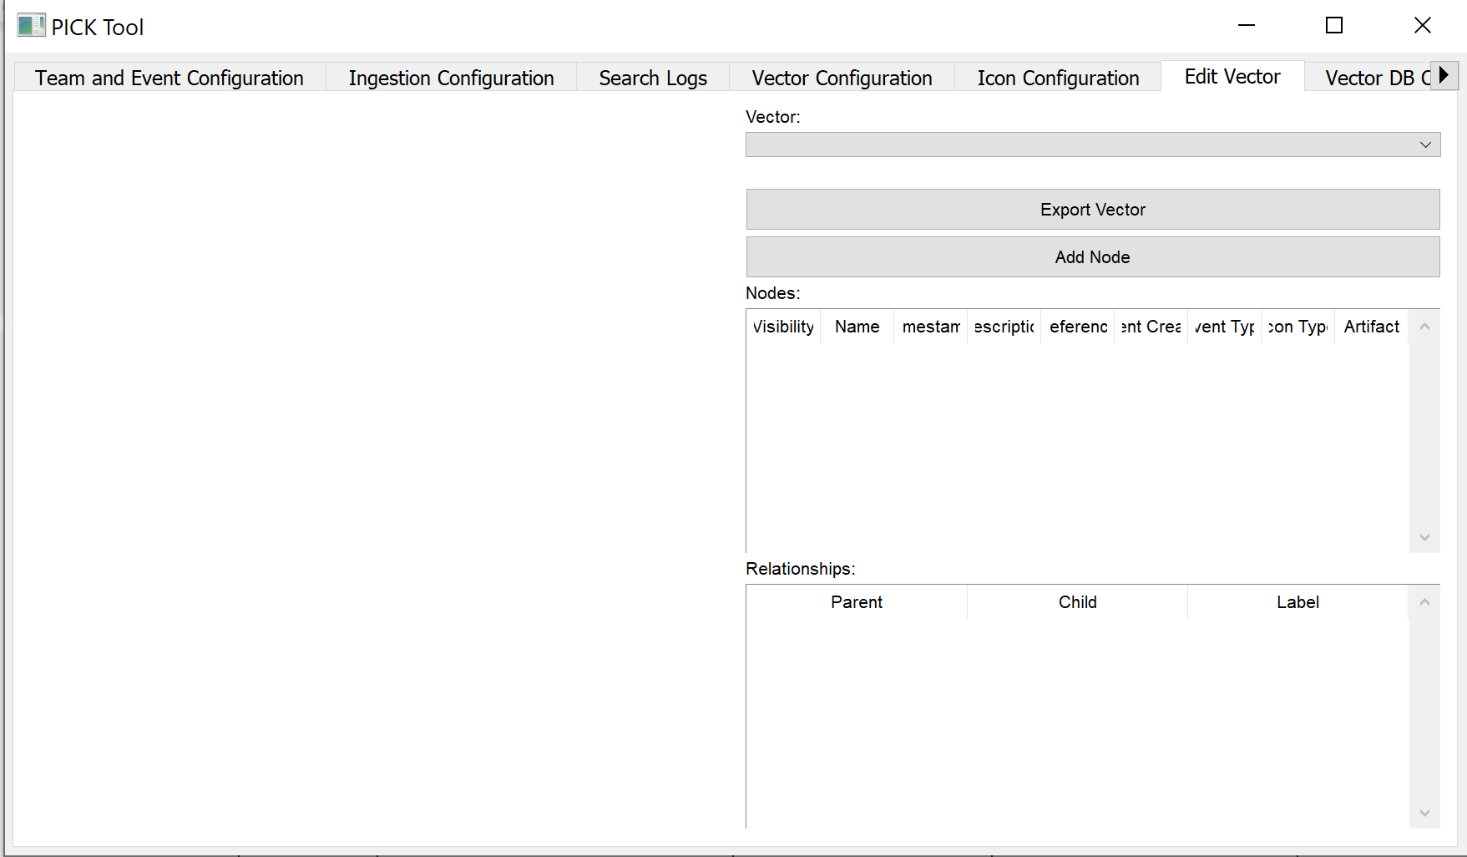

Image 41:

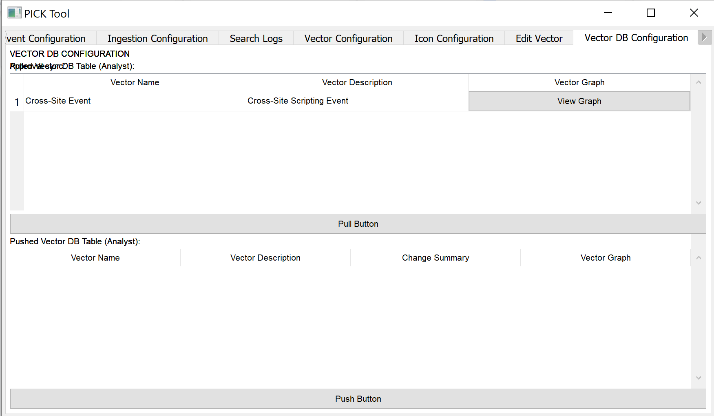

Image 42:

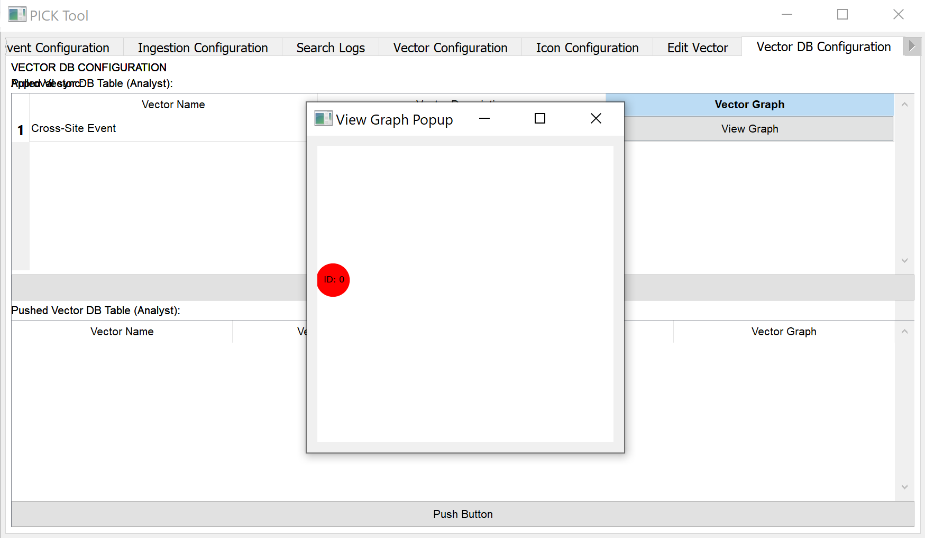

Image 43:

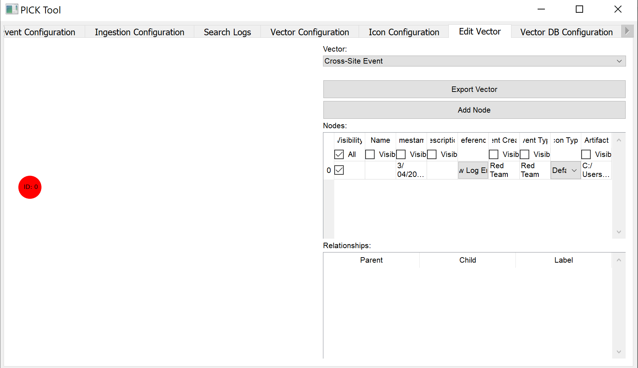

Image 44:

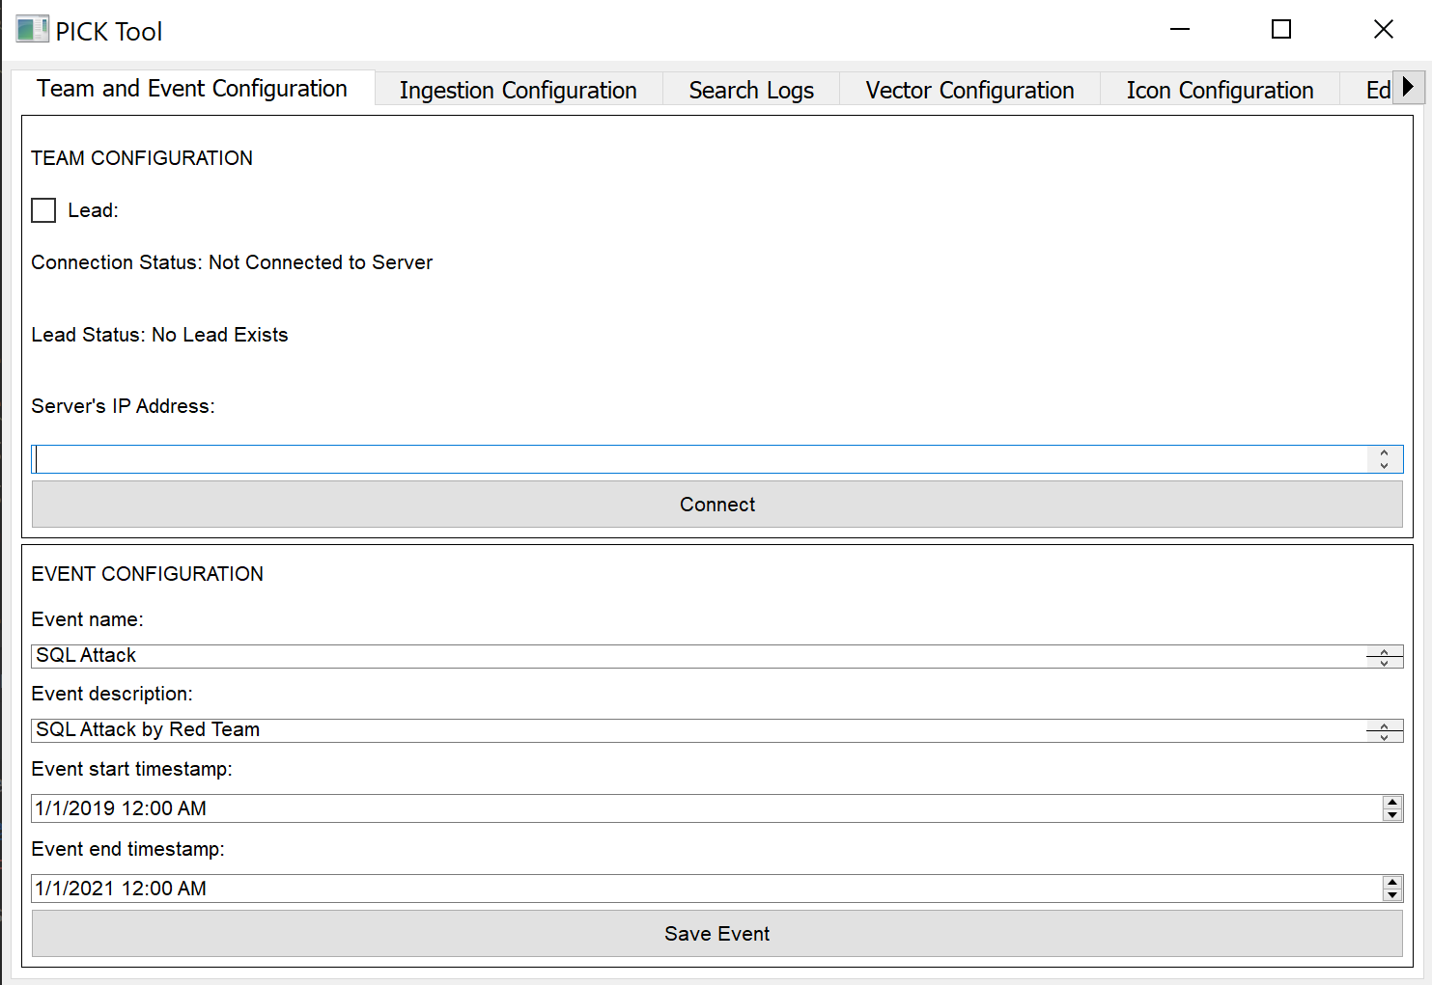

Image 45:

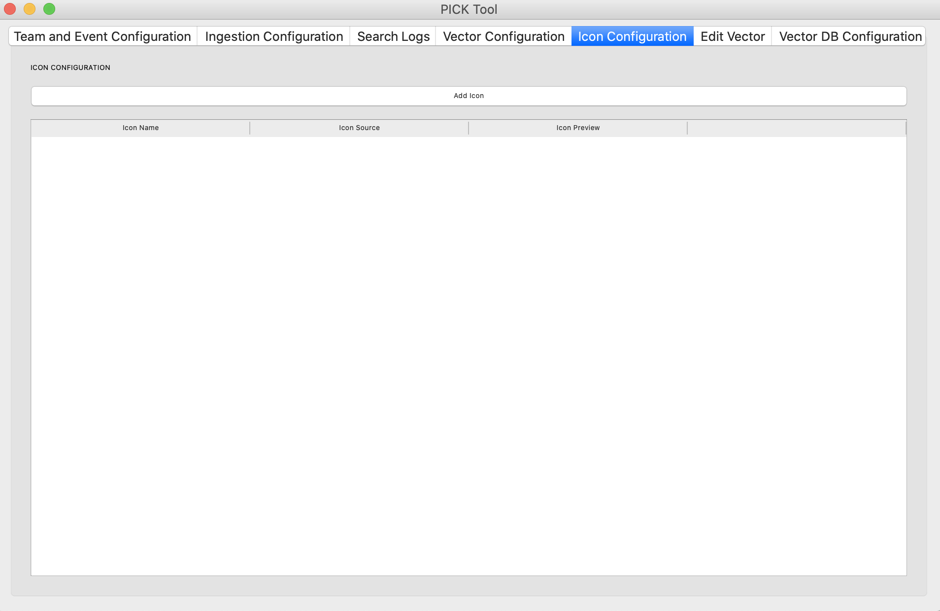

Image 46:

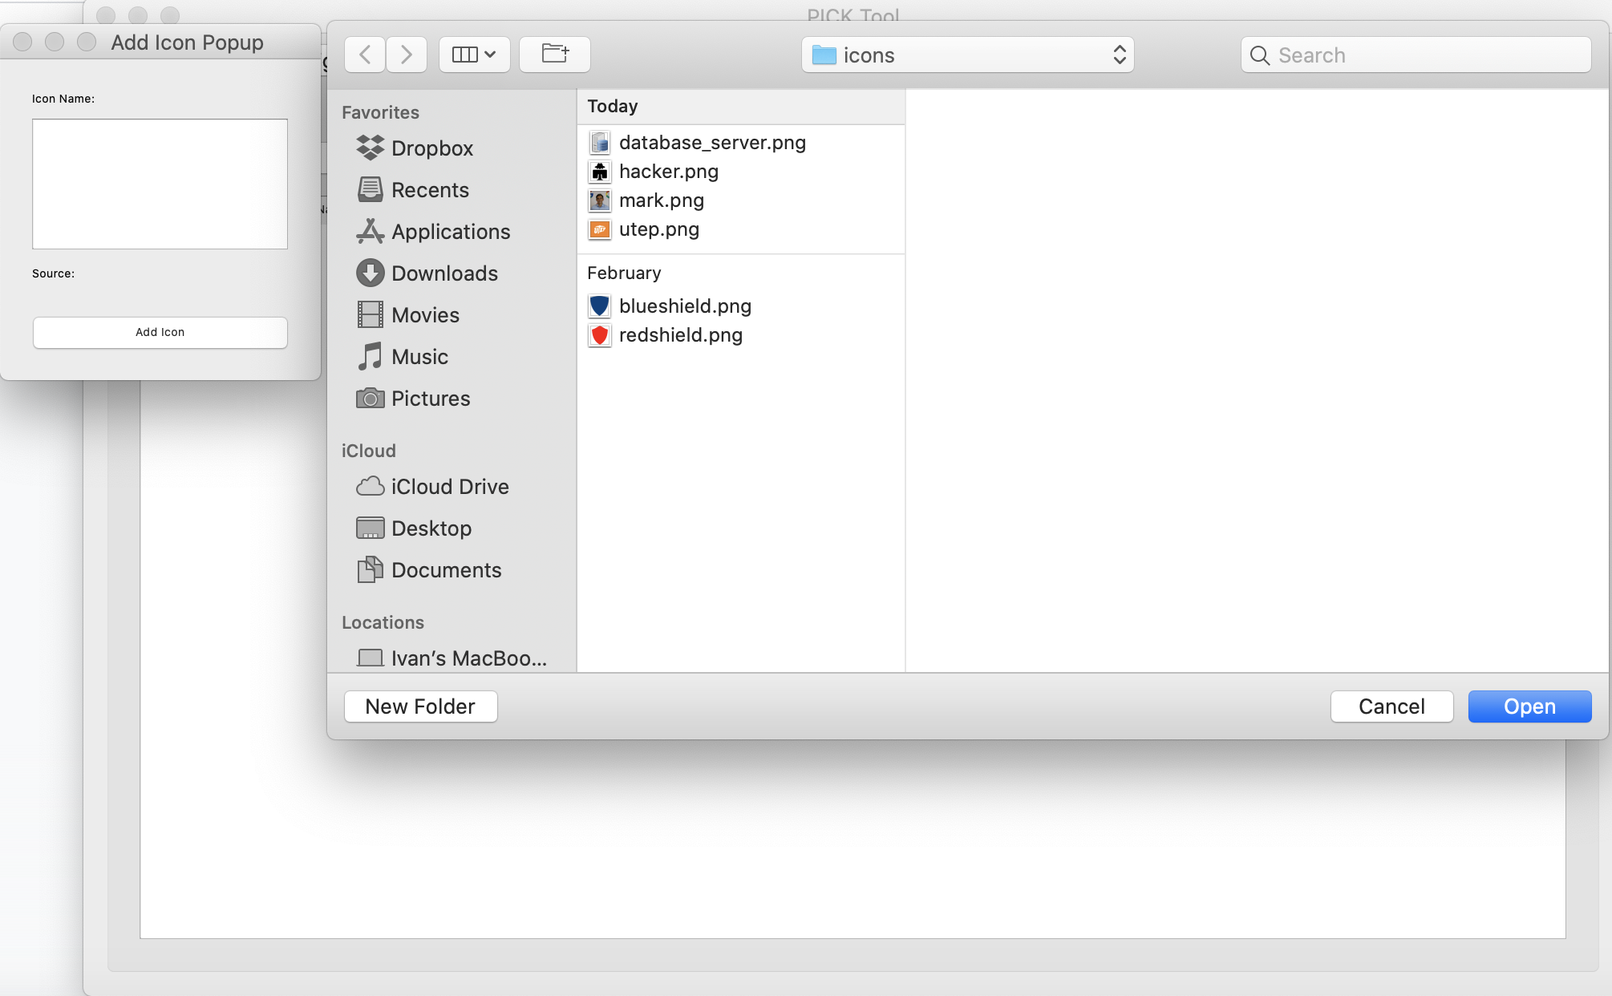

Image 47:

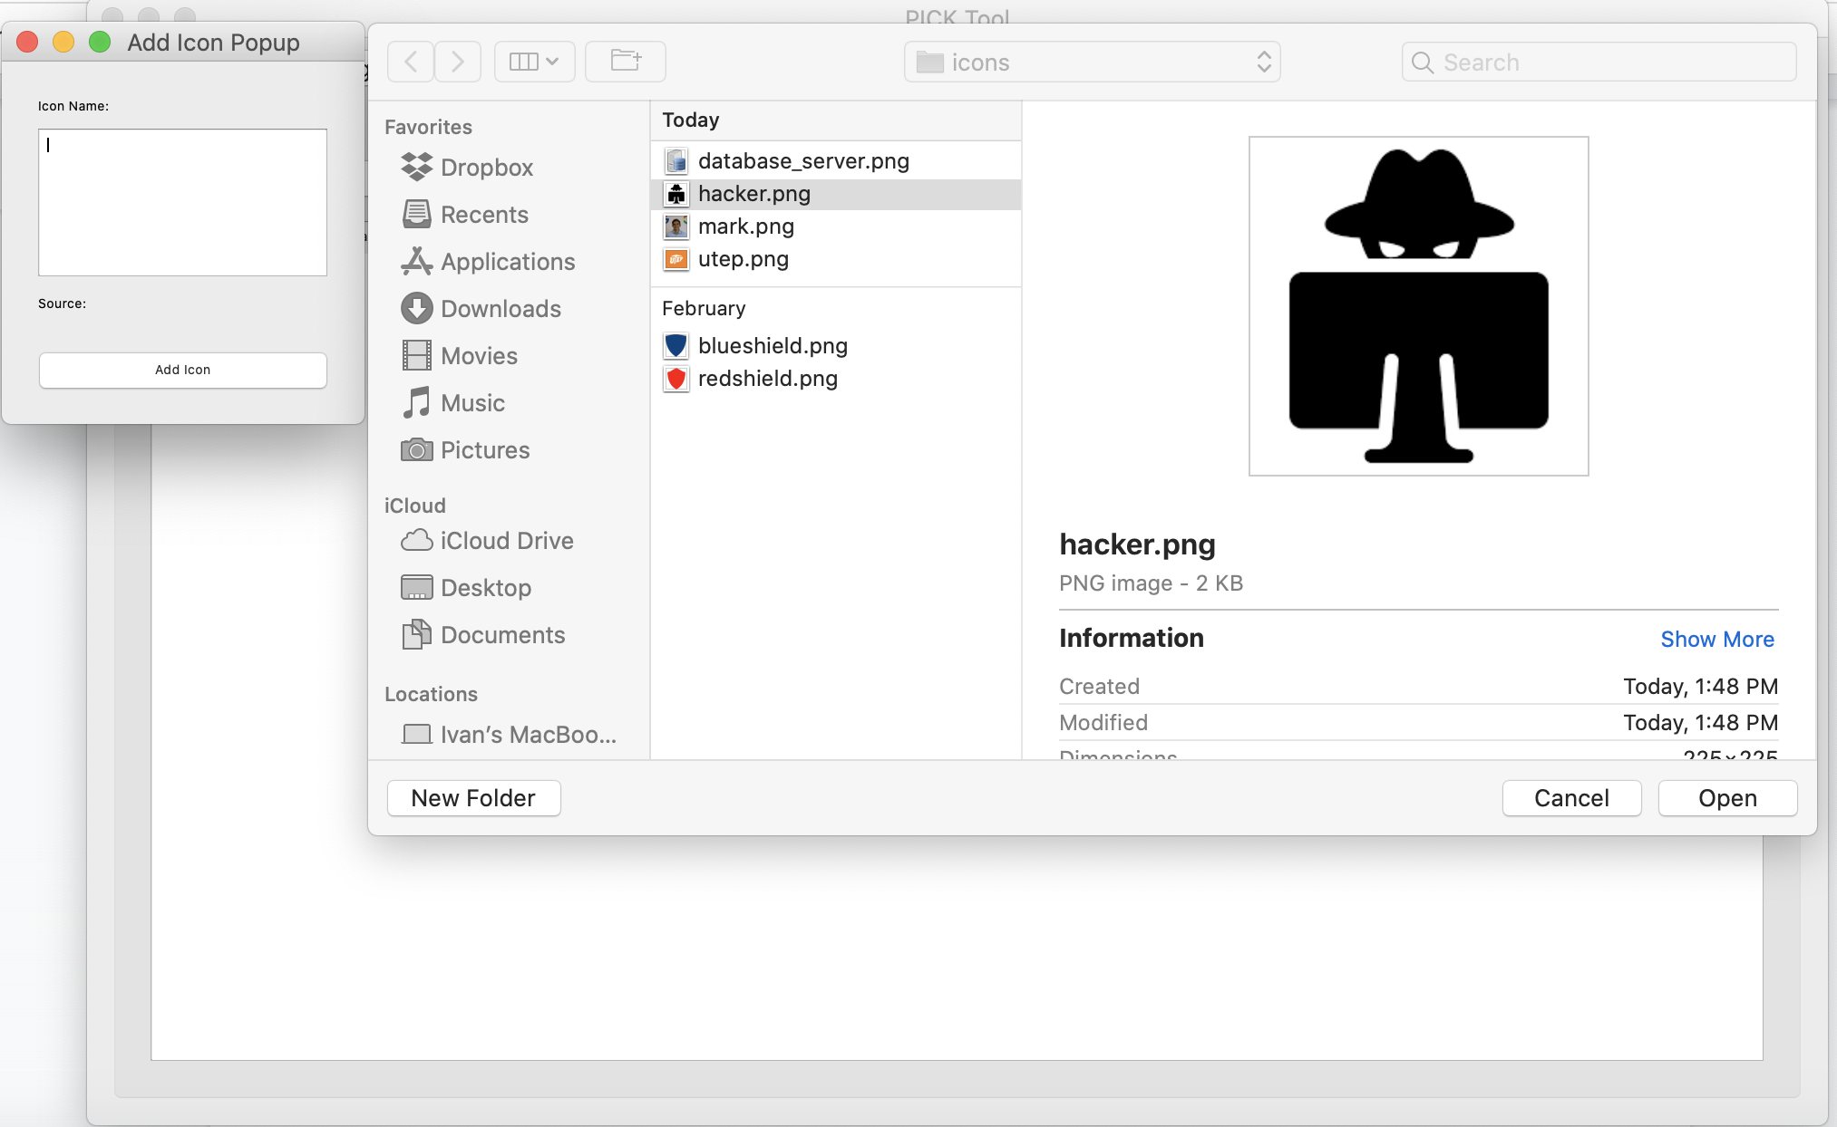

Image 48:

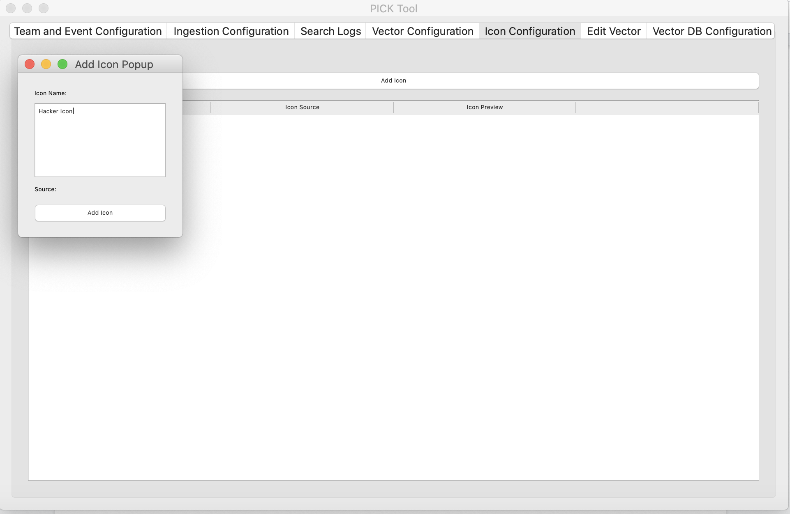

Image 49:

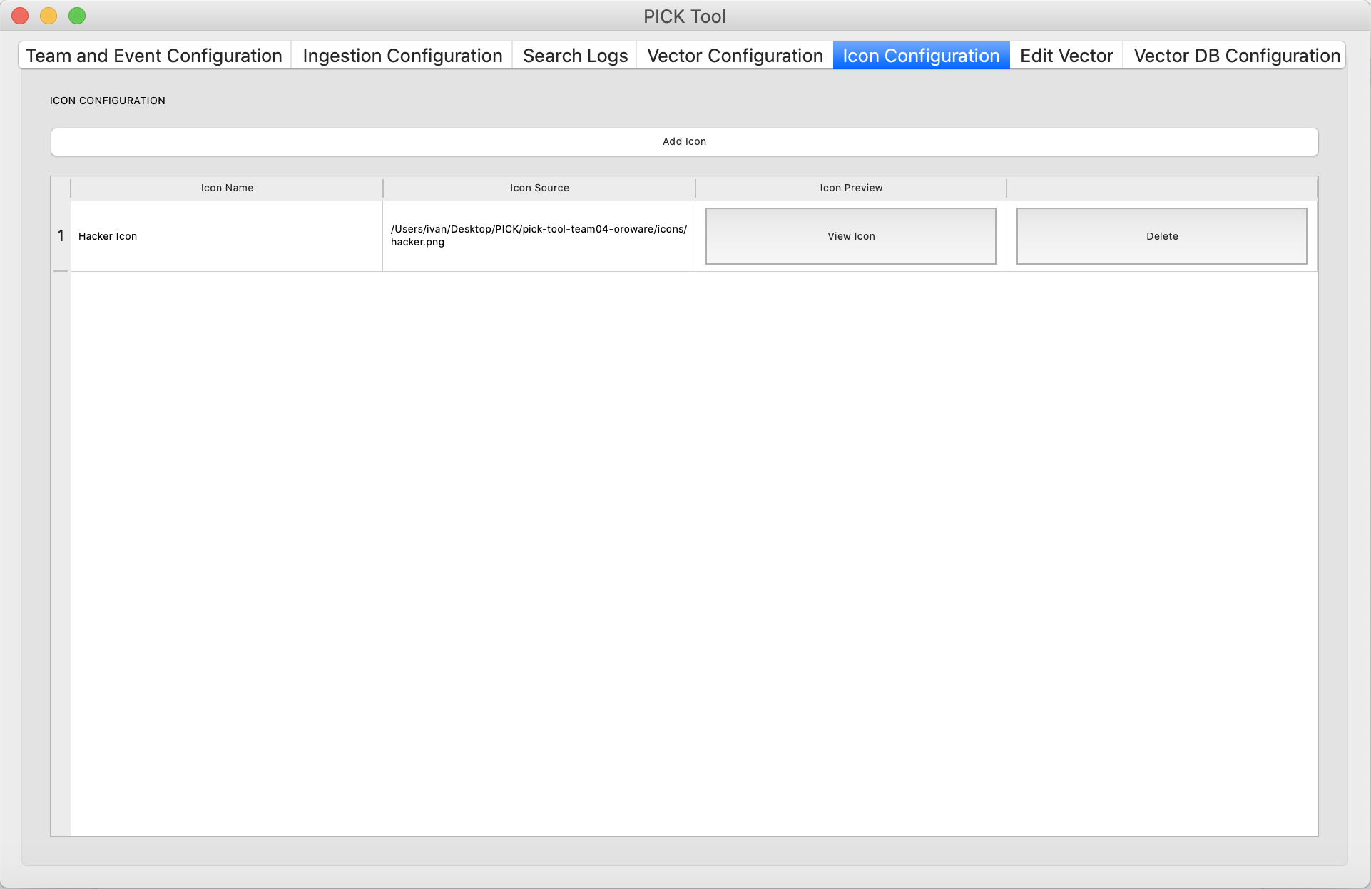

Image 50:

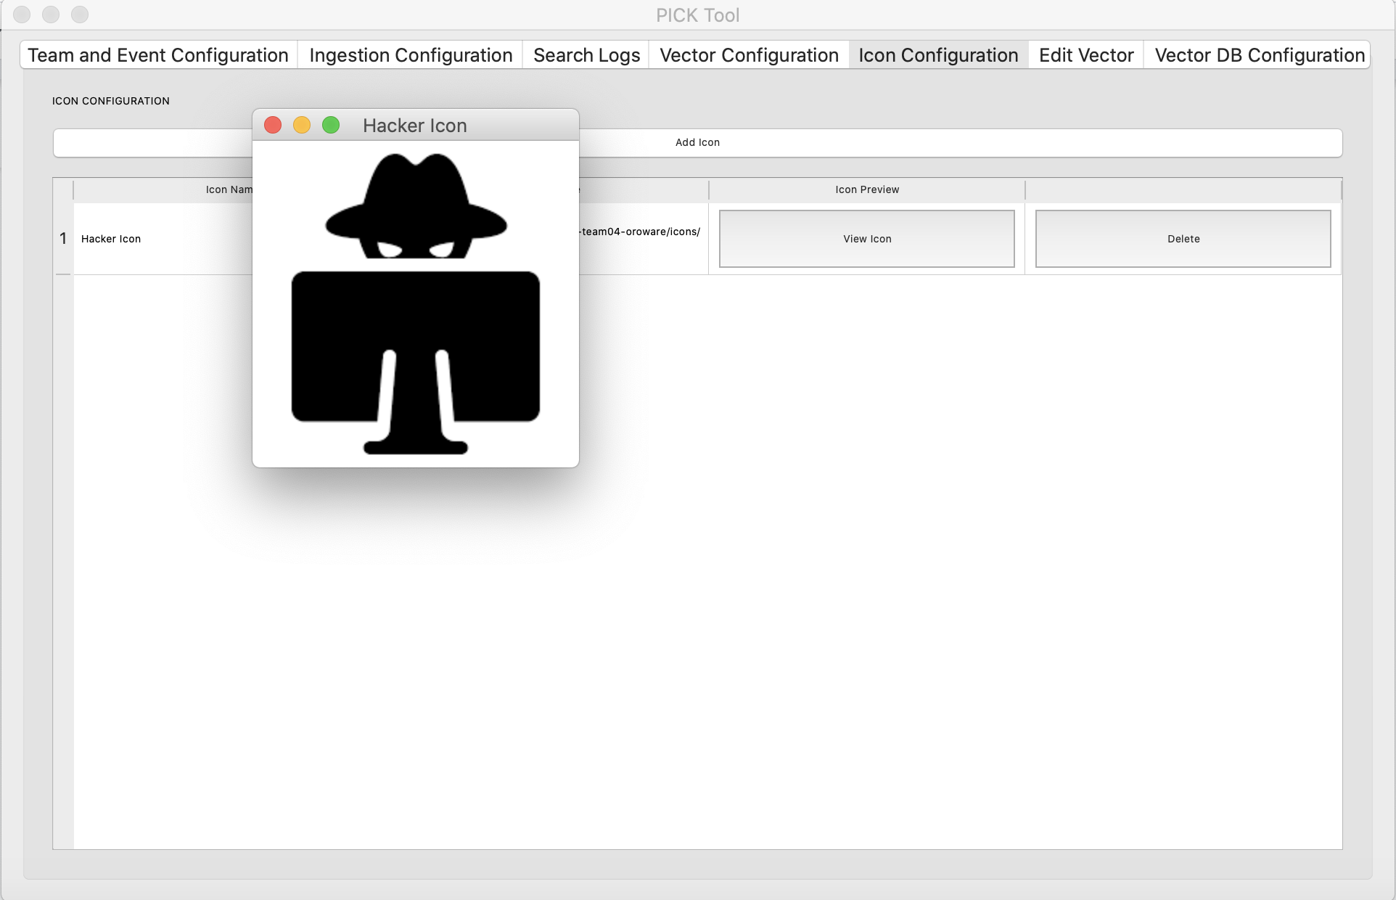

Image 51:

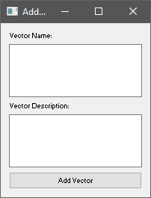

Image 52:

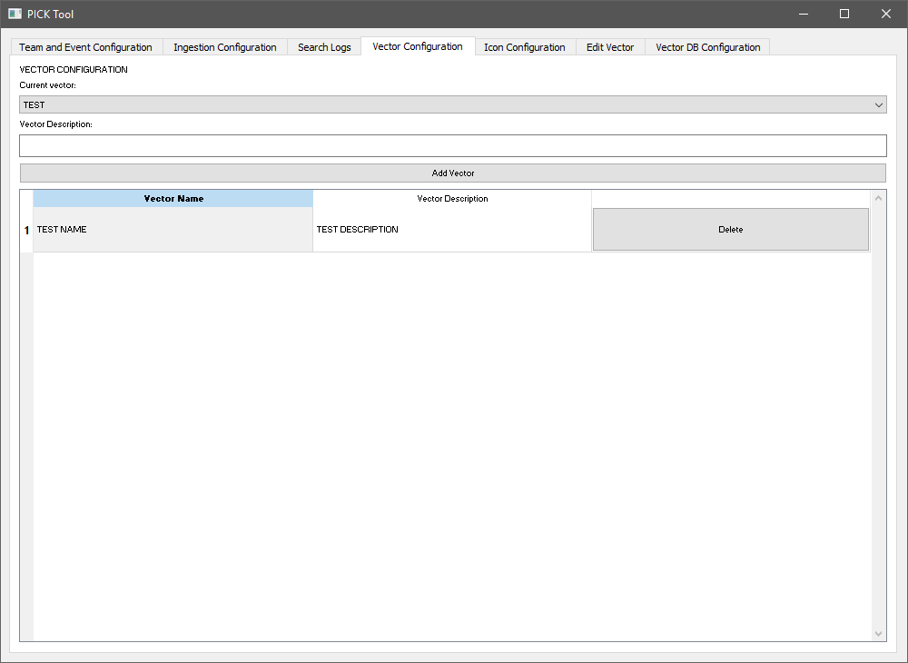

Image 53:



